**CARESTREAM HEALTH**

|  |  |
| --- | --- |
| **Part Number :** | **Autour : Ralf Wang** |
| **Project : KIOSK PUMA System** | **Product : KIOSK** |
| **Document Title: Kiosk PUMA Performance Testing Report\_20170815** | |

**TABLE OF CONTENTS**

[1 Test Environment 5](#_Toc516237482)

[2 Test Requirement 5](#_Toc516237483)

[2.1 Test Scenario 6](#_Toc516237484)

[2.2 Test Tool 6](#_Toc516237485)

[3 Testing work （Phase 1） 7](#_Toc516237486)

[3.1 Strategy and Scenario Setting 7](#_Toc516237487)

[3.2 Background Data 7](#_Toc516237488)

[3.3 Other Setting: 8](#_Toc516237489)

[3.3.1 Database setting 8](#_Toc516237490)

[3.3.2 IIS setting 8](#_Toc516237491)

[3.4 Test Object version 8](#_Toc516237492)

[3.5 Test Error 8](#_Toc516237493)

[3.6 Test result 9](#_Toc516237494)

[3.6.1 Transactions result 9](#_Toc516237495)

[3.6.2 Test Statistic Report 9](#_Toc516237496)

[3.6.3 Transaction summary result 10](#_Toc516237497)

[3.6.4 Transaction response time result 10](#_Toc516237498)

[3.7 Performance bottleneck analysis 11](#_Toc516237499)

[3.7.1 Hardware usage analysis 11](#_Toc516237500)

[3.7.2 SQL Server resource usage analysis 13](#_Toc516237501)

[3.8 Test Conclusion 15](#_Toc516237502)

[3.9 Tune Suggesting 15](#_Toc516237503)

[3.9.1 Slowly SQL statement 15](#_Toc516237504)

[3.9.2 Deadlock SQL 17](#_Toc516237505)

[3.9.3 Other 17](#_Toc516237506)

[4 Testing work （Phase 2） 18](#_Toc516237507)

[4.1 Strategy and Scenario Setting 18](#_Toc516237508)

[4.2 Background Data 18](#_Toc516237509)

[4.3 Other Setting: 19](#_Toc516237510)

[4.3.1 Database setting 19](#_Toc516237511)

[4.3.2 IIS setting 19](#_Toc516237512)

[4.4 Test Object version 19](#_Toc516237513)

[4.5 Test Error 19](#_Toc516237514)

[4.6 Test result 19](#_Toc516237515)

[4.6.1 Transactions result 19](#_Toc516237516)

[4.6.2 Test Statistic Report 20](#_Toc516237517)

[4.6.3 Transaction summary result 21](#_Toc516237518)

[4.6.4 Transaction response time result 21](#_Toc516237519)

[4.7 Performance bottleneck analysis 22](#_Toc516237520)

[4.7.1 Hardware usage analysis 22](#_Toc516237521)

[4.8 Test Conclusion 22](#_Toc516237522)

[5 Testing work （Phase 3） 23](#_Toc516237523)

[5.1 Strategy and Scenario Setting 23](#_Toc516237524)

[5.2 Background Data 23](#_Toc516237525)

[5.3 Other Setting: 24](#_Toc516237526)

[5.3.1 Database setting 24](#_Toc516237527)

[5.3.2 IIS setting 24](#_Toc516237528)

[5.4 Test Object version 24](#_Toc516237529)

[5.5 Test Error 24](#_Toc516237530)

[5.6 Test result 25](#_Toc516237531)

[5.6.1 Transactions result 25](#_Toc516237532)

[5.6.2 Test Statistic Report (True Client) 25](#_Toc516237533)

[5.6.3 Transaction summary result (True Client) 26](#_Toc516237534)

[5.6.4 Transaction response time result (True Client) 26](#_Toc516237535)

[5.7 Performance bottleneck analysis 27](#_Toc516237536)

[5.7.1 Hardware usage analysis 28](#_Toc516237537)

[5.8 Test Conclusion 28](#_Toc516237538)

[6 Testing work （Phase 4） 30](#_Toc516237539)

[6.1 Strategy and Scenario Setting 30](#_Toc516237540)

[6.2 Background Data 30](#_Toc516237541)

[6.3 Other Setting: 31](#_Toc516237542)

[6.3.1 Database setting 31](#_Toc516237543)

[6.3.2 IIS setting 31](#_Toc516237544)

[6.4 Test Object version 31](#_Toc516237545)

[6.5 Test result (Service) 31](#_Toc516237546)

[6.5.1 Test Statistic Report (Service) 31](#_Toc516237547)

[6.5.2 Transaction summary result (Service) 33](#_Toc516237548)

[6.5.3 Transaction response time result (Service) 33](#_Toc516237549)

[6.6 Performance bottleneck analysis (Service) 34](#_Toc516237550)

[6.6.1 Hardware usage analysis 34](#_Toc516237551)

[6.6.2 SQL Server resource usage analysis 35](#_Toc516237552)

[6.7 Test result (True Client) 37](#_Toc516237553)

[6.7.1 Test Statistic Report (True Client) 37](#_Toc516237554)

[6.7.2 Transaction summary result (True Client) 38](#_Toc516237555)

[6.7.3 Transaction response time result (True Client) 38](#_Toc516237556)

[6.8 Performance bottleneck analysis (True Client) 39](#_Toc516237557)

[6.8.1 Hardware usage analysis 39](#_Toc516237558)

[6.9 Test Conclusion 40](#_Toc516237559)

[7 Testing work （Phase 5） 43](#_Toc516237560)

[7.1 Strategy and Scenario Setting 43](#_Toc516237561)

[7.2 Background Data 44](#_Toc516237562)

[7.3 Other Setting: 45](#_Toc516237563)

[7.3.1 Database setting 45](#_Toc516237564)

[7.3.2 IIS setting 45](#_Toc516237565)

[7.4 Test Object version 45](#_Toc516237566)

[7.5 Test result 45](#_Toc516237567)

[7.5.1 Test Statistic Report 45](#_Toc516237568)

[7.5.2 Transaction summary result (Service) 46](#_Toc516237569)

[7.5.3 Transaction response time result (Service) 47](#_Toc516237570)

[7.6 Performance bottleneck analysis (Service) 47](#_Toc516237571)

[7.6.1 Hardware usage analysis 47](#_Toc516237572)

[7.6.2 SQL Server resource usage analysis 49](#_Toc516237573)

[7.7 Test Conclusion 51](#_Toc516237574)

[8 Testing work （Phase 6） 52](#_Toc516237575)

[8.1 Strategy and Scenario Setting 53](#_Toc516237576)

[8.2 Background Data 53](#_Toc516237577)

[8.3 Other Setting: 54](#_Toc516237578)

[8.3.1 Database setting 54](#_Toc516237579)

[8.3.2 IIS setting 54](#_Toc516237580)

[8.4 Test Object version 54](#_Toc516237581)

[8.5 Test result 54](#_Toc516237582)

[8.5.1 Test Statistic Report 54](#_Toc516237583)

[8.5.2 Transaction summary result (Service) 55](#_Toc516237584)

[8.5.3 Transaction response time result (Service) 56](#_Toc516237585)

[8.6 Performance bottleneck analysis (Service) 57](#_Toc516237586)

[8.6.1 Hardware usage analysis 57](#_Toc516237587)

[8.6.2 SQL Server resource usage analysis 58](#_Toc516237588)

[8.7 Test Conclusion 60](#_Toc516237589)

[9 Testing work （Phase 7） 61](#_Toc516237590)

[9.1 Strategy and Scenario Setting 61](#_Toc516237591)

[9.2 Background Data 62](#_Toc516237592)

[9.3 Other Setting: 62](#_Toc516237593)

[9.3.1 Database setting 62](#_Toc516237594)

[9.3.2 IIS setting 63](#_Toc516237595)

[9.4 Test Object version 63](#_Toc516237596)

[9.5 Test result 63](#_Toc516237597)

[9.5.1 Test Statistic Report 63](#_Toc516237598)

[9.5.2 Transaction summary result (Service) 63](#_Toc516237599)

[9.5.3 Transaction response time result (Service) 63](#_Toc516237600)

[9.6 Performance bottleneck analysis (Service) 63](#_Toc516237601)

[9.6.1 Hardware usage analysis 63](#_Toc516237602)

[9.6.2 SQL Server resource usage analysis 63](#_Toc516237603)

[9.7 Test Conclusion 63](#_Toc516237604)

[10 Testing work （Phase 8） 64](#_Toc516237605)

[10.1 Strategy and Scenario Setting 64](#_Toc516237606)

[10.2 Background Data 65](#_Toc516237607)

[10.3 Other Setting: 66](#_Toc516237608)

[10.3.1 Database setting 66](#_Toc516237609)

[10.3.2 IIS setting 66](#_Toc516237610)

[10.4 Test Object version 66](#_Toc516237611)

[10.5 Test result 66](#_Toc516237612)

[10.5.1 Test Statistic Report - PS 66](#_Toc516237613)

[10.5.2 Test Statistic Report - Web 67](#_Toc516237614)

[10.5.3 Transaction summary result (PS) 68](#_Toc516237615)

[10.5.4 Transaction summary result (Web) 69](#_Toc516237616)

[10.5.5 Transaction response time result (PS) 69](#_Toc516237617)

[10.5.6 Transaction response time result (Web) 70](#_Toc516237618)

[10.6 Performance bottleneck analysis (PS) 71](#_Toc516237619)

[10.6.1 Hardware usage analysis 71](#_Toc516237620)

[10.6.2 SQL Server resource usage analysis 72](#_Toc516237621)

[10.7 Test Conclusion 73](#_Toc516237622)

[11 Testing work （Phase 9） 74](#_Toc516237623)

[11.1 Strategy and Scenario Setting 74](#_Toc516237624)

[11.2 Background Data 75](#_Toc516237625)

[11.3 Other Setting: 75](#_Toc516237626)

[11.3.1 Database setting 75](#_Toc516237627)

[11.3.2 IIS setting 75](#_Toc516237628)

[11.4 Test Object version 75](#_Toc516237629)

[11.5 Test result 76](#_Toc516237630)

[11.5.1 Test Statistic Report 76](#_Toc516237631)

[11.5.2 Transaction summary result 76](#_Toc516237632)

[11.6 Performance bottleneck analysis 76](#_Toc516237633)

[11.6.1 Hardware usage analysis 76](#_Toc516237634)

[11.6.2 SQL Server resource usage analysis 76](#_Toc516237635)

[11.7 Issue analysis 77](#_Toc516237636)

[11.8 Test Conclusion 79](#_Toc516237637)

[12 Testing work （Phase 10） 79](#_Toc516237638)

[12.1 Strategy and Scenario Setting 79](#_Toc516237639)

[12.2 Background Data 80](#_Toc516237640)

[12.3 Other Setting: 81](#_Toc516237641)

[12.3.1 Database setting 81](#_Toc516237642)

[12.3.2 IIS setting 81](#_Toc516237643)

[12.4 Test Object version 81](#_Toc516237644)

[12.5 Test result 81](#_Toc516237645)

[12.5.1 Test Statistic Report 81](#_Toc516237646)

[12.5.2 Transaction summary result 82](#_Toc516237647)

[12.5.3 Transaction response time result (PS) 83](#_Toc516237648)

[12.6 Performance bottleneck analysis 83](#_Toc516237649)

[12.6.1 Hardware usage analysis 84](#_Toc516237650)

[12.6.2 SQL Server resource usage analysis 85](#_Toc516237651)

[12.7 Issue analysis 86](#_Toc516237652)

[12.8 Performance tuning 90](#_Toc516237653)

[12.9 Test Conclusion 93](#_Toc516237654)

# Test Environment

Test environment：We use the follow machine to do our performance testing work.

|  |  |  |  |  |  |  |  |  |  |  |  |
| --- | --- | --- | --- | --- | --- | --- | --- | --- | --- | --- | --- |
| **Server Name** | **Type** | **CPU** | | **Hard Disk** | | **RAM** | | **OS** | | **Required Software** | |
| PS Server | Hyper-v virtual machine | Intel Xeon E5-2620 v3 2.40GHz \*12 | 2T SCSI Disk  Seagate MD3002 | | 32G | | Windows 2012 R2 | | SQL 2012  IIS 8 | |
| QTP script machine | Hyper-v virtual machine | Intel Xeon E5-2403 v2 1.80GHz \*4 | 80G Virtual Disk | | 2.5G | | Windows 2012 R2 | | QTP 11 demo | |
| Performance control | Dell optiplex 9020 | Intel core(TM) i7-4790 3.6GHZ\*6 | 1T SATA Disk | | 8G | | Win7 64bit | | Load runner | |

Figure 1.1 Hardware List

# Test Requirement

The PUMA system will support reporting and notice push service for different department of entire hospital. We will integrate with the 3rd party system and patients can print their reports in ONE terminal. The message push service will also be included in the product. Patient can query different information and get the report status notice service from the product.

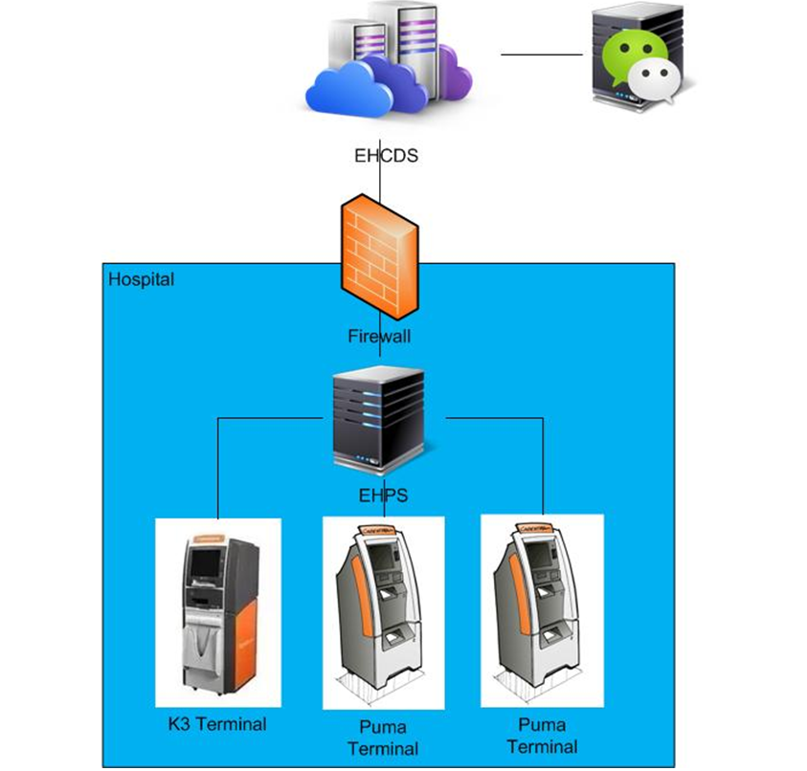

Figure2.1 System structure

We will do the performance testing work to make sure the system can fit the requirements and services work well. The detail plan and strategy please reference the content in document “AE4746\_PUMA\_Verification Test Plan.docx”.

## Test Scenario

The testing work will simulate the real work flow include Print film from workstation, Query and operation in web, OCR operations, terminal print, message push and etc.

## Test Tool

QTP: Simulate doctor print film from workstation.

Load Runner: Simulate the doctor and patient operation by http or web service.

# Testing work （Phase 1）

## Strategy and Scenario Setting

1. Use automation tool simulate the doctor print film work. Simulate 8 GX Platform by using QTP and PDSender tool. Each client prints one film which size is 10MB every 30 seconds.
2. Use LR tool simulate 10 K2/K3 terminals to print film. Each client prints one film which size is 10MB random 5 to 30 seconds.
3. Use LR tool simulate 45 PUMA terminals to print paper reports. Each client prints report random 5 to 30 seconds.
4. Use LR tool simulate the PUMA report archive operations. Each client archive report in random 5 to 30 seconds and size is random with 100kb and 4Mb.
5. The OCR setting is cover the rule for GX platforms in step1 and other setting are set as default.
6. Monitor the hardware resource usage on PS.
7. Monitor the resource usage for database on PS.
8. Start/Stop 2 virtual users every 5 seconds and run the scenario for 2 hours.

## Background Data

We use SQL command statement to add large data in the database, the detail information as follow:

|  |  |
| --- | --- |
| **Table Name** | **Data Volume (records)** |
| printer.dbo.DeliveryJob | 896813 |
| printer.dbo.ImageBox | 997879 |
| printer.dbo.Page | 997813 |
| printer.dbo.Session | 1001132 |
| wggc.dbo.Patient | 1029777 |
| wggc.dbo.Study | 1029789 |
| wggc.dbo.AFP\_PrintTerminalInfo | 62 |
| wggc.dbo.Series | 1029735 |
| wggc.dbo.Image | 1029738 |
| wggc.dbo.AFP\_FilmInfo | 1043592 |
| wggc.dbo.AFP\_ReportInfo | 936761 |
| wggc.dbo.AFP\_ExamInfo | 1997005 |
| wggc.dbo.AFP\_PrintTask | 3696324 |
| wggc.dbo.T\_Integration\_ExamInfo | 119292 |
| AFP\_PrintMode | 87883 |
| wggc.dbo.vi\_KIOSK\_ExamInfo\_Order | 119331 |

Figure 3.2.1 Background Data

## Other Setting:

### Database setting

Memory: Set the min and max memory size to 8GB.

Index fill factor: 80.

File: Increase the data and log files size and the rule is increase 200Mb as fixed size.

### IIS setting

Connection: Set the max connection value to 4000 and keep other setting as default.

## Test Object version

KIOSK Platform 3.0.0.1 B05

## Test Error

There are some errors exist in the testing work and logged as follow:

|  |  |  |
| --- | --- | --- |
| No | description | Counts |
| 1 | "HttpSendRequest" failed, Windows error code=12002 and retry limit (0) exceeded for URL="http://10.184.129.208/EHDPS/printtask/print/3982374?tid=K2\_6" | 9 |
| 2 | HTTP Status-Code=404 (Not Found) for "http://10.184.129.208/EHDPS/printtask/print/?tid=K2\_2" | 13 |
| 3 | HTTP Status-Code=503 (Service Unavailable) for "http://10.184.129.208/EHDPS/printtask/status/3982245?tid=K2\_1" | 6 |
| 4 | No match found for the requested parameter "TaskStatus". Check whether the requested boundaries exist in the response data. Also, if the data you want to save exceeds 10240 bytes, use web\_set\_max\_html\_param\_len to increase the parameter size | 25 |
| 5 | The above "not found" error(s) may be explained by header and body byte counts being 0 and 0, respectively. | 7 |
| 6 | Text=<NotifyReportFileResult>true</NotifyReportFileResult>" not found for web\_reg\_find | 168 |
| 7 | The task do not finished!: \*\*\*\*\*\* From Terminal: \*\*\*\*\*\*\*\*\* | 1006 |

Error analyzes:

1. Http request do not execute successfully, there is some error in IIS.
2. Send the request and server return 404 errors, the print transaction failed. Some errors happened in IIS or database.
3. The IIS error rule limits the server to response. There are many error happens in IIS, then IIS refuse the service.
4. Some requests do not return the response context. The scripts cannot get the value from the response context and it makes the script down.
5. Some requests do not return the response.
6. The notify report service do not execute successfully, the transaction is failed.
7. The errors is make from scripts, it means the print tasks do not print successfully.

## Test result

### Transactions result

After the testing work, the transaction result which collect from database as follow:

|  |  |  |  |
| --- | --- | --- | --- |
| **Transaction** | **All** | **Pass** | **Fail** |
| All Print Tasks | 6575 | N/A | N/A |
| Film print task | 769 | 709 | 60 |
| Report print task | 5803 | 4883 | 920 |
| Report archive | 10770 | N/A | N/A |

Figure 3.6.1.1 Transaction result from DB

### Test Statistic Report

|  |  |  |
| --- | --- | --- |
| **Scenario Name:** | Scenario PUMA | |
| **Duration:** | | 2 hours, 13 minutes and 1 second. |

|  |
| --- |
| Statistics Summary |

|  |  |  |
| --- | --- | --- |
| [**Maximum Running Vusers:**](file:///C:\Users\Administrator\Desktop\Performance%20result\20170531_1\VuserStateGraph) |  | 100 |
| [**Total Throughput (bytes):**](file:///C:\Users\Administrator\Desktop\Performance%20result\20170531_1\Throughput) |  | 26,305,565,808 |
| [**Average Throughput (bytes/second):**](file:///C:\Users\Administrator\Desktop\Performance%20result\20170531_1\Throughput) |  | 3,295,611 |
| [**Total Hits:**](file:///C:\Users\Administrator\Desktop\Performance%20result\20170531_1\HitsperSecond) |  | 75,058 |
| [**Average Hits per Second:**](file:///C:\Users\Administrator\Desktop\Performance%20result\20170531_1\HitsperSecond) |  | 9.403 |  |
| [**Total Errors:**](file:///C:\Users\Administrator\Desktop\Performance%20result\20170531_1\TotalErrorsPerSecond) |  | 1,234 |  |

|  |
| --- |
| Transaction Summary |

|  |  |  |  |  |
| --- | --- | --- | --- | --- |
| [**Transactions:**](file:///C:\Users\Administrator\Desktop\Performance%20result\20170531_1\TransactionSummary) | Total Passed: 90,627 | Total Failed: 1,202 | Total Stopped: 0 | [**Average Response Time**](file:///C:\Users\Administrator\Desktop\Performance%20result\20170531_1\ResponseTime) |

|  |  |  |  |  |  |  |  |  |  |
| --- | --- | --- | --- | --- | --- | --- | --- | --- | --- |
| **Transaction Name** | **SLA Status** | **Minimum** | **Average** | **Maximum** | **Std. Deviation** | **90 Percent** | **Pass** | **Fail** | **Stop** |
| [Film Create\_PrintTask](file:///C:\Users\Administrator\Desktop\Performance%20result\20170531_1\ResponseTime0000(Film%20Create_PrintTask)0000) |  | 0.04 | 0.407 | 11.454 | 0.632 | 0.794 | 989 | 1 | 0 |
| [Film PrintTask](file:///C:\Users\Administrator\Desktop\Performance%20result\20170531_1\ResponseTime0000(Film%20PrintTask)0000) |  | 0.059 | 0.884 | 11.887 | 1.086 | 1.658 | 987 | 3 | 0 |
| [Film PrintTask\_Check](file:///C:\Users\Administrator\Desktop\Performance%20result\20170531_1\ResponseTime0000(Film%20PrintTask_Check)0000) |  | 0.01 | 0.447 | 29.884 | 1.203 | 0.83 | 5,272 | 24 | 0 |
| [Film PrintTask\_Result](file:///C:\Users\Administrator\Desktop\Performance%20result\20170531_1\ResponseTime0000(Film%20PrintTask_Result)0000) |  | 0 | 0 | 0 | 0 | 0 | 0 | 288 | 0 |
| [Film TerminalStatus](file:///C:\Users\Administrator\Desktop\Performance%20result\20170531_1\ResponseTime0000(Film%20TerminalStatus)0000) |  | 0.019 | 0.468 | 8.512 | 0.599 | 1.073 | 1,980 | 0 | 0 |
| [Notify File 100k](file:///C:\Users\Administrator\Desktop\Performance%20result\20170531_1\ResponseTime0000(Notify%20File%20100K)0000) |  | 1.576 | 15.165 | 106.73 | 9.877 | 22.015 | 238 | 3 | 0 |
| [Notify File 4M](file:///C:\Users\Administrator\Desktop\Performance%20result\20170531_1\ResponseTime0000(Notify%20File%204M)0000) |  | 0.454 | 16.026 | 124.852 | 11.987 | 24.059 | 11,682 | 165 | 0 |
| [Report Create\_PrintTask](file:///C:\Users\Administrator\Desktop\Performance%20result\20170531_1\ResponseTime0000(Report%20Create_PrintTask)0000) |  | 0.027 | 0.503 | 40.779 | 1.402 | 0.907 | 5,583 | 0 | 0 |
| [Report Download File](file:///C:\Users\Administrator\Desktop\Performance%20result\20170531_1\ResponseTime0000(Report%20Download%20File)0000) |  | 0.027 | 1.794 | 36.419 | 1.425 | 3.359 | 5,583 | 0 | 0 |
| [Report PrintTask](file:///C:\Users\Administrator\Desktop\Performance%20result\20170531_1\ResponseTime0000(Report%20PrintTask)0000) |  | 0.1 | 3.823 | 54.344 | 4.423 | 7.351 | 5,583 | 0 | 0 |
| [Report PrintTask\_Check](file:///C:\Users\Administrator\Desktop\Performance%20result\20170531_1\ResponseTime0000(Report%20PrintTask_Check)0000) |  | 0.011 | 0.406 | 39.1 | 1.207 | 0.776 | 19,234 | 0 | 0 |
| [Report QueryFilmReportInfo](file:///C:\Users\Administrator\Desktop\Performance%20result\20170531_1\ResponseTime0000(Report%20QueryFilmReportInfo)0000) |  | 0.004 | 0.062 | 15.485 | 0.289 | 0.11 | 11,166 | 0 | 0 |
| [Report Task Result](file:///C:\Users\Administrator\Desktop\Performance%20result\20170531_1\ResponseTime0000(Report%20Task%20Result)0000) |  | 0 | 0 | 0 | 0 | 0 | 0 | 718 | 0 |
| [Report TerminalStatus](file:///C:\Users\Administrator\Desktop\Performance%20result\20170531_1\ResponseTime0000(Report%20TerminalStatus)0000) |  | 0.016 | 0.489 | 17.066 | 0.859 | 1.05 | 11,166 | 0 | 0 |
| [Report Update PrintTask](file:///C:\Users\Administrator\Desktop\Performance%20result\20170531_1\ResponseTime0000(Report%20Update%20PrintTask)0000) |  | 0.282 | 5.733 | 48.45 | 5.367 | 11.366 | 5,581 | 0 | 0 |
| [Report Update report printer info](file:///C:\Users\Administrator\Desktop\Performance%20result\20170531_1\ResponseTime0000(Report%20Update%20report%20printer%20info)0000) |  | 0.028 | 0.562 | 29.721 | 0.817 | 1.17 | 5,583 | 0 | 0 |

Figure 3.6.2.1 Summary Report

Follow the summary result information; we can get the information that:

All testing work duration time is 2 hours and 13 minutes. There are 90627 transactions passed and 1202 transactions failed. The follow transactions` response times are not meets the requirements and value is too big:

|  |  |  |  |  |  |  |  |  |  |
| --- | --- | --- | --- | --- | --- | --- | --- | --- | --- |
| **Transaction Name** | **SLA Status** | **Minimum** | **Average** | **Maximum** | **Std. Deviation** | **90 Percent** | **Pass** | **Fail** | **Stop** |
| [Notify File 100k](file:///C:\Users\Administrator\Desktop\Performance%20result\20170531_1\ResponseTime0000(Notify%20File%20100K)0000) |  | 1.576 | 15.165 | 106.73 | 9.877 | 22.015 | 238 | 3 | 0 |
| [Notify File 4M](file:///C:\Users\Administrator\Desktop\Performance%20result\20170531_1\ResponseTime0000(Notify%20File%204M)0000) |  | 0.454 | 16.026 | 124.852 | 11.987 | 24.059 | 11,682 | 165 | 0 |
| [Report PrintTask](file:///C:\Users\Administrator\Desktop\Performance%20result\20170531_1\ResponseTime0000(Report%20PrintTask)0000) |  | 0.1 | 3.823 | 54.344 | 4.423 | 7.351 | 5,583 | 0 | 0 |
| [Report Update PrintTask](file:///C:\Users\Administrator\Desktop\Performance%20result\20170531_1\ResponseTime0000(Report%20Update%20PrintTask)0000) |  | 0.282 | 5.733 | 48.45 | 5.367 | 11.366 | 5,581 | 0 | 0 |

Figure 3.6.2.2 big value of response time

The team should focus on the tuning works to enhance the service performance and find out the reason why some transactions are failed.

### Transaction summary result

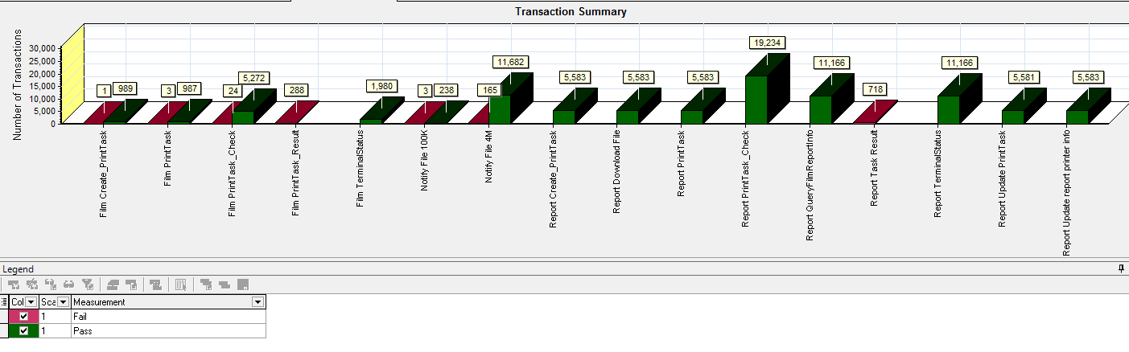

Figure 3.6.3.1 Transaction Summary

We can notice that there are some transactions failed during the testing work. We should find out the reason and fix it in the next version.

### Transaction response time result

We can get the transaction response time information from the figure as follow:

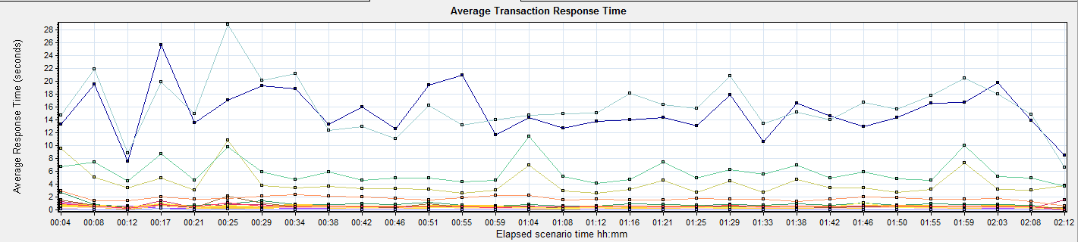

|  |  |  |  |  |  |  |  |  |  |  |  |  |  |  |  |  |  |  |  |  |  |  |  |  |  |  |  |  |  |  |  |  |  |  |  |  |  |  |  |  |  |  |  |  |  |  |  |  |  |  |  |  |  |  |  |  |  |  |  |  |  |  |  |  |  |  |  |  |  |  |  |  |  |  |  |  |  |  |  |  |  |  |  |  |  |  |  |  |  |  |  |  |  |  |  |  |  |  |  |  |  |  |  |  |  |  |  |  |  |  |  |  |  |  |  |  |  |  |  |  |
| --- | --- | --- | --- | --- | --- | --- | --- | --- | --- | --- | --- | --- | --- | --- | --- | --- | --- | --- | --- | --- | --- | --- | --- | --- | --- | --- | --- | --- | --- | --- | --- | --- | --- | --- | --- | --- | --- | --- | --- | --- | --- | --- | --- | --- | --- | --- | --- | --- | --- | --- | --- | --- | --- | --- | --- | --- | --- | --- | --- | --- | --- | --- | --- | --- | --- | --- | --- | --- | --- | --- | --- | --- | --- | --- | --- | --- | --- | --- | --- | --- | --- | --- | --- | --- | --- | --- | --- | --- | --- | --- | --- | --- | --- | --- | --- | --- | --- | --- | --- | --- | --- | --- | --- | --- | --- | --- | --- | --- | --- | --- | --- | --- | --- | --- | --- | --- | --- | --- | --- | --- |
| |  |  |  |  |  |  |  |  | | --- | --- | --- | --- | --- | --- | --- | --- | | **Color** | **Scale** | **Measurement** | **Graph's Minimum** | **Graph's Average** | **Graph's Maximum** | **Graph's Median** | **Graph's Std. Deviation** | |  | 1 | Film Create\_PrintTask | 0.06 | 0.396 | 1.082 | 0.364 | 0.165 | |  | 1 | Film PrintTask | 0.168 | 0.897 | 2.686 | 0.862 | 0.397 | |  | 1 | Film PrintTask\_Check | 0.245 | 0.507 | 1.594 | 0.352 | 0.341 | |  | 1 | Film TerminalStatus | 0.165 | 0.46 | 0.804 | 0.447 | 0.123 | |  | 1 | Notify File 4M | 7.601 | 15.299 | 25.731 | 14.368 | 3.702 | |  | 1 | Notify File 100k | 6.607 | 16.115 | 28.851 | 15.153 | 4.146 | |  | 1 | Report Create\_PrintTask | 0.312 | 0.563 | 2.21 | 0.399 | 0.396 | |  | 1 | Report Download File | 0.639 | 1.791 | 3.007 | 1.726 | 0.403 | |  | 1 | Report PrintTask | 2.598 | 4.167 | 10.881 | 3.444 | 1.953 | |  | 1 | Report PrintTask\_Check | 0.077 | 0.375 | 1.226 | 0.339 | 0.177 | |  | 1 | Report QueryFilmReportInfo | 0.038 | 0.067 | 0.255 | 0.051 | 0.049 | |  | 1 | Report TerminalStatus | 0.105 | 0.496 | 1.126 | 0.458 | 0.207 | |  | 1 | Report Update PrintTask | 3.694 | 5.906 | 11.482 | 5.019 | 1.858 | |  | 1 | Report Update report printer info | 0.072 | 0.569 | 1.114 | 0.536 | 0.185 | |
|  |

Figure 3.6.4.1 Transaction response time

This figure information shows all transaction response time. We can analysis that there are four transaction time is very big which mentioned in chapter 3.6.2. There are : Notify File 4m, Notify File 100k, Report Print Task and Report Update Print Task. The service for these transactions should enhance.

## Performance bottleneck analysis

### Hardware usage analysis

During the testing work, we use the test tool to monitor the server hardware usage include the CPU, Memory, hard disk and etc.

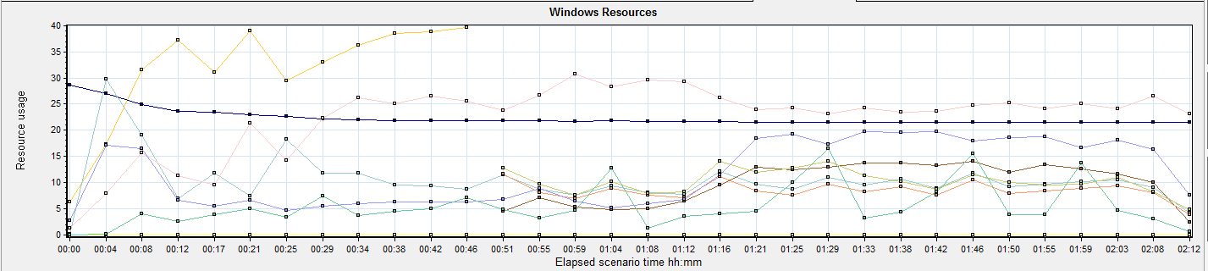

|  |  |  |  |  |  |  |
| --- | --- | --- | --- | --- | --- | --- |
| **Color** | **Scale** | **Measurement** | **Minimum** | **Average** | **Maximum** | **Std. Deviation** |
|  | 0.1 | % Disk Read Time (PhysicalDisk \_Total):10.184.129.208 | 0 | 104.067 | 1843.83 | 109.482 |
|  | 0.01 | % Disk Time (PhysicalDisk \_Total):10.184.129.208 | 1.865 | 1057.717 | 47176.98 | 1699.254 |
|  | 0.01 | % Disk Write Time (PhysicalDisk \_Total):10.184.129.208 | 55.1 | 857.615 | 4116.794 | 504.563 |
|  | 1 | % Processor Time (Processor \_Total):10.184.129.208 | 4.059 | 31.383 | 78.454 | 13.647 |
|  | 0.001 | Available MBytes (Memory):10.184.129.208 | 21266 | 22360.382 | 28699 | 1646.69 |
|  | 1 | Avg. Disk Queue Length (PhysicalDisk \_Total):10.184.129.208 | 0.019 | 10.577 | 471.77 | 16.993 |
|  | 10 | Avg. Disk Read Queue Length (PhysicalDisk \_Total):10.184.129.208 | 0 | 1.041 | 18.438 | 1.095 |
|  | 1 | Avg. Disk Write Queue Length (PhysicalDisk \_Total):10.184.129.208 | 0.551 | 8.576 | 41.168 | 5.046 |
|  | 1 | Current Disk Queue Length (PhysicalDisk \_Total):10.184.129.208 | 0 | 10.379 | 58 | 8.309 |
|  | 0.001 | Page Faults/sec (Memory):10.184.129.208 | 112.97 | 22389.925 | 72649.68 | 11624.931 |
|  | 1 | Page Reads/sec (Memory):10.184.129.208 | 0 | 11.65 | 207.454 | 11.089 |
|  | 1 | Page Writes/sec (Memory):10.184.129.208 | 0 | 0 | 0 | 0 |
|  | 10 | Processor Queue Length (System):10.184.129.208 | 0 | 0.554 | 60 | 3.644 |

Follow this information we can get that:

The CPU usage do not exist bottleneck, the average process time is 31% and max value is 78%. All value is less than 80%.The average process queue length is 0.5, it less than 24(CPU count \* 2), so the CPU resource is enough.

The memory available value is 22.3G and the system use 6.3 G. The memory do not has bottleneck as current testing stress.

|  |
| --- |
| We notice that the disk time is 1057(% Disk Time), it means the disk is very busy. Most time is cost on write operation (% Disk Write Time 857). Because we simulate the report archived operations, it will write the report files to local disk. |

*4M\*11,682 transaction count/2hours/60minute/60seconds = 6.49Mb/seconds.*

The notify report service will use the disk resource with 6.5 Mb/seconds; system also need do some other disk operation during the testing work.

|  |  |  |  |  |  |  |
| --- | --- | --- | --- | --- | --- | --- |
| **Color** | **Scale** | **Measurement** | **Minimum** | **Average** | **Maximum** | **Std. Deviation** |
|  | 0.1 | % Disk Read Time (PhysicalDisk \_Total):10.184.129.208 | 0 | 104.067 | 1843.83 | 109.482 |
|  | 0.01 | % Disk Time (PhysicalDisk \_Total):10.184.129.208 | 1.865 | 1057.717 | 47176.98 | 1699.254 |
|  | 0.01 | % Disk Write Time (PhysicalDisk \_Total):10.184.129.208 | 55.1 | 857.615 | 4116.794 | 504.563 |
|  | 1 | % Idle Time (PhysicalDisk \_Total):10.184.129.208 | 0 | 10.248 | 98.711 | 18.714 |
|  | 0.0001 | Avg. Disk Bytes/Transfer (PhysicalDisk \_Total):10.184.129.208 | 4608 | 470190.952 | 2042554.182 | 261126.199 |
|  | 1 | Avg. Disk Queue Length (PhysicalDisk \_Total):10.184.129.208 | 0.019 | 10.577 | 471.77 | 16.993 |
|  | 10 | Avg. Disk Read Queue Length (PhysicalDisk \_Total):10.184.129.208 | 0 | 1.041 | 18.438 | 1.095 |
|  | 1 | Avg. Disk Write Queue Length (PhysicalDisk \_Total):10.184.129.208 | 0.551 | 8.576 | 41.168 | 5.046 |
|  | 1 | Current Disk Queue Length (PhysicalDisk \_Total):10.184.129.208 | 0 | 10.379 | 58 | 8.309 |
|  | 1E-06 | Disk Bytes/sec (PhysicalDisk \_Total):10.184.129.208 | 361235.425 | 26977575.43 | 59949809.535 | 8807127.049 |
|  | 1E-06 | Disk Read Bytes/sec (PhysicalDisk \_Total):10.184.129.208 | 0 | 9509305.421 | 42217025.513 | 6538140.809 |
|  | 1 | Disk Reads/sec (PhysicalDisk \_Total):10.184.129.208 | 0 | 13.507 | 101.852 | 9.606 |
|  | 0.1 | Disk Transfers/sec (PhysicalDisk \_Total):10.184.129.208 | 2.658 | 57.29 | 548.233 | 38.609 |
|  | **1E-06** | **Disk Write Bytes/sec (PhysicalDisk \_Total):10.184.129.208** | **317778.532** | **17522953.713** | **105466788.548** | **6923172.893** |
|  | 1 | Disk Writes/sec (PhysicalDisk \_Total):10.184.129.208 | 14.951 | 46.404 | 401.91 | 35.726 |
|  | 10 | Processor Queue Length (System):10.184.129.208 | 0 | 0.554 | 60 | 3.644 |

The average disk write counter value is 17.5Mb (Disk Write Bytes/sec); the disk is under big stress during the testing work.

The Page Faults/sec counter value is 22G, but the other page counter values are low. Normally, if this counter is high, it perhaps exist the memory leak. But we notice the memory usage in system is enough and do not reduce quickly, other page counter value is also low. So we consider it does not have the issues and it cause by the report download operation. The system will read the file and transfer to the client with http protocol.

### SQL Server resource usage analysis

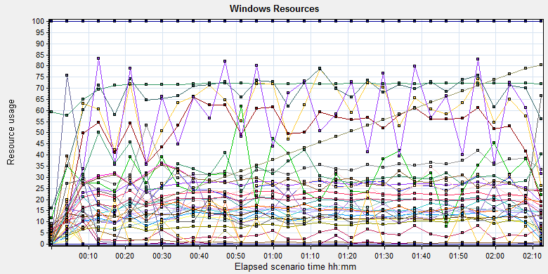

|  |  |  |  |  |  |  |  |  |  |  |  |  |  |  |  |  |  |  |  |  |  |  |  |  |  |  |  |  |  |  |  |  |  |  |  |  |  |  |  |  |  |  |  |  |  |  |  |  |  |  |  |  |  |  |  |  |  |  |  |  |  |  |  |  |  |  |  |  |  |  |  |  |  |  |  |  |  |  |  |  |  |  |  |  |  |  |  |  |  |  |  |  |  |  |  |  |  |  |  |  |  |  |  |  |  |  |  |  |  |  |  |  |  |  |  |  |  |  |  |  |  |  |  |  |  |  |  |  |  |  |  |  |  |  |  |  |  |  |  |  |  |  |  |  |  |  |  |  |  |  |  |  |  |  |  |  |  |  |  |  |  |  |  |  |  |  |  |  |  |  |  |  |  |  |  |  |  |  |  |  |  |  |  |  |  |  |  |  |  |  |  |  |  |  |  |  |  |  |  |  |  |  |  |  |  |  |  |  |  |  |  |  |  |  |  |  |  |  |  |  |  |  |  |  |  |  |  |  |  |  |  |  |  |  |  |  |  |  |  |  |  |  |  |  |  |  |  |  |  |  |  |  |  |  |  |  |  |  |  |  |  |  |  |  |  |  |  |  |  |  |  |  |  |  |  |  |  |  |  |  |  |  |  |  |  |  |  |  |  |  |  |  |  |  |  |  |  |  |  |  |  |
| --- | --- | --- | --- | --- | --- | --- | --- | --- | --- | --- | --- | --- | --- | --- | --- | --- | --- | --- | --- | --- | --- | --- | --- | --- | --- | --- | --- | --- | --- | --- | --- | --- | --- | --- | --- | --- | --- | --- | --- | --- | --- | --- | --- | --- | --- | --- | --- | --- | --- | --- | --- | --- | --- | --- | --- | --- | --- | --- | --- | --- | --- | --- | --- | --- | --- | --- | --- | --- | --- | --- | --- | --- | --- | --- | --- | --- | --- | --- | --- | --- | --- | --- | --- | --- | --- | --- | --- | --- | --- | --- | --- | --- | --- | --- | --- | --- | --- | --- | --- | --- | --- | --- | --- | --- | --- | --- | --- | --- | --- | --- | --- | --- | --- | --- | --- | --- | --- | --- | --- | --- | --- | --- | --- | --- | --- | --- | --- | --- | --- | --- | --- | --- | --- | --- | --- | --- | --- | --- | --- | --- | --- | --- | --- | --- | --- | --- | --- | --- | --- | --- | --- | --- | --- | --- | --- | --- | --- | --- | --- | --- | --- | --- | --- | --- | --- | --- | --- | --- | --- | --- | --- | --- | --- | --- | --- | --- | --- | --- | --- | --- | --- | --- | --- | --- | --- | --- | --- | --- | --- | --- | --- | --- | --- | --- | --- | --- | --- | --- | --- | --- | --- | --- | --- | --- | --- | --- | --- | --- | --- | --- | --- | --- | --- | --- | --- | --- | --- | --- | --- | --- | --- | --- | --- | --- | --- | --- | --- | --- | --- | --- | --- | --- | --- | --- | --- | --- | --- | --- | --- | --- | --- | --- | --- | --- | --- | --- | --- | --- | --- | --- | --- | --- | --- | --- | --- | --- | --- | --- | --- | --- | --- | --- | --- | --- | --- | --- | --- | --- | --- | --- | --- | --- | --- | --- | --- | --- | --- | --- | --- | --- | --- | --- | --- | --- | --- | --- | --- | --- | --- | --- | --- | --- | --- | --- | --- | --- | --- | --- | --- | --- | --- |
| |  |  |  |  |  |  |  | | --- | --- | --- | --- | --- | --- | --- | | **Color** | **Scale** | **Measurement** | **Minimum** | **Average** | **Maximum** | **Std. Deviation** | |  | 0.1 | Batch Requests/sec (MSSQL$GCPACSWS|SQL Statistics):10.184.129.208 | 4.651 | 255.989 | 1332.855 | 80.648 | |  | 1 | Buffer cache hit ratio (MSSQL$GCPACSWS|Buffer Manager):10.184.129.208 | 94.667 | 99.997 | 100 | 0.104 | |  | 1 | Cache Hit Ratio (MSSQL$GCPACSWS|Catalog Metadata WGGC):10.184.129.208 | 55.192 | 70.815 | 72.339 | 3.577 | |  | 0.001 | Cursor memory usage (MSSQL$GCPACSWS|Cursor Manager by Type \_Total):10.184.129.208 | 240 | 4556.62 | 18752 | 3426.99 | |  | 10 | Cursor Requests/sec (MSSQL$GCPACSWS|Cursor Manager by Type \_Total):10.184.129.208 | 0 | 5.866 | 31.23 | 4.01 | |  | 1 | Database Cache Size (MB) (Database svchost):10.184.129.208 | 0 | 0 | 0 | 0 | |  | 1 | Distributed Query (MSSQL$GCPACSWS|Exec Statistics Average execution time (ms)):10.184.129.208 | 0 | 2.782 | 716 | 23.743 | |  | 100 | Distributed Query (MSSQL$GCPACSWS|Exec Statistics Cumulative execution time (ms) per second):10.184.129.208 | 0 | 0.012 | 12 | 0.33 | |  | 100 | Distributed Query (MSSQL$GCPACSWS|Exec Statistics Execs in progress):10.184.129.208 | 0 | 0.006 | 10 | 0.217 | |  | 1E-17 | Distributed Query (MSSQL$GCPACSWS|Exec Statistics Execs started per second):10.184.129.208 | 0 | 2.23258627215849E+18 | 1.84467440737096E+19 | 6.01660253983545E+18 | |  | 1 | Errors/sec (MSSQL$GCPACSWS|SQL Errors \_Total):10.184.129.208 | 0 | 13.546 | 81.737 | 7.408 | |  | 1 | Errors/sec (MSSQL$GCPACSWS|SQL Errors User Errors):10.184.129.208 | 0 | 9.956 | 69.77 | 6.114 | |  | 1 | Extended Procedures (MSSQL$GCPACSWS|Exec Statistics Average execution time (ms)):10.184.129.208 | 0 | 0 | 0 | 0 | |  | 0.1 | Full Scans/sec (MSSQL$GCPACSWS|Access Methods):10.184.129.208 | 2.654 | 214.618 | 1006.711 | 99.882 | |  | 0.001 | Index Searches/sec (MSSQL$GCPACSWS|Access Methods):10.184.129.208 | 0 | 32976.584 | 587279.921 | 21183.07 | |  | 1000 | Latch waits/sec (MSOLAP$GCPACSWS|Locks):10.184.129.208 | 0 | 0.031 | 0.665 | 0.101 | |  | 1 | Lazy writes/sec (MSSQL$GCPACSWS|Buffer Manager):10.184.129.208 | 0 | 0 | 0 | 0 | |  | 1E-05 | Lock Requests/sec (MSSQL$GCPACSWS|Locks \_Total):10.184.129.208 | 0 | 827162.689 | 2539012.006 | 315313.265 | |  | 0.1 | Lock Timeouts/sec (MSSQL$GCPACSWS|Locks \_Total):10.184.129.208 | 0 | 175.637 | 527.516 | 88.695 | |  | 0.0001 | Lock Wait Time (ms) (MSSQL$GCPACSWS|Locks \_Total):10.184.129.208 | 0 | 235431.872 | 1450366.673 | 173747.617 | |  | 0.01 | Lock waits (MSSQL$GCPACSWS|Wait Statistics Average wait time (ms)):10.184.129.208 | 0 | 1579.483 | 21480 | 2213.928 | |  | 0.1 | Lock waits (MSSQL$GCPACSWS|Wait Statistics Waits in progress):10.184.129.208 | 0 | 237.348 | 527 | 117.584 | |  | 0.1 | Lock Waits/sec (MSSQL$GCPACSWS|Locks \_Total):10.184.129.208 | 0 | 115.725 | 400.368 | 61.581 | |  | 1 | Log write waits (MSSQL$GCPACSWS|Wait Statistics Average wait time (ms)):10.184.129.208 | 0 | 12.29 | 237 | 8.549 | |  | 0.1 | Logical Connections (MSSQL$GCPACSWS|General Statistics):10.184.129.208 | 45 | 275.19 | 401 | 60.9 | |  | 10 | Logins/sec (MSSQL$GCPACSWS|General Statistics):10.184.129.208 | 0 | 1.509 | 40.536 | 1.87 | |  | 10 | Logouts/sec (MSSQL$GCPACSWS|General Statistics):10.184.129.208 | 0 | 1.493 | 40.869 | 1.72 | |  | 1 | Lookups/sec (MSOLAP$GCPACSWS|Cache):10.184.129.208 | 0 | 0 | 0 | 0 | |  | 10 | Number of Deadlocks/sec (MSSQL$GCPACSWS|Locks \_Total):10.184.129.208 | 0 | 5.091 | 26.932 | 3.32 | |  | 1 | OLEDB calls (MSSQL$GCPACSWS|Exec Statistics Average execution time (ms)):10.184.129.208 | 0 | 14.306 | 1356 | 46.429 | |  | 1 | Page IO latch waits (MSSQL$GCPACSWS|Wait Statistics Average wait time (ms)):10.184.129.208 | 0 | 14.602 | 951 | 44.535 | |  | 10 | Page latch waits (MSSQL$GCPACSWS|Wait Statistics Waits in progress):10.184.129.208 | 0 | 0.078 | 68 | 1.644 | |  | 0.01 | Page life expectancy (MSSQL$GCPACSWS|Buffer Manager):10.184.129.208 | 93 | 4077.936 | 8069 | 2304.095 | |  | 0.0001 | Page lookups/sec (MSSQL$GCPACSWS|Buffer Manager):10.184.129.208 | 0 | 665659.219 | 2555050.444 | 207134.866 | |  | 0.1 | Page reads/sec (MSSQL$GCPACSWS|Buffer Manager):10.184.129.208 | 0 | 50.612 | 11614.586 | 464.057 | |  | 10 | Page writes/sec (MSSQL$GCPACSWS|Buffer Manager):10.184.129.208 | 0 | 5.617 | 109.634 | 12.078 | |  | 10 | Safe Auto-Params/sec (MSSQL$GCPACSWS|SQL Statistics):10.184.129.208 | 0 | 3.066 | 18.569 | 2.37 | |  | 0.1 | SQL Compilations/sec (MSSQL$GCPACSWS|SQL Statistics):10.184.129.208 | 2.658 | 188.65 | 1083.63 | 60.746 | |  | 1000 | SQL Re-Compilations/sec (MSSQL$GCPACSWS|SQL Statistics):10.184.129.208 | 0 | 0.005 | 1.329 | 0.06 | |  | 1 | Total deadlocks detected (MSOLAP$GCPACSWS|Locks):10.184.129.208 | 0 | 0 | 0 | 0 | |  | 0.1 | Transactions (MSSQL$GCPACSWS|Transactions):10.184.129.208 | 6 | 121.053 | 768 | 113.708 | |  | 0.1 | User Connections (MSSQL$GCPACSWS|General Statistics):10.184.129.208 | 45 | 274.14 | 401 | 60.211 | |

Figure 3.7.2.1 Database result

Follow the SQL server monitor resource, we can find the Database has some issues that make the system performance not well:

There are cursors operations exist in the database:

|  |  |  |  |  |  |  |
| --- | --- | --- | --- | --- | --- | --- |
|  | 0.001 | Cursor memory usage (MSSQL$GCPACSWS|Cursor Manager by Type \_Total):10.184.129.208 | 240 | 4556.62 | 18752 | 3426.99 |
|  | 10 | Cursor Requests/sec (MSSQL$GCPACSWS|Cursor Manager by Type \_Total):10.184.129.208 | 0 | 5.866 | 31.23 | 4.01 |

Database does the cursor operations every 5.8 seconds. SQL server suggests users to do the operation base on column data. Please indentify the SQL statement and do some enhance works.

There are some error happens during the testing work:

|  |  |  |  |  |  |  |
| --- | --- | --- | --- | --- | --- | --- |
|  | 1 | Errors/sec (MSSQL$GCPACSWS|SQL Errors \_Total):10.184.129.208 | 0 | 13.546 | 81.737 | 7.408 |
|  | 1 | Errors/sec (MSSQL$GCPACSWS|SQL Errors User Errors):10.184.129.208 | 0 | 9.956 | 69.77 | 6.114 |

Database has 13.5 errors every second and 10 records are user errors. It maybe cause by the dead lock or other issues.

There are too many full scans operations exist in the database:

|  |  |  |  |  |  |  |
| --- | --- | --- | --- | --- | --- | --- |
|  | 0.1 | Full Scans/sec (MSSQL$GCPACSWS|Access Methods):10.184.129.208 | 2.654 | 214.618 | 1006.711 | 99.882 |

Database has full scans issues and average value is 214/sec. This issue will affect the SQL statement executes slowly because it does not use the index. Some operations will cause the full scans such as select count (\*), use <> and! =, use like fuzzy query etc. Please enhance the SQL statement performance ASAP.

There are many locks and deadlocks issues exist in the database:

|  |  |  |  |  |  |  |
| --- | --- | --- | --- | --- | --- | --- |
|  | 1E-05 | Lock Requests/sec (MSSQL$GCPACSWS|Locks \_Total):10.184.129.208 | 0 | 827162.689 | 2539012.006 | 315313.265 |
|  | 0.1 | Lock Timeouts/sec (MSSQL$GCPACSWS|Locks \_Total):10.184.129.208 | 0 | 175.637 | 527.516 | 88.695 |
|  | 0.0001 | Lock Wait Time (ms) (MSSQL$GCPACSWS|Locks \_Total):10.184.129.208 | 0 | 235431.872 | 1450366.673 | 173747.617 |
|  | 0.01 | Lock waits (MSSQL$GCPACSWS|Wait Statistics Average wait time (ms)):10.184.129.208 | 0 | 1579.483 | 21480 | 2213.928 |
|  | 0.1 | Lock waits (MSSQL$GCPACSWS|Wait Statistics Waits in progress):10.184.129.208 | 0 | 237.348 | 527 | 117.584 |
|  | 0.1 | Lock Waits/sec (MSSQL$GCPACSWS|Locks \_Total):10.184.129.208 | 0 | 115.725 | 400.368 | 61.581 |
|  | 10 | Number of Deadlocks/sec (MSSQL$GCPACSWS|Locks \_Total):10.184.129.208 | 0 | 5.091 | 26.932 | 3.32 |

We can see that the average lock waits time is 1.58 seconds and timeouts average value is 0.175 seconds. There are 115 locks and 5 deadlocks every second. The database design is very bad, the deadlocks makes many test transactions failed. We should find out them and fix it as the high level tasks.

There are about 275 database connections in the database, but login and logout frequency is 1.5/sec. Can we reduce the connection number?

|  |  |  |  |  |  |  |  |  |
| --- | --- | --- | --- | --- | --- | --- | --- | --- |
|  | | 0.1 | Logical Connections (MSSQL$GCPACSWS|General Statistics):10.184.129.208 | 45 | 275.19 | 401 | 60.9 | |
|  | | 10 | Logins/sec (MSSQL$GCPACSWS|General Statistics):10.184.129.208 | 0 | 1.509 | 40.536 | 1.87 | |
|  | | 10 | Logouts/sec (MSSQL$GCPACSWS|General Statistics):10.184.129.208 | 0 | 1.493 | 40.869 | 1.72 | |
|  | | 0.1 | User Connections (MSSQL$GCPACSWS|General Statistics):10.184.129.208 | 45 | 274.14 | 401 | 60.211 | |
| C:\Users\Administrator\Desktop\Performance result\20170531_1\Report\dot_trans.gif | | | | | | |

## Test Conclusion

As current hardware and software setting, the system performance cannot meet the requirements of design. Many transactions are failed, the database has several issues. The issues summary information as follow:

1. Some transaction is failed which cause by database or service. It must be resolve before publish.
2. Some transaction response time is high, the performance need enhance.
3. The hard disk has bottleneck, need monitor and tuning in next testing work.
4. There are some issues exist in the database include full scans, lock, deadlock, cursor operation and other issue. These issues need fix ASAP.
5. We do not monitor the IIS middle software this performance testing work, this work will be focus on next testing work.

## Tune Suggesting

### Slowly SQL statement

We use the SQL command collects some SQL statement execute slowly, team should enhance the design to make them has good performance:

1. SQL statement 1

*SELECT \* FROM APF\_View\_TerminalPrinterStatus WHERE TerminalID='Terminal23'*

This SQL execute 2872 times in testing work. There are many SQL like this one which terminalID value is different. This is a view object, Database cannot use index to query information. Suggests changing the view to table, and then add the index for it.

1. SQL statement 2



This SQL execute 1914 times and average cost time is 3 seconds. SQL server do not suggest user to use the complex triggers. We can notice some procedure and function in this statement, it will make the trigger execute slowly. Use update operation in statement also has probability to cause the lock and dead lock.

Please avoid or carefully use ‘or’ and ‘!=’ operator, it maybe cause the full scan issues.

1. SQL statement 3



This SQL execute 1622 times and average cost time is 3 seconds. Please avoid to inner function in SQL statement such as get date, is null and etc. The studyInstanceUID is the primary key and please make it as the first condition after ‘where’. Change the index sort rule from ASC to DESC in report table.

1. SQL statement 4

CREATE PROCEDURE [dbo].[AFP\_SP\_GetPrintTask]

@TerminalId nvarchar(20)

AS

BEGIN

-- SET NOCOUNT ON added to prevent extra result sets from

-- interfering with SELECT statements.

SET NOCOUNT ON;

-- Insert statements for procedure here

DECLARE @sn int

SELECT @sn=-1

SELECT @sn=(SELECT top 1 CONVERT(nvarchar(20),sn) FROM AFP\_PrintTask WHERE

AFP\_PrintTask.TerminalID=@TerminalId AND AFP\_PrintTask.Status =0)

SELECT CONVERT(nvarchar(20),sn) as SN, PatientID,AFP\_PrintTerminalInfo.FilmPrinterID,PrinterReg.PrinterName,

AFP\_PrintTerminalInfo.ReportPrinterFullName, EnableReportPrint,AFP\_PrintTerminalInfo.TerminalID, ErrorCode

FROM AFP\_PrintTask

INNER JOIN AFP\_PrintTerminalInfo ON

AFP\_PrintTask.TerminalID= AFP\_PrintTerminalInfo.TerminalID

LEFT JOIN PrinterReg ON

AFP\_PrintTerminalInfo.FilmPrinterID=PrinterReg.PrinterDBID

WHERE AFP\_PrintTask.SN =@sn

--UPDATE AFP\_PrintTask SET [Status]=0 WHERE SN=@sn

END

This SQL execute 296615 times and average cost time is 0.017 seconds. Add index on AFP\_PrintTerminalInfo.FilmPrinterID to enhance the performance. Please avoid using convert function in the SQL statement. Suggest filtering the data from print task table with SN and then joining with other tables.

1. SQL statement 5

CREATE PROCEDURE [dbo].[AFP\_SP\_SetReportPrinted]

-- Add the parameters for the stored procedure here

@ReportId nvarchar(80),

@TaskId int

AS

BEGIN

-- SET NOCOUNT ON added to prevent extra result sets from

-- interfering with SELECT statements.

SET NOCOUNT ON;

IF EXISTS (SELECT \* FROM AFP\_PrintTaskOfReport WHERE TaskSN=@TaskId AND StudyInstanceUID=@ReportId)

BEGIN

UPDATE AFP\_PrintTask SET ReportPrinted=ReportPrinted+1 WHERE SN=@TaskId

EXEC AFP\_SP\_UpdateReportPrintStatus '', @ReportId, 1

END

END

There is no index on AFP\_PrintTaskOfReport table. Suggest to add index on column TaskSN and StudInstanceUID.

1. SQL statement SQL 5

CREATE PROCEDURE [dbo].[AFP\_SP\_GetTaskOfReports]

-- Add the parameters for the stored procedure here

@TaskSN nvarchar(20)--,

AS

BEGIN

SET NOCOUNT ON;

SELECT dbo.AFP\_PrintTaskOfReport.StudyInstanceUID FROM dbo.AFP\_PrintTaskOfReport

WHERE dbo.AFP\_PrintTaskOfReport.TaskSN=@TaskSN AND

(

(dbo.AFP\_PrintTaskOfReport.AccessionNumber <> '' AND dbo.AFP\_PrintTaskOfReport.AccessionNumber is not NULL) OR

(dbo.AFP\_PrintTaskOfReport.StudyInstanceUID <> '' AND dbo.AFP\_PrintTaskOfReport.StudyInstanceUID is not NULL)

)

END

This SQL statement need modify and add primary key for the table. Suggest delete the filter condition except TASKSN.

1. SQL statement SQL 6

SELECT TOP 100 JobInstanceUID FROM dbo.DeliveryJob WHERE DATEDIFF(HOUR,DeliveryJob.CreateDateTime,GETDATE())> [WGGC].[dbo].AFP\_F\_GetParameterInt('Outdated\_RawImage\_Hours')

AND (DeleteStatus = 0 AND JobStatus IN (2, 11))

This SQL execute very frequently (32012 times) and suggest to modify the filter condition. Please add the index on the deletestatus and Jobstatus clolumn.

### Deadlock SQL

There are some locks and deadlocks issues happened in the database during the testing work. We collect some SQL statement by using tool. The detail information as follow:



### Other

1. Use the SQL script to set the database data file and log file with default size and increase rule with fixed value. Please reference the file: 
2. Rebuild and organize the index and statistic with schedule task. The SQL statement can reference the file: 
3. Backup the database files with SQL server schedule task instead the application. The application will delete by the antivirus program sometimes.
4. This is the suggest come from SQL server profiler, team can reference it and do some enhance works.



# Testing work （Phase 2）

## Strategy and Scenario Setting

This phase we will focus on the transactions for web site. The statistic function module is not ready, so it is no include the testing work. We will test the performance of work list query, Terminal monitor and reconciliation query module. We design the scenarios to get the result as follow:

1. Use automation tool simulate the doctor print film work. Simulate 2 GX Platform by using QTP and PDSender tool. Each client prints one film which size is 10MB every 30 seconds.
2. Use automation script to print paper report to PS which cannot verify by report OCR.
3. Use LR tool simulate one user login the web site and do other transaction as a virtual user. The script is use the Truclient protocol, it can monitor the whole requests of transaction include the http request, JS execute and object verify operations.
4. Monitor the transaction response time.
5. Monitor the client hardware and software usage.
6. The scenario will execute for one hour.

## Background Data

We use SQL command statement to add large data in the database, the detail information as follow:

|  |  |
| --- | --- |
| **Table Name** | **Data Volume (records)** |
| printer.dbo.DeliveryJob | 815812 |
| printer.dbo.ImageBox | 999537 |
| printer.dbo.Page | 999471 |
| printer.dbo.Session | 1002790 |
| wggc.dbo.Patient | 1114734 |
| wggc.dbo.Study | 1114822 |
| wggc.dbo.AFP\_PrintTerminalInfo | 61 |
| wggc.dbo.Series | 1114768 |
| wggc.dbo.Image | 1114771 |
| wggc.dbo.AFP\_FilmInfo | 1085084 |
| wggc.dbo.AFP\_ReportInfo | 1271916 |
| wggc.dbo.AFP\_ExamInfo | 2073925 |
| wggc.dbo.AFP\_PrintTask | 2365371 |
| wggc.dbo.T\_Integration\_ExamInfo | 500253 |
| AFP\_PrintMode | 195684 |
| wggc.dbo.vi\_KIOSK\_ExamInfo\_Order | 287991 |

Figure 4.2.1 Background Data

## Other Setting:

### Database setting

Memory: Set the min and max memory size to 8GB.

Index fill factor: 80.

File: Increase the data and log files size and the rule is increase 200Mb as fixed size.

### IIS setting

Connection: Turn off the IIS error protect module for connect pool and keep other setting as default.

## Test Object version

KIOSK Platform 3.0.0.1 B07

## Test Error

No error appears in current testing work.

## Test result

### Transactions result

After the testing work, the transaction result which collect from result as follow:

|  |  |  |  |
| --- | --- | --- | --- |
| **Transaction** | **All** | **Pass** | **Fail** |
| Reconcilation\_Film\_queryAll | 24 | 24 | N/A |
| Reconcilation\_Report\_queryAll | 24 | 24 | N/A |
| Terminal\_monitor | 24 | 24 | N/A |
| [User\_Login](file:///D:\Performance\LR_result\PUMA_WEB_TRUCLIENT_0705\ResponseTime0000(User_Login)0000) | 24 | 24 | N/A |
| [Worklist\_LatestTwoDays](file:///D:\Performance\LR_result\PUMA_WEB_TRUCLIENT_0705\ResponseTime0000(Worklist_LatestTwoDays)0000) | 24 | 24 | N/A |
| [Worklist\_LatestWeek](file:///D:\Performance\LR_result\PUMA_WEB_TRUCLIENT_0705\ResponseTime0000(Worklist_LatestWeek)0000) | 24 | 24 | N/A |
| [Worklist\_OneMonth](file:///D:\Performance\LR_result\PUMA_WEB_TRUCLIENT_0705\ResponseTime0000(Worklist_OneMonth)0000) | 24 | 24 | N/A |
| [Worklist\_Query\_ByACCN](file:///D:\Performance\LR_result\PUMA_WEB_TRUCLIENT_0705\ResponseTime0000(Worklist_Query_ByACCN)0000) | 24 | 24 | N/A |
| [Worklist\_Query\_ByPID](file:///D:\Performance\LR_result\PUMA_WEB_TRUCLIENT_0705\ResponseTime0000(Worklist_Query_ByPID)0000) | 24 | 24 | N/A |
|  |  |  |  |

### Test Statistic Report

|  |  |
| --- | --- |
| Analysis Summary | Period: 2017/7/4 22:06 - 2017/7/4 23:07 |

|  |  |
| --- | --- |
| **Scenario Name:** | C:\Program Files (x86)\HP\LoadRunner\scenario\Scenario3.lrs |
| **Results in Session:** | D:\Performance\WebClient\WebTest\_TruClient\res\res.lrr |
| **Duration:** | 1 hour, 1 minute and 50 seconds. |

|  |
| --- |
|  |

|  |
| --- |
| Transaction Summary |

|  |  |  |  |  |  |  |  |
| --- | --- | --- | --- | --- | --- | --- | --- |
| [**Transactions:**](file:///D:\Performance\LR_result\PUMA_WEB_TRUCLIENT_0705\Report\Report3.html) | Total Passed: 216 | | Total Failed: 0 | Total Stopped: 0 | | [**Average Response Time**](file:///D:\Performance\LR_result\PUMA_WEB_TRUCLIENT_0705\Report\Report4.html) | |
|  | | **Pass** | | | **Fail** | | **Stop** | |
| Total | | 216 | | | 0 | | 0 | |

|  |  |  |  |  |  |  |  |  |
| --- | --- | --- | --- | --- | --- | --- | --- | --- |
| **Transaction Name** | **Minimum** | **Average** | **Maximum** | **Std. Deviation** | **90 Percent** | **Pass** | **Fail** | **Stop** |
| Reconcilation\_Film\_queryAll | 0.665 | 0.986 | 1.411 | 0.202 | 1.243 | 24 | 0 | 0 |
| Reconcilation\_Report\_queryAll | 0.448 | 0.747 | 1.212 | 0.231 | 1.062 | 24 | 0 | 0 |
| Terminal\_monitor | 1.909 | 2.11 | 2.325 | 0.104 | 2.214 | 24 | 0 | 0 |
| User\_Login | 0.766 | 2.328 | 2.796 | 0.618 | 2.697 | 24 | 0 | 0 |
| Worklist\_LatestTwoDays | 4.168 | 4.354 | 5.036 | 0.224 | 4.691 | 24 | 0 | 0 |
| Worklist\_LatestWeek | 2.538 | 2.881 | 3.591 | 0.295 | 3.402 | 24 | 0 | 0 |
| Worklist\_OneMonth | 2.231 | 2.891 | 3.812 | 0.32 | 3.272 | 24 | 0 | 0 |
| Worklist\_Query\_ByACCN | 9.436 | 10.287 | 12.224 | 0.672 | 11.26 | 24 | 0 | 0 |
| Worklist\_Query\_ByPID | 11.138 | 12.05 | 13.208 | 0.631 | 13.113 | 24 | 0 | 0 |

Figure 4.6.2.1 Summary Report

Follow the summary the report, we can get the result as follow: there are two transactions are not meets the requirements (Transaction response time less than 5 seconds.)

|  |  |  |  |  |  |  |  |  |
| --- | --- | --- | --- | --- | --- | --- | --- | --- |
| **Transaction Name** | **Minimum** | **Average** | **Maximum** | **Std. Deviation** | **90 Percent** | **Pass** | **Fail** | **Stop** |
| Worklist\_Query\_ByACCN | 9.436 | 10.287 | 12.224 | 0.672 | 11.26 | 24 | 0 | 0 |
| Worklist\_Query\_ByPID | 11.138 | 12.05 | 13.208 | 0.631 | 13.113 | 24 | 0 | 0 |

Figure 4.6.2.2 big value of response time

Team should indentify the issue and fix it. It may be cause by the SQL statement in the database.

### Transaction summary result

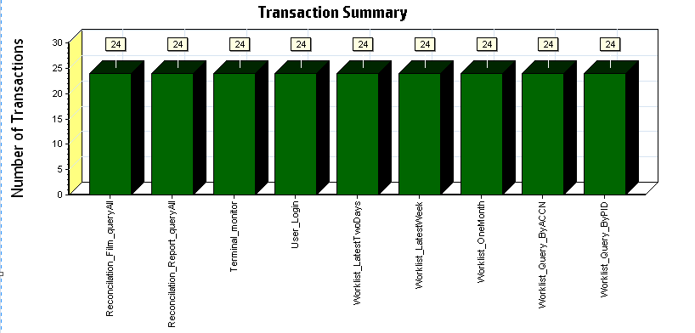

|  |
| --- |
|  |
|  |
| |  |  |  | | --- | --- | --- | | **Color** | **Scale** | **Measurement** | |  | 1 | Pass | |

Figure 4.6.3.1 Transaction Summary

All transactions are passed during the testing work.

### Transaction response time result

We can get the transaction response time information from the figure as follow:

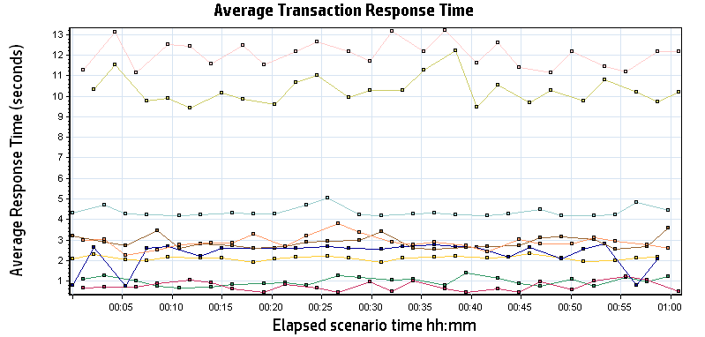

|  |  |  |  |  |  |  |  |  |  |  |  |  |  |  |  |  |  |  |  |  |  |  |  |  |  |  |  |  |  |  |  |  |  |  |  |  |  |  |  |  |  |  |  |  |  |  |  |  |  |  |  |  |  |  |  |  |  |  |  |  |  |  |  |  |  |  |  |  |  |  |
| --- | --- | --- | --- | --- | --- | --- | --- | --- | --- | --- | --- | --- | --- | --- | --- | --- | --- | --- | --- | --- | --- | --- | --- | --- | --- | --- | --- | --- | --- | --- | --- | --- | --- | --- | --- | --- | --- | --- | --- | --- | --- | --- | --- | --- | --- | --- | --- | --- | --- | --- | --- | --- | --- | --- | --- | --- | --- | --- | --- | --- | --- | --- | --- | --- | --- | --- | --- | --- | --- | --- |
| |  |  |  |  |  |  |  | | --- | --- | --- | --- | --- | --- | --- | | **Color** | **Scale** | **Measurement** | **Minimum** | **Average** | **Maximum** | **Std. Deviation** | |  | 1 | Reconcilation\_Film\_queryAll | 0.665 | 0.986 | 1.411 | 0.202 | |  | 1 | Reconcilation\_Report\_queryAll | 0.448 | 0.747 | 1.212 | 0.231 | |  | 1 | Terminal\_monitor | 1.909 | 2.110 | 2.325 | 0.104 | |  | 1 | User\_Login | 0.766 | 2.328 | 2.796 | 0.618 | |  | 1 | Worklist\_LatestTwoDays | 4.168 | 4.354 | 5.036 | 0.224 | |  | 1 | Worklist\_LatestWeek | 2.538 | 2.881 | 3.591 | 0.295 | |  | 1 | Worklist\_OneMonth | 2.231 | 2.891 | 3.812 | 0.320 | |  | 1 | Worklist\_Query\_ByACCN | 9.436 | 10.287 | 12.224 | 0.672 | |  | 1 | Worklist\_Query\_ByPID | 11.138 | 12.050 | 13.208 | 0.631 | |
|  |
|  |
|  |
|  |
| |  | | --- | | **Description:**Displays the average time taken to perform transactions during each second of the load test. This graph helps you determine whether the performance of the server is within acceptable minimum and maximum transaction performance time ranges defined for your system. | |

This figure information shows all transactions response time. We can analysis that there are two transactions time are very big which mentioned in chapter 4.6.2. There are : Worklist\_Query\_ByACCN and Worklist\_Query\_ByPID. The service for these transactions should enhance.

## Performance bottleneck analysis

### Hardware usage analysis

During the testing work, we use the test tool to monitor the client hardware usage include the CPU, Memory, hard disk and etc.

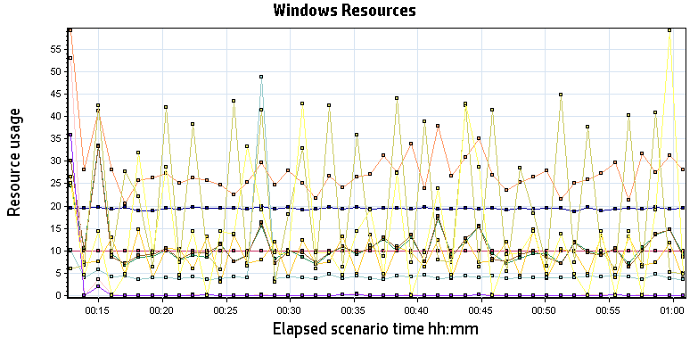

|  |  |  |  |  |  |  |
| --- | --- | --- | --- | --- | --- | --- |
| **Color** | **Scale** | **Measurement** | **Minimum** | **Average** | **Maximum** | **Std. Deviation** |
|  | 100 | % Disk Time (PhysicalDisk \_Total):localhost | 0.013 | 0.106 | 2.613 | 0.149 |
|  | 0.1 | % Idle Time (PhysicalDisk \_Total):localhost | 97.580 | 100.090 | 100.236 | 0.122 |
|  | 1 | % Processor Time (Processor \_Total):localhost | 0.000 | 8.769 | 43.919 | 11.369 |
|  | 0.01 | Available MBytes (Memory):localhost | 1,833.000 | 1,940.999 | 2,151.000 | 38.813 |
|  | 0.001 | Avg. Disk Bytes/Transfer (PhysicalDisk \_Total):localhost | 1,365.333 | 5,162.505 | 989,610.667 | 31,824.192 |
|  | 10000 | Avg. Disk Queue Length (PhysicalDisk \_Total):localhost | 0.000 | 0.001 | 0.026 | 0.002 |
|  | 10 | Disk Transfers/sec (PhysicalDisk \_Total):localhost | 0.661 | 2.742 | 16.905 | 2.136 |
|  | 0.01 | Page Faults/sec (Memory):localhost | 12.954 | 2,063.605 | 51,378.407 | 6,103.074 |
|  | 10 | Page Reads/sec (Memory):localhost | 0.000 | 0.041 | 25.887 | 0.863 |
|  | 1 | Pages/sec (Memory):localhost | 0.000 | 0.249 | 174.789 | 5.755 |
|  | 100 | Processor Queue Length (System):localhost | 0.000 | 0.138 | 6.000 | 0.594 |

Follow this information we can get that:

There is no hardware bottle during the testing work. The CPU, memory and hardware are work well.

## Test Conclusion

As current hardware and software setting, the tested transactions can execute successfully in the system. But there are two transactions do not meet the requirements. These two operations are fuzzy query from the database. The SQL statement needs to enhance by team.

# Testing work （Phase 3）

## Strategy and Scenario Setting

This phase we will focus on the transactions for web site. The statistic function module is not ready, so it is no include the testing work. We will test the performance of work list query, Terminal monitor and reconciliation query module. We design the scenarios to get the result as follow:

1. Use automation tool simulate the doctor print film work. Simulate 2 GX Platform by using QTP and PDSender tool. Each client prints one film which size is 10MB every 30 seconds.
2. Use automation script to print paper report to PS which cannot verify by report OCR.
3. Use LR tool simulate one user login the web site and do other transaction as a virtual user. The script is use the Truclient protocol, it can monitor the whole requests of transaction include the http request, JS execute and object verify operations.
4. Use LR tool to simulate 20 users which use the Http/html protocol. The scripts can only get the http and API response time but exclude the JS and object indentify time. We use it to increase the stress for web service.
5. Monitor the transaction response time.
6. Monitor the client hardware and software usage.
7. The scenario will execute for one hour.

## Background Data

We use SQL command statement to add large data in the database, the detail information as follow:

|  |  |
| --- | --- |
| **Table Name** | **Data Volume (records)** |
| printer.dbo.DeliveryJob | 815812 |
| printer.dbo.ImageBox | 999537 |
| printer.dbo.Page | 999471 |
| printer.dbo.Session | 1002790 |
| wggc.dbo.Patient | 1114734 |
| wggc.dbo.Study | 1114822 |
| wggc.dbo.AFP\_PrintTerminalInfo | 61 |
| wggc.dbo.Series | 1114768 |
| wggc.dbo.Image | 1114771 |
| wggc.dbo.AFP\_FilmInfo | 1085084 |
| wggc.dbo.AFP\_ReportInfo | 1271916 |
| wggc.dbo.AFP\_ExamInfo | 2073925 |
| wggc.dbo.AFP\_PrintTask | 2365371 |
| wggc.dbo.T\_Integration\_ExamInfo | 500253 |
| AFP\_PrintMode | 195684 |
| wggc.dbo.vi\_KIOSK\_ExamInfo\_Order | 287991 |

Figure 4.2.1 Background Data

## Other Setting:

### Database setting

Memory: Set the min and max memory size to 8GB.

Index fill factor: 80.

File: Increase the data and log files size and the rule is increase 200Mb as fixed size.

### IIS setting

Connection: Turn off the IIS error protect module for connect pool and keep other setting as default.

## Test Object version

KIOSK Platform 3.0.0.1 B07

## Test Error

There are some errors appear during our test works.

|  |  |  |
| --- | --- | --- |
| From | Information | Times |
| True Client | Error -205177: \*\* 16.6: Verify FirstRow\_accessionNumber's "Visible Text" Contain ACCN \*\* failed - target object was not found. | 3 |
| Html/Http | Error -26612: HTTP Status-Code=500 (EntityCommandExecutionException) for "http://10.184.129.208/webapi/api/worklist/searchWorklist" | 176 |

Error analyzes:

1. There is error in the true client that means the result cannot find in the browser.
2. There are some 500 errors exist in the testing work. Team should enhance the concurrency ability for the web service.

## Test result

### Transactions result

After the testing work, the transaction result which collect from database as follow:

|  |  |  |  |
| --- | --- | --- | --- |
| **True Client Transaction** | **All** | **Pass** | **Fail** |
| Reconcilation\_Film\_queryAll | 23 | 23 | N/A |
| Reconcilation\_Report\_queryAll | 22 | 22 | N/A |
| Terminal\_monitor | 24 | 24 | N/A |
| [User\_Login](file:///D:\Performance\LR_result\PUMA_WEB_TRUCLIENT_0705\ResponseTime0000(User_Login)0000) | 25 | 25 | N/A |
| [Worklist\_LatestTwoDays](file:///D:\Performance\LR_result\PUMA_WEB_TRUCLIENT_0705\ResponseTime0000(Worklist_LatestTwoDays)0000) | 23 | 23 | N/A |
| [Worklist\_LatestWeek](file:///D:\Performance\LR_result\PUMA_WEB_TRUCLIENT_0705\ResponseTime0000(Worklist_LatestWeek)0000) | 23 | 23 | N/A |
| [Worklist\_OneMonth](file:///D:\Performance\LR_result\PUMA_WEB_TRUCLIENT_0705\ResponseTime0000(Worklist_OneMonth)0000) | 22 | 22 | N/A |
| [Worklist\_Query\_ByACCN](file:///D:\Performance\LR_result\PUMA_WEB_TRUCLIENT_0705\ResponseTime0000(Worklist_Query_ByACCN)0000) | 25 | 22 | 3 |
| [Worklist\_Query\_ByPID](file:///D:\Performance\LR_result\PUMA_WEB_TRUCLIENT_0705\ResponseTime0000(Worklist_Query_ByPID)0000) | 23 | 23 | N/A |
|  |  |  |  |

|  |  |  |  |
| --- | --- | --- | --- |
| **Http Transaction** | **All** | **Pass** | **Fail** |
| Reconcilation\_Film\_queryAll | 799 | 799 | N/A |
| Reconcilation\_Report\_queryAll | 799 | 799 | N/A |
| Terminal\_monitor | 799 | 799 | N/A |
| [User\_Login](file:///D:\Performance\LR_result\PUMA_WEB_TRUCLIENT_0705\ResponseTime0000(User_Login)0000) | 800 | 800 | N/A |
| [Worklist\_LatestTwoDays](file:///D:\Performance\LR_result\PUMA_WEB_TRUCLIENT_0705\ResponseTime0000(Worklist_LatestTwoDays)0000) | 798 | 798 | N/A |
| [Worklist\_LatestWeek](file:///D:\Performance\LR_result\PUMA_WEB_TRUCLIENT_0705\ResponseTime0000(Worklist_LatestWeek)0000) | 798 | 798 | N/A |
| [Worklist\_OneMonth](file:///D:\Performance\LR_result\PUMA_WEB_TRUCLIENT_0705\ResponseTime0000(Worklist_OneMonth)0000) | 798 | 798 | N/A |
| [Worklist\_Query\_ByACCN](file:///D:\Performance\LR_result\PUMA_WEB_TRUCLIENT_0705\ResponseTime0000(Worklist_Query_ByACCN)0000) | 606 | 606 | 306 |
| [Worklist\_Query\_ByPID](file:///D:\Performance\LR_result\PUMA_WEB_TRUCLIENT_0705\ResponseTime0000(Worklist_Query_ByPID)0000) | 642 | 642 | 156 |
|  |  |  |  |

### Test Statistic Report (True Client)

|  |  |
| --- | --- |
| Analysis Summary | Period: 2017/7/5 11:45 - 2017/7/5 12:47 |

|  |  |
| --- | --- |
| **Scenario Name:** | C:\Program Files (x86)\HP\LoadRunner\scenario\Scenario3.lrs |
| **Results in Session:** | d:\Performance\WebClient\WebTest\_TruClient\res\res.lrr |
| **Duration:** | 1 hour, 1 minute and 50 seconds. |

|  |  |  |
| --- | --- | --- |
| Statistics Summary | | |
| [**Maximum Running Vusers:**](file:///D:\Performance\LR_result\Report\Report0.html) | |  | 1 |
| [**Total Throughput (bytes):**](file:///D:\Performance\LR_result\Report\Report2.html) | |  | 96,342,753 |
| [**Average Throughput (bytes/second):**](file:///D:\Performance\LR_result\Report\Report2.html) | |  | 25,961 |
| [**Total Hits:**](file:///D:\Performance\LR_result\Report\Report1.html) | |  | 5,291 |

|  |  |  |  |
| --- | --- | --- | --- |
|  | | | |
| Transaction Summary | | | |
| [**Transactions:**](file:///D:\Performance\LR_result\Report\Report3.html) | | | Total Passed: 207 | | | Total Failed: 3 | Total Stopped: 0 |  |
|  |

|  |  |  |  |  |  |  |  |  |
| --- | --- | --- | --- | --- | --- | --- | --- | --- |
| **Transaction Name** | **Minimum** | **Average** | **Maximum** | **Std. Deviation** | **90 Percent** | **Pass** | **Fail** | **Stop** |
| Reconcilation\_Film\_queryAll | 0.77 | 2.709 | 4.487 | 1.171 | 4.176 | 23 | 0 | 0 |
| Reconcilation\_Report\_queryAll | 1.342 | 2.296 | 4.919 | 0.72 | 2.523 | 22 | 0 | 0 |
| Terminal\_monitor | 1.619 | 2.152 | 3.262 | 0.271 | 2.272 | 24 | 0 | 0 |
| User\_Login | 0.688 | 2.359 | 2.791 | 0.703 | 2.777 | 25 | 0 | 0 |
| Worklist\_LatestTwoDays | 4.085 | 4.366 | 6.865 | 0.55 | 4.514 | 23 | 0 | 0 |
| Worklist\_LatestWeek | 2.517 | 3.225 | 5.151 | 0.585 | 3.803 | 23 | 0 | 0 |
| Worklist\_OneMonth | 2.382 | 3.138 | 3.985 | 0.473 | 3.888 | 22 | 0 | 0 |
| Worklist\_Query\_ByACCN | 8.464 | 14.851 | 29.851 | 5.33 | 18.735 | 22 | 3 | 0 |
| Worklist\_Query\_ByPID | 10.141 | 18.686 | 29.427 | 6.256 | 27.452 | 23 | 0 | 0 |

Follow the summary the report, we can get the result as follow: there are two transactions are not meets the requirements (Transaction response time less than 5 seconds.)

|  |  |  |  |  |  |  |  |  |
| --- | --- | --- | --- | --- | --- | --- | --- | --- |
| **Transaction Name** | **Minimum** | **Average** | **Maximum** | **Std. Deviation** | **90 Percent** | **Pass** | **Fail** | **Stop** |
| Worklist\_Query\_ByACCN | 8.464 | 14.851 | 29.851 | 5.33 | 18.735 | 22 | 3 | 0 |
| Worklist\_Query\_ByPID | 10.141 | 18.686 | 29.427 | 6.256 | 27.452 | 23 | 0 | 0 |

Figure 5.6.2.2 big value of response time

These two transactions response time has increase than independent scenario. The query by accession number transaction has 3 failed. We should indentify the issue and fix it.

### Transaction summary result (True Client)

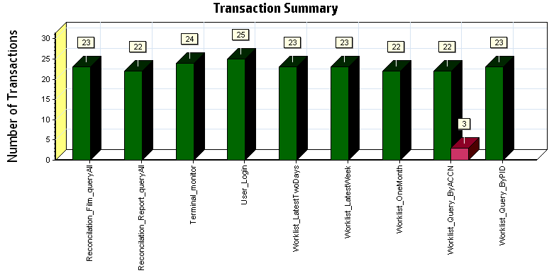

|  |  |  |
| --- | --- | --- |
| **Color** | **Scale** | **Measurement** |
|  | 1 | Pass |
|  | 1 | Fail |

|  |
| --- |
|  |
|  |

Some transaction has failed during testing work.

### Transaction response time result (True Client)

We can get the transaction response time information from the figure as follow:

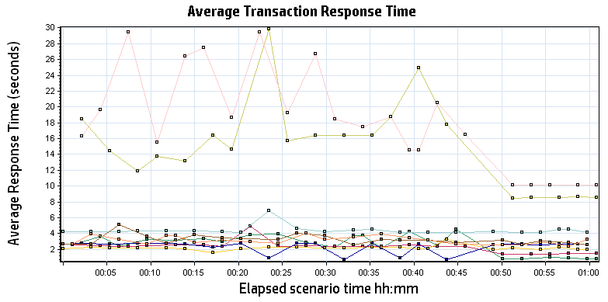

|  |  |  |  |  |  |  |  |  |  |  |  |  |  |  |  |  |  |  |  |  |  |  |  |  |  |  |  |  |  |  |  |  |  |  |  |  |  |  |  |  |  |  |  |  |  |  |  |  |  |  |  |  |  |  |  |  |  |  |  |  |  |  |  |  |  |  |  |  |  |  |
| --- | --- | --- | --- | --- | --- | --- | --- | --- | --- | --- | --- | --- | --- | --- | --- | --- | --- | --- | --- | --- | --- | --- | --- | --- | --- | --- | --- | --- | --- | --- | --- | --- | --- | --- | --- | --- | --- | --- | --- | --- | --- | --- | --- | --- | --- | --- | --- | --- | --- | --- | --- | --- | --- | --- | --- | --- | --- | --- | --- | --- | --- | --- | --- | --- | --- | --- | --- | --- | --- | --- |
| |  |  |  |  |  |  |  | | --- | --- | --- | --- | --- | --- | --- | | **Color** | **Scale** | **Measurement** | **Minimum** | **Average** | **Maximum** | **Std. Deviation** | |  | 1 | Reconcilation\_Film\_queryAll | 0.770 | 2.709 | 4.487 | 1.171 | |  | 1 | Reconcilation\_Report\_queryAll | 1.342 | 2.296 | 4.919 | 0.720 | |  | 1 | Terminal\_monitor | 1.619 | 2.152 | 3.262 | 0.271 | |  | 1 | User\_Login | 0.688 | 2.359 | 2.791 | 0.703 | |  | 1 | Worklist\_LatestTwoDays | 4.085 | 4.366 | 6.865 | 0.550 | |  | 1 | Worklist\_LatestWeek | 2.517 | 3.225 | 5.151 | 0.585 | |  | 1 | Worklist\_OneMonth | 2.382 | 3.138 | 3.985 | 0.473 | |  | 1 | Worklist\_Query\_ByACCN | 8.464 | 14.851 | 29.851 | 5.330 | |  | 1 | Worklist\_Query\_ByPID | 10.141 | 18.686 | 29.427 | 6.256 | |
|  |
|  |
|  |
|  |
| |  | | --- | | **Description:**Displays the average time taken to perform transactions during each second of the load test. This graph helps you determine whether the performance of the server is within acceptable minimum and maximum transaction performance time ranges defined for your system. | |

We can see the transactions query by patient id or accession number response time is between 10 to 30 seconds. It cannot be accepted.

## Performance bottleneck analysis

### Hardware usage analysis

During the testing work, we use the test tool to monitor the Client hardware usage include the CPU, Memory, hard disk and etc.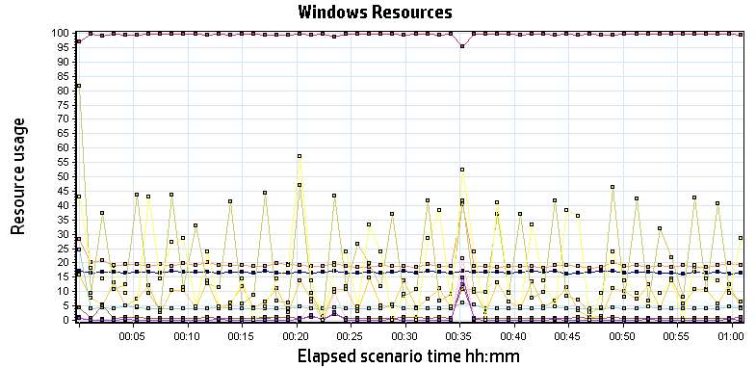

|  |  |  |  |  |  |  |
| --- | --- | --- | --- | --- | --- | --- |
| **Color** | **Scale** | **Measurement** | **Minimum** | **Average** | **Maximum** | **Std. Deviation** |
|  | 1 | % Disk Time (PhysicalDisk \_Total):localhost | 0.282 | 1.142 | 164.759 | 5.968 |
|  | 1 | % Idle Time (PhysicalDisk \_Total):localhost | 47.072 | 99.391 | 99.990 | 2.299 |
|  | 1 | % Processor Time (Processor \_Total):localhost | 0.000 | 8.016 | 43.386 | 10.690 |
|  | 0.01 | Available MBytes (Memory):localhost | 1,563.000 | 1,668.693 | 2,030.000 | 46.282 |
|  | 0.001 | Avg. Disk Bytes/Transfer (PhysicalDisk \_Total):localhost | 3,635.200 | 4,591.805 | 147,280.457 | 5,331.561 |
|  | 100 | Avg. Disk Queue Length (PhysicalDisk \_Total):localhost | 0.003 | 0.011 | 1.648 | 0.060 |
|  | 1 | Disk Transfers/sec (PhysicalDisk \_Total):localhost | 10.954 | 19.576 | 420.832 | 13.025 |
|  | 0.01 | Page Faults/sec (Memory):localhost | 14.946 | 2,099.934 | 51,139.358 | 6,446.817 |
|  | 1 | Page Reads/sec (Memory):localhost | 0.000 | 0.688 | 401.884 | 13.514 |
|  | 0.1 | Pages/sec (Memory):localhost | 0.000 | 4.094 | 2,596.459 | 78.850 |
|  | 100 | Processor Queue Length (System):localhost | 0.000 | 0.171 | 5.000 | 0.543 |

|  |
| --- |
| **Description:**Displays a summary of the System Resources usage for each Windows based host. |
|  |

Follow the content in figure, we can get the result as follow:

The hardware do not has bottle neck during the testing work. The CPU, memory and hard disk usage works well.

## Test Conclusion

The performance of two transactions does not meet the requirements. We can compare the result between independent and concurrency scenario:

|  |
| --- |
|  |

|  |  |  |  |  |  |
| --- | --- | --- | --- | --- | --- |
| **Scenario** | **Measurement** | **Minimum** | **Average** | **Maximum** | **Std. Deviation** |
| Independent | Reconcilation\_Film\_queryAll | 0.665 | 0.986 | 1.411 | 0.202 |
| Concurrency | Reconcilation\_Film\_queryAll | 0.770 | 2.709 | 4.487 | 1.171 |
| Independent | Reconcilation\_Report\_queryAll | 0.448 | 0.747 | 1.212 | 0.231 |
| Concurrency | Reconcilation\_Report\_queryAll | 1.342 | 2.296 | 4.919 | 0.720 |
| Independent | Terminal\_monitor | 1.909 | 2.110 | 2.325 | 0.104 |
| Concurrency | Terminal\_monitor | 1.619 | 2.152 | 3.262 | 0.271 |
| Independent | User\_Login | 0.766 | 2.328 | 2.796 | 0.618 |
| Concurrency | User\_Login | 0.688 | 2.359 | 2.791 | 0.703 |
| Independent | Worklist\_LatestTwoDays | 4.168 | 4.354 | 5.036 | 0.224 |
| Concurrency | Worklist\_LatestTwoDays | 4.085 | 4.366 | 6.865 | 0.550 |
| Independent | Worklist\_LatestWeek | 2.538 | 2.881 | 3.591 | 0.295 |
| Concurrency | Worklist\_LatestWeek | 2.517 | 3.225 | 5.151 | 0.585 |
| Independent | Worklist\_OneMonth | 2.231 | 2.891 | 3.812 | 0.320 |
| Concurrency | Worklist\_OneMonth | 2.382 | 3.138 | 3.985 | 0.473 |
| Independent | Worklist\_Query\_ByACCN | 9.436 | 10.287 | 12.224 | 0.672 |
| Concurrency | Worklist\_Query\_ByACCN | 8.464 | 14.851 | 29.851 | 5.330 |
| Independent | Worklist\_Query\_ByPID | 11.138 | 12.050 | 13.208 | 0.631 |
| Concurrency | Worklist\_Query\_ByPID | 10.141 | 18.686 | 29.427 | 6.256 |

Compare the result from two scenarios, we can see the query by patient id and accession number transaction is affect obviously by concurrency users.

We also find that the performance for web http request is unaccepted. The detail information as follow:

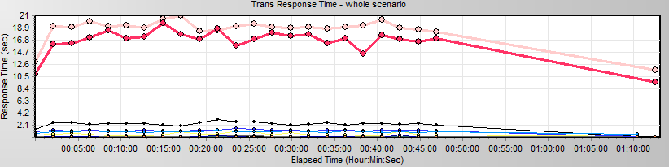

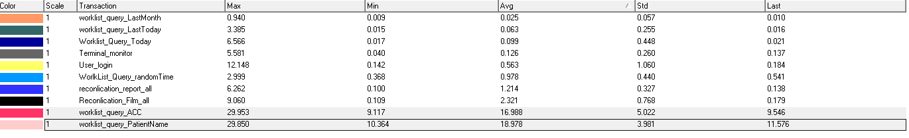

Refer the transaction response time of true client protocol. We can confirm that the performance bottle neck is cause by the service. Some services will be blocked by the middle software (IIS) and we should enhance the concurrency of the service. We still monitor the SQL statement of the services and find the SQL need to updated. The SQL for query result by patient ID and accession number is used the ‘like ‘with ‘%’ for option:

IF LEN(ISNULL(@PatientId, ''))>0

begin

SELECT @FilmWhere = @FilmWhere +' AND PatientId Like ''%'+@PatientId+'%'''

SELECT @ReportWhere = @ReportWhere+' AND PatientId Like ''%'+@PatientId+'%'''

end

-------------------------------------

IF LEN(ISNULL(@PatientName, ''))>0

begin

SELECT @FilmWhere = @FilmWhere +' AND PatientName Like ''%'+@PatientName+'%'''

SELECT @ReportWhere = @ReportWhere+' AND PatientName Like ''%'+@PatientName+'%'''

end

Please enhance the WebAPI and SQL performance ability ASAP.

# Testing work （Phase 4）

## Strategy and Scenario Setting

1. Use automation tool simulate the doctor print film work. Simulate 6 GX Platform by using QTP and PDSender tool. Each client prints one film which size is 10MB every 30 seconds.(Two QTP client environment is not ready cause by the errors of server.)
2. Use LR tool simulate 8 K2/K3 terminals to print film. Each client prints one film which size is 10MB random 5 to 30 seconds.
3. Use LR tool simulate 45 PUMA terminals to print paper reports. Each client prints report random 5 to 30 seconds.
4. Use LR tool simulate the PUMA report archive operations. Each client archive report in random 5 to 30 seconds and size is random with 100kb and 4Mb.
5. The OCR setting is not has rule for GX platforms in step1 and other setting are set as default. The OCR service will under the strong stress without configure the rule.
6. Use LR tool simulate one user login the web site and do other transaction as a virtual user. The script is use the Truclient protocol, it can monitor the whole requests of transaction include the http request, JS execute and object verify operations.
7. Use LR tool to simulate 20 users which use the Http/html protocol. The scripts can only get the http and API response time but exclude the JS and object indentify time. We use it to increase the stress for web service.
8. Monitor the transaction response time.
9. Monitor the client hardware and software usage of step6.
10. Monitor the hardware resource usage on PS.
11. Monitor the resource usage for database on PS.
12. Start/Stop 2 virtual users every 5 seconds and run the scenario for 2 hours.

## Background Data

We use SQL command statement to add large data in the database, the detail information as follow:

|  |  |
| --- | --- |
| **Table Name** | **Data Volume (records)** |
| printer.dbo.DeliveryJob | 896813 |
| printer.dbo.ImageBox | 997879 |
| printer.dbo.Page | 997813 |
| printer.dbo.Session | 1001132 |
| wggc.dbo.Patient | 1029777 |
| wggc.dbo.Study | 1029789 |
| wggc.dbo.AFP\_PrintTerminalInfo | 62 |
| wggc.dbo.Series | 1029735 |
| wggc.dbo.Image | 1029738 |
| wggc.dbo.AFP\_FilmInfo | 1243592 |
| wggc.dbo.AFP\_ReportInfo | 1136761 |
| wggc.dbo.AFP\_ExamInfo | 2397005 |
| wggc.dbo.AFP\_PrintTask | 4196324 |
| wggc.dbo.T\_Integration\_ExamInfo | 119292 |
| AFP\_PrintMode | 87883 |
| wggc.dbo.vi\_KIOSK\_ExamInfo\_Order | 119331 |

Figure 6.2.1 Background Data

## Other Setting:

### Database setting

Memory: Set the min and max memory size to 8GB.

Index fill factor: 80.

File: Increase the data and log files size and the rule is increase 500Mb as fixed size.

### IIS setting

Connection: Keep the settings as default.

## Test Object version

KIOSK Platform 3.0.0.1 B08P02 + tuning operations by team.

## Test result (Service)

### Test Statistic Report (Service)

|  |  |
| --- | --- |
| Analysis Summary | Period: 2017/7/22 16:30 - 2017/7/22 18:47 |

|  |  |
| --- | --- |
| **Scenario Name:** | E:\ECS\Performance\Script\208\ScenarioPUMA\_Reliability.lrs |
| **Results in Session:** | C:\Users\Administrator\AppData\Local\Temp\res\res.lrr |
| **Duration:** | 2 hours, 16 minutes and 42 seconds. |

|  |
| --- |
| Statistics Summary |

|  |  |  |
| --- | --- | --- |
| [**Maximum Running Vusers:**](file:///C:\Users\Administrator\Desktop\DK\Performance_20170722_2\VuserStateGraph) |  | 98 |
| [**Total Throughput (bytes):**](file:///C:\Users\Administrator\Desktop\DK\Performance_20170722_2\Throughput) | [Show SLA Results](slarules:total_throughput) | 37,026,506 |
| [**Average Throughput (bytes/second):**](file:///C:\Users\Administrator\Desktop\DK\Performance_20170722_2\Throughput) | [Show SLA Results](slarules:average_throughput) | 4,514 |
| [**Total Hits:**](file:///C:\Users\Administrator\Desktop\DK\Performance_20170722_2\HitsperSecond) | [Show SLA Results](slarules:total_hits) | 54,707 |
| [**Average Hits per Second:**](file:///C:\Users\Administrator\Desktop\DK\Performance_20170722_2\HitsperSecond) | [Show SLA Results](slarules:average_hits) | 6.669 | [**View HTTP Responses Summary**](file:///C:\Users\Administrator\Desktop\DK\Performance_20170722_2\Performance_20170722_2.html#1) |
| [**Total Errors:**](file:///C:\Users\Administrator\Desktop\DK\Performance_20170722_2\TotalErrorsPerSecond) | [Show SLA Results](slarules:errors_per_second) | 319 |  |

|  |
| --- |
| Transaction Summary |

|  |  |  |  |  |
| --- | --- | --- | --- | --- |
| [**Transactions:**](file:///C:\Users\Administrator\Desktop\DK\Performance_20170722_2\TransactionSummary) | Total Passed: 71,039 | Total Failed: 312 | Total Stopped: 2 | [**Average Response Time**](file:///C:\Users\Administrator\Desktop\DK\Performance_20170722_2\ResponseTime) |

|  |  |  |  |  |  |  |  |  |  |  |  |  |  |  |
| --- | --- | --- | --- | --- | --- | --- | --- | --- | --- | --- | --- | --- | --- | --- |
| **Transaction Name** | | | | | | | **Minimum** | **Average** | **Maximum** | **Std. Deviation** | **90 Percent** | **Pass** | **Fail** | **Stop** |
| [Create New Patient](file:///C:\Users\Administrator\Desktop\DK\Performance_20170722_2\ResponseTime0000(Create%20New%20Patient)0000) | | | | | | | 0.197 | 0.623 | 6.805 | 0.486 | 0.927 | 10,253 | 0 | 0 |
| [Film Create\_PrintTask](file:///C:\Users\Administrator\Desktop\DK\Performance_20170722_2\ResponseTime0000(Film%20Create_PrintTask)0000) | | | | | | | 0.008 | 0.07 | 1.409 | 0.09 | 0.148 | 927 | 0 | 0 |
| [Film PrintTask](file:///C:\Users\Administrator\Desktop\DK\Performance_20170722_2\ResponseTime0000(Film%20PrintTask)0000) | | | | | | | 0.014 | 0.079 | 1.741 | 0.101 | 0.161 | 927 | 0 | 0 |
| [Film PrintTask\_Result\_Correct](file:///C:\Users\Administrator\Desktop\DK\Performance_20170722_2\ResponseTime0000(Film%20PrintTask_Result_Correct)0000) | | | | | | | 0 | 0 | 0.001 | 0 | 0 | 919 | 0 | 0 |
| [**Film PrintTask\_Result\_Fail**](file:///C:\Users\Administrator\Desktop\DK\Performance_20170722_2\ResponseTime0000(Film%20PrintTask_Result_Fail)0000) | | | | | | | **0** | **0** | **0** | **0** | **0** | **0** | **8** | **0** |
| [Film TerminalStatus](file:///C:\Users\Administrator\Desktop\DK\Performance_20170722_2\ResponseTime0000(Film%20TerminalStatus)0000) | | | | | | | 0.007 | 0.05 | 0.614 | 0.059 | 0.098 | 1,854 | 0 | 0 |
| [Film\_PrintStatus\_CheckService](file:///C:\Users\Administrator\Desktop\DK\Performance_20170722_2\ResponseTime0000(Film_PrintStatus_CheckService)0000) | | | | | | | 0.004 | 0.051 | 3.712 | 0.102 | 0.101 | 2,849 | 0 | 0 |
| [**Notify File 100k**](file:///C:\Users\Administrator\Desktop\DK\Performance_20170722_2\ResponseTime0000(Notify%20File%20100k)0000) | | | | | | | **0.154** | **5.752** | **29.31** | **4.16** | **12.013** | **9,774** | **289** | **2** |
| [**Notify File 4M**](file:///C:\Users\Administrator\Desktop\DK\Performance_20170722_2\ResponseTime0000(Notify%20File%204M)0000) | | | | | | | **0.724** | **5.523** | **17.498** | **3.773** | **11.357** | **184** | **4** | **0** |
| [Report Print Task Correct](file:///C:\Users\Administrator\Desktop\DK\Performance_20170722_2\ResponseTime0000(Report%20%20Print%20Task%20Correct)0000) | | | | | | | 0 | 0 | 0.004 | 0 | 0.001 | 4,769 | 0 | 0 |
| [**Report Print Task fail**](file:///C:\Users\Administrator\Desktop\DK\Performance_20170722_2\ResponseTime0000(Report%20%20Print%20Task%20fail)0000) | | | | | | | **0** | **0** | **0** | **0** | **0** | **0** | **11** | **0** |
| [Report Create\_PrintTask](file:///C:\Users\Administrator\Desktop\DK\Performance_20170722_2\ResponseTime0000(Report%20Create_PrintTask)0000) | | | | | | | 0.006 | 0.06 | 3.357 | 0.097 | 0.122 | 4,783 | 0 | 0 |
| [Report PrintTask](file:///C:\Users\Administrator\Desktop\DK\Performance_20170722_2\ResponseTime0000(Report%20PrintTask)0000) | | | | | | | 0.015 | 0.077 | 3.384 | 0.109 | 0.158 | 4,783 | 0 | 0 |
| [Report PrintTask Status Check](file:///C:\Users\Administrator\Desktop\DK\Performance_20170722_2\ResponseTime0000(Report%20PrintTask%20Status%20Check)0000) | | | | | | | 0.005 | 0.051 | 1.088 | 0.068 | 0.109 | 5,099 | 0 | 0 |
| [Report QueryFilmReportInfo](file:///C:\Users\Administrator\Desktop\DK\Performance_20170722_2\ResponseTime0000(Report%20QueryFilmReportInfo)0000) | | | | | | | 0.011 | 0.044 | 0.394 | 0.035 | 0.087 | 4,784 | 0 | 0 |
| [Report TerminalStatus](file:///C:\Users\Administrator\Desktop\DK\Performance_20170722_2\ResponseTime0000(Report%20TerminalStatus)0000) | | | | | | | 0.007 | 0.051 | 1.635 | 0.061 | 0.105 | 9,568 | 0 | 0 |
| [Report Update PrintTask](file:///C:\Users\Administrator\Desktop\DK\Performance_20170722_2\ResponseTime0000(Report%20Update%20PrintTask)0000) | | | | | | | 0.022 | 0.106 | 4.366 | 0.151 | 0.219 | 4,782 | 0 | 0 |
| [Report Update report printer info](file:///C:\Users\Administrator\Desktop\DK\Performance_20170722_2\ResponseTime0000(Report%20Update%20report%20printer%20info)0000) | | | | | | | 0.021 | 0.101 | 2.473 | 0.118 | 0.205 | 4,784 | 0 | 0 |
|  |  |  |  |  |  |  |

Follow the summary report, we can get the result as follow: there are some transactions failed during the testing work.

|  |  |  |  |  |  |  |  |  |
| --- | --- | --- | --- | --- | --- | --- | --- | --- |
| **Transaction Name** | **Minimum** | **Average** | **Maximum** | **Std. Deviation** | **90 Percent** | **Pass** | **Fail** | **Stop** |
| [**Film PrintTask\_Result\_Fail**](file:///C:\Users\Administrator\Desktop\DK\Performance_20170722_2\ResponseTime0000(Film%20PrintTask_Result_Fail)0000) | **0** | **0** | **0** | **0** | **0** | **0** | **8** | **0** |
| [**Notify File 100k**](file:///C:\Users\Administrator\Desktop\DK\Performance_20170722_2\ResponseTime0000(Notify%20File%20100k)0000) | **0.154** | **5.752** | **29.31** | **4.16** | **12.013** | **9,774** | **289** | **2** |
| [**Notify File 4M**](file:///C:\Users\Administrator\Desktop\DK\Performance_20170722_2\ResponseTime0000(Notify%20File%204M)0000) | **0.724** | **5.523** | **17.498** | **3.773** | **11.357** | **184** | **4** | **0** |
| [**Report Print Task fail**](file:///C:\Users\Administrator\Desktop\DK\Performance_20170722_2\ResponseTime0000(Report%20%20Print%20Task%20fail)0000) | **0** | **0** | **0** | **0** | **0** | **0** | **11** | **0** |

Figure big value of response time

These are four transactions failed, we will analysis the reason at the test errors chapter. If the transaction caused by the service, we should fixed it as the follow version.

### Transaction summary result (Service)

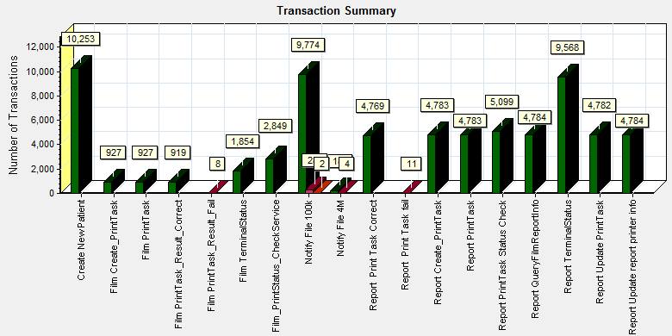

|  |  |  |
| --- | --- | --- |
| **Color** | **Scale** | **Measurement** |
|  | 1 | Pass |
|  | 1 | Fail |

|  |
| --- |
|  |
|  |

Some transaction has failed during testing work.

### Transaction response time result (Service)

We can get the transaction response time information from the figure as follow:

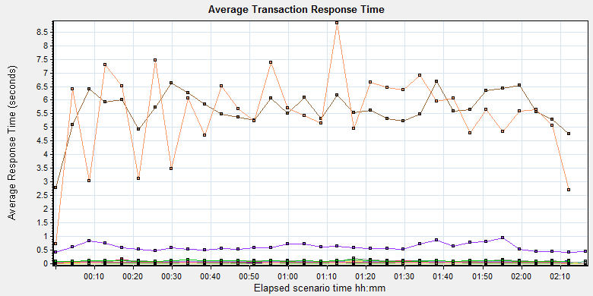

|  |
| --- |
|  |
|  |
|  |
|  |
|  |
|  |
| |  |  |  |  |  |  |  |  | | --- | --- | --- | --- | --- | --- | --- | --- | | **Color** | **Scale** | **Measurement** | **Graph's Minimum** | **Graph's Average** | **Graph's Maximum** | **Graph's Median** | **Graph's Std. Deviation** | |  | 1 | Create New Patient | 0.409 | 0.61 | 0.959 | 0.58 | 0.134 | |  | 1 | Film Create\_PrintTask | 0.041 | 0.071 | 0.125 | 0.058 | 0.026 | |  | 1 | Film PrintTask | 0.051 | 0.078 | 0.153 | 0.075 | 0.02 | |  | 1 | Film PrintTask\_Result\_Correct | 0 | 0 | 0 | 0 | 0 | |  | 1 | Film TerminalStatus | 0.034 | 0.051 | 0.104 | 0.049 | 0.012 | |  | 1 | Film\_PrintStatus\_CheckService | 0.033 | 0.05 | 0.13 | 0.048 | 0.016 | |  | 1 | Notify File 100k | 2.772 | 5.655 | 6.693 | 5.62 | 0.72 | |  | 1 | Notify File 4M | 0.724 | 5.512 | 8.825 | 5.687 | 1.573 | |  | 1 | Report Print Task Correct | 0 | 0 | 0.001 | 0 | 0 | |  | 1 | Report Create\_PrintTask | 0.014 | 0.058 | 0.107 | 0.057 | 0.014 | |  | 1 | Report PrintTask | 0.017 | 0.075 | 0.103 | 0.074 | 0.014 | |  | 1 | Report PrintTask Status Check | 0.024 | 0.049 | 0.078 | 0.05 | 0.009 | |  | 1 | Report QueryFilmReportInfo | 0.028 | 0.045 | 0.094 | 0.04 | 0.015 | |  | 1 | Report TerminalStatus | 0.035 | 0.05 | 0.064 | 0.05 | 0.006 | |  | 1 | Report Update PrintTask | 0.026 | 0.102 | 0.205 | 0.103 | 0.027 | |  | 1 | Report Update report printer info | 0.073 | 0.1 | 0.127 | 0.099 | 0.014 | |
|  |
|  |
| C:\Users\Administrator\Desktop\DK\Performance_20170722_2\Report\dot_trans.gif |
|  |
| |  | | --- | | **Description:**Displays the average time taken to perform transactions during each second of the load test. This graph helps you determine whether the performance of the server is within acceptable minimum and maximum transaction performance time ranges defined for your system. | |

We can see the transaction response time for notify report file. The average time is less than 10 seconds is can accepted.

## Performance bottleneck analysis (Service)

### Hardware usage analysis

During the testing work, we use the test tool to monitor the server hardware usage include the CPU, Memory, hard disk and etc.

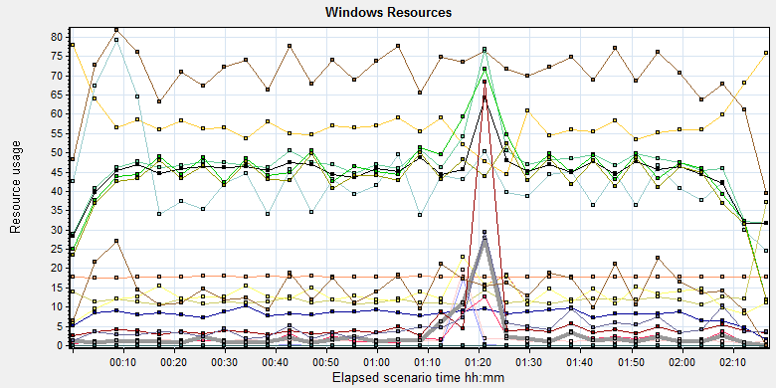

|  |  |  |  |  |  |  |
| --- | --- | --- | --- | --- | --- | --- |
|  | | | | | | |
|  | | | | | | |
|  | | | | | | |
| C:\Users\Administrator\Desktop\DK\Performance_20170722_2\Report\dot_trans.gif | | | | | | |
|  | | | | | | |
| |  | | --- | |  | | | | | | | |
| **Color** | | **Scale** | **Measurement** | **Minimum** | **Average** | **Maximum** | **Std. Deviation** |
|  | | 0.01 | % Disk Read Time (PhysicalDisk \_Total):10.184.129.208 | 0 | 56.033 | 108450.388 | 2189.9 |
|  | | 0.01 | % Disk Time (PhysicalDisk \_Total):10.184.129.208 | 4.497 | 186.386 | 108662.242 | 2244.83 |
|  | | 0.1 | % Disk Write Time (PhysicalDisk \_Total):10.184.129.208 | 4.497 | 130.353 | 7512.404 | 201.386 |
|  | | 1 | % Idle Time (PhysicalDisk \_Total):10.184.129.208 | 0 | 57.109 | 95.96 | 21.713 |
|  | | 100 | % Interrupt Time (Processor \_Total):10.184.129.208 | 0 | 0.082 | 0.475 | 0.067 |
|  | | 10 | % Privileged Time (Processor \_Total):10.184.129.208 | 0.214 | 4.338 | 13.144 | 1.791 |
|  | | 1 | % Processor Time (Processor \_Total):10.184.129.208 | 6.131 | 70.725 | 99.74 | 17.075 |
|  | | 0.001 | Available MBytes (Memory):10.184.129.208 | 17262 | 17841.341 | 18122 | 125.206 |
|  | | 0.0001 | Avg. Disk Bytes/Transfer (PhysicalDisk \_Total):10.184.129.208 | 3968 | 117263.276 | 1029656.381 | 94605.594 |
|  | | 1 | Avg. Disk Queue Length (PhysicalDisk \_Total):10.184.129.208 | 0.045 | 1.864 | 1086.622 | 22.448 |
|  | | 1 | Avg. Disk Read Queue Length (PhysicalDisk \_Total):10.184.129.208 | 0 | 0.56 | 1084.504 | 21.899 |
|  | | 10 | Avg. Disk Write Queue Length (PhysicalDisk \_Total):10.184.129.208 | 0.045 | 1.303 | 75.124 | 2.014 |
|  | | 1E-05 | Disk Bytes/sec (PhysicalDisk \_Total):10.184.129.208 | 28588.599 | 4730573.485 | 39999204.547 | 3590423.415 |
|  | | 1E-05 | Disk Read Bytes/sec (PhysicalDisk \_Total):10.184.129.208 | 0 | 212134.946 | 35623181.025 | 1091489.231 |
|  | | 1 | Disk Reads/sec (PhysicalDisk \_Total):10.184.129.208 | 0 | 2.742 | 551.928 | 20.123 |
|  | | 1 | Disk Transfers/sec (PhysicalDisk \_Total):10.184.129.208 | 5.329 | 46.132 | 552.936 | 33.521 |
|  | | 1E-05 | Disk Write Bytes/sec (PhysicalDisk \_Total):10.184.129.208 | 4130.384 | 4518438.54 | 39999204.547 | 3394582.325 |
|  | | 1 | Disk Writes/sec (PhysicalDisk \_Total):10.184.129.208 | 1.008 | 43.39 | 323.923 | 26.921 |
|  | | 1 | Page Reads/sec (Memory):10.184.129.208 | 0 | 5.935 | 3093.838 | 61.258 |
|  | | 1 | Page Writes/sec (Memory):10.184.129.208 | 0 | 0 | 0 | 0 |
|  | | 0.1 | Pages Input/sec (Memory):10.184.129.208 | 0 | 50.981 | 7245.452 | 204.553 |
|  | | 1 | Pages Output/sec (Memory):10.184.129.208 | 0 | 0 | 0 | 0 |
|  | | 0.1 | Pages/sec (Memory):10.184.129.208 | 0 | 50.981 | 7245.452 | 204.553 |
|  | | 10 | Processor Queue Length (System):10.184.129.208 | 0 | 1.49 | 37 | 2.98 |

C:\Users\Administrator\Desktop\DK\Performance_20170722_2\Report\dot_trans.gif

|  |
| --- |
| **Description:**Displays a summary of the System Resources usage for each Windows based host. |
|  |

Follow this information we can get that:

The CPU usage do not exist bottleneck, the average process time is 70% and value is between 50% and 80%. The average value is less than 80%.The average process queue length is 1.5 and values are between 5 and 20, it less than 24(CPU count \* 2), so the CPU resource is enough.

The memory available value is 17.8G and the system use 0.8 G. The memory do not has bottleneck as current testing stress.

### SQL Server resource usage analysis

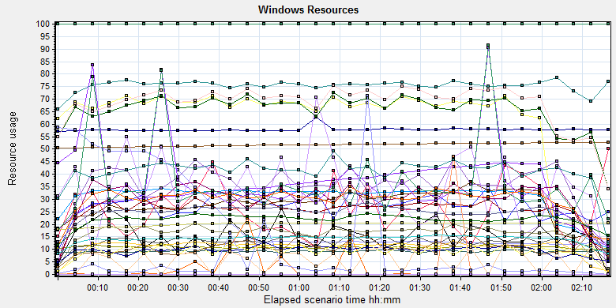

|  |  |  |  |  |  |  |  |  |  |  |  |  |  |  |  |  |  |  |  |  |  |  |  |  |  |  |  |  |  |  |  |  |  |  |  |  |  |  |  |  |  |  |  |  |  |  |  |  |  |  |  |  |  |  |  |  |  |  |  |  |  |  |  |  |  |  |  |  |  |  |  |  |  |  |  |  |  |  |  |  |  |  |  |  |  |  |  |  |  |  |  |  |  |  |  |  |  |  |  |  |  |  |  |  |  |  |  |  |  |  |  |  |  |  |  |  |  |  |  |  |  |  |  |  |  |  |  |  |  |  |  |  |  |  |  |  |  |  |  |  |  |  |  |  |  |  |  |  |  |  |  |  |  |  |  |  |  |  |  |  |  |  |  |  |  |  |  |  |  |  |  |  |  |  |  |  |  |  |  |  |  |  |  |  |  |  |  |  |  |  |  |  |  |  |  |  |  |  |  |  |  |  |  |  |  |  |  |  |  |  |  |  |  |  |  |  |  |  |  |  |  |  |  |  |  |  |  |  |  |  |  |  |  |  |  |  |  |  |  |  |  |  |  |  |  |  |  |  |  |  |  |  |  |  |  |  |  |  |  |  |  |  |  |  |  |  |  |  |  |  |  |  |  |  |  |  |  |  |  |  |  |  |  |  |  |  |  |  |  |  |  |  |  |  |  |  |  |  |  |  |  |  |  |  |  |  |  |  |  |  |  |  |  |  |  |  |  |  |  |  |  |  |  |  |  |
| --- | --- | --- | --- | --- | --- | --- | --- | --- | --- | --- | --- | --- | --- | --- | --- | --- | --- | --- | --- | --- | --- | --- | --- | --- | --- | --- | --- | --- | --- | --- | --- | --- | --- | --- | --- | --- | --- | --- | --- | --- | --- | --- | --- | --- | --- | --- | --- | --- | --- | --- | --- | --- | --- | --- | --- | --- | --- | --- | --- | --- | --- | --- | --- | --- | --- | --- | --- | --- | --- | --- | --- | --- | --- | --- | --- | --- | --- | --- | --- | --- | --- | --- | --- | --- | --- | --- | --- | --- | --- | --- | --- | --- | --- | --- | --- | --- | --- | --- | --- | --- | --- | --- | --- | --- | --- | --- | --- | --- | --- | --- | --- | --- | --- | --- | --- | --- | --- | --- | --- | --- | --- | --- | --- | --- | --- | --- | --- | --- | --- | --- | --- | --- | --- | --- | --- | --- | --- | --- | --- | --- | --- | --- | --- | --- | --- | --- | --- | --- | --- | --- | --- | --- | --- | --- | --- | --- | --- | --- | --- | --- | --- | --- | --- | --- | --- | --- | --- | --- | --- | --- | --- | --- | --- | --- | --- | --- | --- | --- | --- | --- | --- | --- | --- | --- | --- | --- | --- | --- | --- | --- | --- | --- | --- | --- | --- | --- | --- | --- | --- | --- | --- | --- | --- | --- | --- | --- | --- | --- | --- | --- | --- | --- | --- | --- | --- | --- | --- | --- | --- | --- | --- | --- | --- | --- | --- | --- | --- | --- | --- | --- | --- | --- | --- | --- | --- | --- | --- | --- | --- | --- | --- | --- | --- | --- | --- | --- | --- | --- | --- | --- | --- | --- | --- | --- | --- | --- | --- | --- | --- | --- | --- | --- | --- | --- | --- | --- | --- | --- | --- | --- | --- | --- | --- | --- | --- | --- | --- | --- | --- | --- | --- | --- | --- | --- | --- | --- | --- | --- | --- | --- | --- | --- | --- | --- | --- | --- | --- | --- | --- | --- | --- | --- | --- | --- | --- | --- | --- | --- | --- | --- | --- | --- | --- | --- | --- | --- | --- | --- | --- | --- | --- | --- | --- | --- | --- |
| |  |  |  |  |  |  |  | | --- | --- | --- | --- | --- | --- | --- | | **Color** | **Scale** | **Measurement** | **Minimum** | **Average** | **Maximum** | **Std. Deviation** | |  | 0.1 | Batch Requests/sec (MSSQL$GCPACSWS|SQL Statistics):10.184.129.208 | 81.736 | 341.83 | 1087.458 | 136.82 | |  | 1 | Buffer cache hit ratio (MSSQL$GCPACSWS|Buffer Manager):10.184.129.208 | 93.066 | 99.993 | 100 | 0.217 | |  | 1 | Bytes Total/sec (Network Adapter isatap.{10A2210A-DDA4-4C95-B4CA-0678E1454D07}):10.184.129.208 | 0 | 0 | 0 | 0 | |  | 1 | Bytes Total/sec (Network Adapter isatap.{AB372A06-51DD-4DF9-B94D-2654E039A5A0}):10.184.129.208 | 0 | 0 | 0 | 0 | |  | 0.001 | Bytes Total/sec (Server):10.184.129.208 | 47442.991 | 57884.421 | 281970.626 | 5650.075 | |  | 1 | Cache Hit Ratio (MSSQL$GCPACSWS|Catalog Metadata WGGC):10.184.129.208 | 50.589 | 51.749 | 52.708 | 0.642 | |  | 0.0001 | Cursor memory usage (MSSQL$GCPACSWS|Cursor Manager by Type \_Total):10.184.129.208 | 118400 | 236222.503 | 594216 | 164195.345 | |  | 10 | Cursor Requests/sec (MSSQL$GCPACSWS|Cursor Manager by Type \_Total):10.184.129.208 | 0 | 6.26 | 35.424 | 5.592 | |  | 1 | Database Cache Size (MB) (Database svchost):10.184.129.208 | 0 | 0 | 0 | 0 | |  | 100 | Distributed Query (MSSQL$GCPACSWS|Exec Statistics Average execution time (ms)):10.184.129.208 | 0 | 0.253 | 12 | 0.803 | |  | 1 | Distributed Query (MSSQL$GCPACSWS|Exec Statistics Cumulative execution time (ms) per second):10.184.129.208 | 0 | 0 | 0 | 0 | |  | 1 | Distributed Query (MSSQL$GCPACSWS|Exec Statistics Execs in progress):10.184.129.208 | 0 | 0 | 0 | 0 | |  | 1E-17 | Distributed Query (MSSQL$GCPACSWS|Exec Statistics Execs started per second):10.184.129.208 | 0 | 1.59082013112724E+18 | 1.84467440737095E+19 | 5.1782953890841E+18 | |  | 1 | Errors/sec (MSSQL$GCPACSWS|SQL Errors \_Total):10.184.129.208 | 0 | 10.861 | 99.83 | 4.017 | |  | 10 | Errors/sec (MSSQL$GCPACSWS|SQL Errors User Errors):10.184.129.208 | 0 | 7.529 | 16.664 | 2.472 | |  | 100 | Extended Procedures (MSSQL$GCPACSWS|Exec Statistics Average execution time (ms)):10.184.129.208 | 0 | 0.272 | 1 | 0.445 | |  | 0.1 | Full Scans/sec (MSSQL$GCPACSWS|Access Methods):10.184.129.208 | 9.645 | 311.977 | 864.434 | 138.73 | |  | 0.001 | Index Searches/sec (MSSQL$GCPACSWS|Access Methods):10.184.129.208 | 0 | 28049.941 | 87984.134 | 12141.342 | |  | 1000 | Latch waits/sec (MSOLAP$GCPACSWS|Locks):10.184.129.208 | 0 | 0.035 | 1.014 | 0.109 | |  | 100 | Lazy writes/sec (MSSQL$GCPACSWS|Buffer Manager):10.184.129.208 | 0 | 0.02 | 9.783 | 0.353 | |  | 0.0001 | Lock Requests/sec (MSSQL$GCPACSWS|Locks \_Total):10.184.129.208 | 0 | 664088.018 | 1167432.728 | 162406.987 | |  | 1 | Lock Timeouts/sec (MSSQL$GCPACSWS|Locks \_Total):10.184.129.208 | 0 | 25.839 | 130.898 | 23.282 | |  | 0.001 | Lock Wait Time (ms) (MSSQL$GCPACSWS|Locks \_Total):10.184.129.208 | 0 | 35963.485 | 822942.765 | 63478.402 | |  | 0.01 | Lock waits (MSSQL$GCPACSWS|Wait Statistics Average wait time (ms)):10.184.129.208 | 0 | 1311.452 | 14517 | 1588.782 | |  | 1 | Lock waits (MSSQL$GCPACSWS|Wait Statistics Waits in progress):10.184.129.208 | 0 | 30.406 | 347 | 40.627 | |  | 1 | Lock Waits/sec (MSSQL$GCPACSWS|Locks \_Total):10.184.129.208 | 0 | 16.622 | 133.582 | 19.992 | |  | 1 | Log write waits (MSSQL$GCPACSWS|Wait Statistics Average wait time (ms)):10.184.129.208 | 0 | 9.191 | 28 | 3.456 | |  | 0.1 | Logical Connections (MSSQL$GCPACSWS|General Statistics):10.184.129.208 | 88 | 247.967 | 301 | 31.13 | |  | 100 | Logins/sec (MSSQL$GCPACSWS|General Statistics):10.184.129.208 | 0 | 0.376 | 28.759 | 1.063 | |  | 100 | Logouts/sec (MSSQL$GCPACSWS|General Statistics):10.184.129.208 | 0 | 0.368 | 29.09 | 1.084 | |  | 1 | Lookups/sec (MSOLAP$GCPACSWS|Cache):10.184.129.208 | 0 | 0 | 0 | 0 | |  | 10 | Number of Deadlocks/sec (MSSQL$GCPACSWS|Locks \_Total):10.184.129.208 | 0 | 1.11 | 9.554 | 1.648 | |  | 0.1 | OLEDB calls (MSSQL$GCPACSWS|Exec Statistics Average execution time (ms)):10.184.129.208 | 0 | 97.338 | 1953 | 95.889 | |  | 1 | Page IO latch waits (MSSQL$GCPACSWS|Wait Statistics Average wait time (ms)):10.184.129.208 | 0 | 10.844 | 389 | 21.194 | |  | 1000 | Page latch waits (MSSQL$GCPACSWS|Wait Statistics Waits in progress):10.184.129.208 | 0 | 0.001 | 2 | 0.054 | |  | 0.001 | Page life expectancy (MSSQL$GCPACSWS|Buffer Manager):10.184.129.208 | 17906 | 20198.688 | 20662 | 798.141 | |  | 0.0001 | Page lookups/sec (MSSQL$GCPACSWS|Buffer Manager):10.184.129.208 | 0 | 690535.709 | 1168057.616 | 161497.899 | |  | 1 | Page reads/sec (MSSQL$GCPACSWS|Buffer Manager):10.184.129.208 | 0 | 5.04 | 5764.655 | 115.468 | |  | 1 | Page writes/sec (MSSQL$GCPACSWS|Buffer Manager):10.184.129.208 | 0 | 9.457 | 179.646 | 29.398 | |  | 10 | Safe Auto-Params/sec (MSSQL$GCPACSWS|SQL Statistics):10.184.129.208 | 0 | 4.19 | 17.291 | 2.328 | |  | 0.1 | SQL Compilations/sec (MSSQL$GCPACSWS|SQL Statistics):10.184.129.208 | 56.81 | 142.516 | 240.649 | 23.051 | |  | 10 | SQL Re-Compilations/sec (MSSQL$GCPACSWS|SQL Statistics):10.184.129.208 | 0 | 0.568 | 39.521 | 3.394 | |  | 1 | Total deadlocks detected (MSOLAP$GCPACSWS|Locks):10.184.129.208 | 0 | 0 | 0 | 0 | |  | 1 | Transactions (MSSQL$GCPACSWS|Transactions):10.184.129.208 | 6 | 30.007 | 223 | 14.183 | |  | 0.1 | User Connections (MSSQL$GCPACSWS|General Statistics):10.184.129.208 | 82 | 219.401 | 255 | 24.581 |   C:\Users\Administrator\Desktop\DK\Performance_20170722_2\Report\dot_trans.gif   |  | | --- | | **Description:**Displays a summary of the System Resources usage for each Windows based host. | |  | |  | |

Figure 6.6..2.1 Database result

Follow the SQL server monitor resource, we can find the Database has some issues that make the system performance not well:

There are cursors operations exist in the database:

|  |  |  |  |  |  |  |
| --- | --- | --- | --- | --- | --- | --- |
|  | 0.0001 | Cursor memory usage (MSSQL$GCPACSWS|Cursor Manager by Type \_Total):10.184.129.208 | 118400 | 236222.503 | 594216 | 164195.345 |
|  | 10 | Cursor Requests/sec (MSSQL$GCPACSWS|Cursor Manager by Type \_Total):10.184.129.208 | 0 | 6.26 | 35.424 | 5.592 |

Database does the cursor operations every 6.26 seconds. SQL server suggests users to do the operation base on column data. Please indentify the SQL statement and do some enhance works.

There are some error happens during the testing work:

|  |  |  |  |  |  |  |
| --- | --- | --- | --- | --- | --- | --- |
|  | 1 | Errors/sec (MSSQL$GCPACSWS|SQL Errors \_Total):10.184.129.208 | 0 | 10.861 | 99.83 | 4.017 |
|  | 10 | Errors/sec (MSSQL$GCPACSWS|SQL Errors User Errors):10.184.129.208 | 0 | 7.529 | 16.664 | 2.472 |

Database has 10.8 errors every second and 7.5 records are user errors. It maybe cause by the dead lock or other issues.

There are too many full scans operations exist in the database:

|  |  |  |  |  |  |  |
| --- | --- | --- | --- | --- | --- | --- |
|  | 0.1 | Full Scans/sec (MSSQL$GCPACSWS|Access Methods):10.184.129.208 | 9.645 | 311.977 | 864.434 | 138.73 |

Database has full scans issues and average value is 311/sec. This issue will affect the SQL statement executes slowly because it does not use the index. Some operations will cause the full scans such as select count (\*), use <> and! =, use like fuzzy query etc. Please enhance the SQL statement performance ASAP.

There are some locks and deadlocks issues exist in the database:

|  |  |  |  |  |  |  |
| --- | --- | --- | --- | --- | --- | --- |
|  | 0.0001 | Lock Requests/sec (MSSQL$GCPACSWS|Locks \_Total):10.184.129.208 | 0 | 664088.018 | 1167432.728 | 162406.987 |
|  | 1 | Lock Timeouts/sec (MSSQL$GCPACSWS|Locks \_Total):10.184.129.208 | 0 | 25.839 | 130.898 | 23.282 |
|  | 0.001 | Lock Wait Time (ms) (MSSQL$GCPACSWS|Locks \_Total):10.184.129.208 | 0 | 35963.485 | 822942.765 | 63478.402 |
|  | 0.01 | Lock waits (MSSQL$GCPACSWS|Wait Statistics Average wait time (ms)):10.184.129.208 | 0 | 1311.452 | 14517 | 1588.782 |
|  | 1 | Lock waits (MSSQL$GCPACSWS|Wait Statistics Waits in progress):10.184.129.208 | 0 | 30.406 | 347 | 40.627 |
|  | 1 | Lock Waits/sec (MSSQL$GCPACSWS|Locks \_Total):10.184.129.208 | 0 | 16.622 | 133.582 | 19.992 |
|  | 1 | Log write waits (MSSQL$GCPACSWS|Wait Statistics Average wait time (ms)):10.184.129.208 | 0 | 9.191 | 28 | 3.456 |
|  | 1 | Lookups/sec (MSOLAP$GCPACSWS|Cache):10.184.129.208 | 0 | 0 | 0 | 0 |
|  | 10 | Number of Deadlocks/sec (MSSQL$GCPACSWS|Locks \_Total):10.184.129.208 | 0 | 1.11 | 9.554 | 1.648 |

We can see that the average lock waits time is 1.3 seconds and timeouts average value is 25 every second. There are 16.6 locks and 1.1 deadlocks every second. The database design is better than B05, the deadlocks will makes the test transactions failed. We should find out them and fix it as the high level tasks.

There are about 247 database connections in the database, but login and logout frequency is 0.3/sec. It is better than B05 version.

|  |  |  |  |  |  |  |  |  |
| --- | --- | --- | --- | --- | --- | --- | --- | --- |
|  | | 0.1 | Logical Connections (MSSQL$GCPACSWS|General Statistics):10.184.129.208 | 88 | 247.967 | 301 | 31.13 | |
|  | | 100 | Logins/sec (MSSQL$GCPACSWS|General Statistics):10.184.129.208 | 0 | 0.376 | 28.759 | 1.063 | |
|  | | 100 | Logouts/sec (MSSQL$GCPACSWS|General Statistics):10.184.129.208 | 0 | 0.368 | 29.09 | 1.084 | |
|  | | 0.1 | User Connections (MSSQL$GCPACSWS|General Statistics):10.184.129.208 | 82 | 219.401 | 255 | 24.581 | |
| C:\Users\Administrator\Desktop\Performance result\20170531_1\Report\dot_trans.gif | | | | | | |

## Test result (True Client)

### Test Statistic Report (True Client)

|  |  |
| --- | --- |
| Analysis Summary | Period: 2017/7/22 17:50 - 2017/7/22 19:51 |

|  |  |
| --- | --- |
| **Scenario Name:** | C:\Program Files (x86)\HP\LoadRunner\scenario\Scenario3.lrs |
| **Results in Session:** | d:\Performance\WebClient\WebTest\_TruClient\res\res.lrr |
| **Duration:** | 2 hours and 44 seconds. |

|  |  |  |  |  |
| --- | --- | --- | --- | --- |
| Statistics Summary | | | | |
| [**Maximum Running Vusers:**](file:///D:\Performance\LR_result\Report\Session2_20170722_1\Report\Report0.html) | |  | 1 |
| [**Total Throughput (bytes):**](file:///D:\Performance\LR_result\Report\Session2_20170722_1\Report\Report2.html) | |  | 129,054,504 |
| [**Average Throughput (bytes/second):**](file:///D:\Performance\LR_result\Report\Session2_20170722_1\Report\Report2.html) | |  | 17,813 |
|  | |  |  |
| [**Total Hits:**](file:///D:\Performance\LR_result\Report\Session2_20170722_1\Report\Report1.html) | |  | 11,353 |
| [**Average Hits per Second:**](file:///D:\Performance\LR_result\Report\Session2_20170722_1\Report\Report1.html) | |  | 1.567 | [**View HTTP Responses Summary**](file:///D:\Performance\LR_result\Report\Session2_20170722_1\Report\summary.html#1) |
|  | |  |  |  |
| Transaction Summary | | | | |

|  |  |  |  |  |
| --- | --- | --- | --- | --- |
| [**Transactions:**](file:///D:\Performance\LR_result\Report\Session2_20170722_1\Report\Report3.html) | Total Passed: 460 | Total Failed: 0 | Total Stopped: 0 | [**Average Response Time**](file:///D:\Performance\LR_result\Report\Session2_20170722_1\Report\Report4.html) |

|  |  |  |  |
| --- | --- | --- | --- |
|  | **Pass** | **Fail** | **Stop** |
| Total | 460 | 0 | 0 |

|  |  |  |  |  |  |  |  |  |
| --- | --- | --- | --- | --- | --- | --- | --- | --- |
| **Transaction Name** | **Minimum** | **Average** | **Maximum** | **Std. Deviation** | **90 Percent** | **Pass** | **Fail** | **Stop** |
| Reconcilation\_Film\_queryAll | 1.281 | 2.532 | 4.387 | 0.711 | 3.42 | 46 | 0 | 0 |
| Reconcilation\_Report\_queryAll | 0.537 | 1.118 | 1.605 | 0.34 | 1.504 | 46 | 0 | 0 |
| Terminal\_monitor | 0.897 | 4.236 | 122.577 | 17.642 | 1.764 | 46 | 0 | 0 |
| User\_Login | 0.732 | 2.426 | 3.034 | 0.831 | 2.922 | 46 | 0 | 0 |
| Worklist\_LatestTwoDays | 1.749 | 4.854 | 6.153 | 0.901 | 5.964 | 46 | 0 | 0 |
| Worklist\_LatestWeek | 2.273 | 3.237 | 4.279 | 0.483 | 3.835 | 46 | 0 | 0 |
| Worklist\_OneMonth | 2.128 | 3.469 | 5.126 | 0.584 | 4.158 | 46 | 0 | 0 |
| Worklist\_Query\_ByACCN | 0.411 | 0.444 | 0.583 | 0.038 | 0.471 | 46 | 0 | 0 |
| Worklist\_Query\_ByPID | 0.396 | 0.431 | 0.5 | 0.019 | 0.454 | 46 | 0 | 0 |
| Worklist\_Query\_ByPName | 0.379 | 0.416 | 0.494 | 0.033 | 0.477 | 46 | 0 | 0 |

Follow the summary report, we can get the result as follow: All transactions response time is less than 6 seconds. The performance of the web operations are all pass for requirements.

### Transaction summary result (True Client)

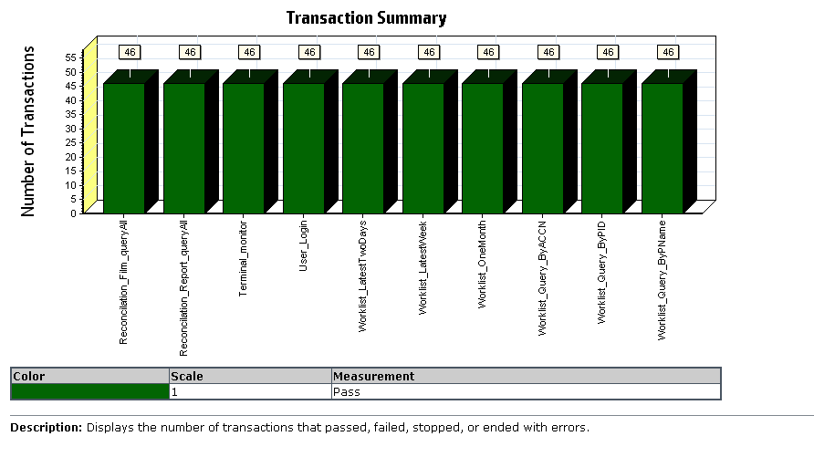

There are no error happened during the testing work.

### Transaction response time result (True Client)

We can get the transaction response time information from the figure as follow:

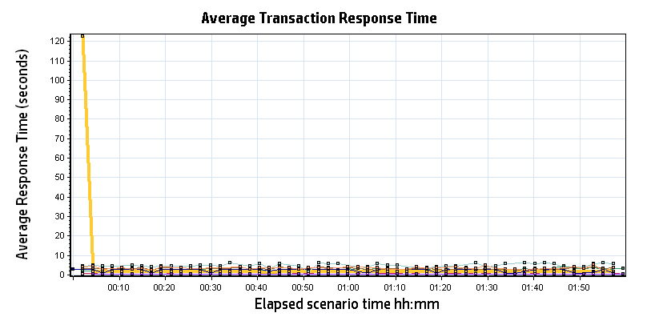

|  |  |  |  |  |  |  |  |  |  |  |  |  |  |  |  |  |  |  |  |  |  |  |  |  |  |  |  |  |  |  |  |  |  |  |  |  |  |  |  |  |  |  |  |  |  |  |  |  |  |  |  |  |  |  |  |  |  |  |  |  |  |  |  |  |  |  |  |  |  |  |  |  |  |  |  |  |  |
| --- | --- | --- | --- | --- | --- | --- | --- | --- | --- | --- | --- | --- | --- | --- | --- | --- | --- | --- | --- | --- | --- | --- | --- | --- | --- | --- | --- | --- | --- | --- | --- | --- | --- | --- | --- | --- | --- | --- | --- | --- | --- | --- | --- | --- | --- | --- | --- | --- | --- | --- | --- | --- | --- | --- | --- | --- | --- | --- | --- | --- | --- | --- | --- | --- | --- | --- | --- | --- | --- | --- | --- | --- | --- | --- | --- | --- | --- |
| |  |  |  |  |  |  |  | | --- | --- | --- | --- | --- | --- | --- | | **Color** | **Scale** | **Measurement** | **Minimum** | **Average** | **Maximum** | **Std. Deviation** | |  | 1 | Reconcilation\_Film\_queryAll | 1.281 | 2.532 | 4.387 | 0.711 | |  | 1 | Reconcilation\_Report\_queryAll | 0.537 | 1.118 | 1.605 | 0.340 | |  | 1 | Terminal\_monitor | 0.897 | 4.236 | 122.577 | 17.642 | |  | 1 | User\_Login | 0.732 | 2.426 | 3.034 | 0.831 | |  | 1 | Worklist\_LatestTwoDays | 1.749 | 4.854 | 6.153 | 0.901 | |  | 1 | Worklist\_LatestWeek | 2.273 | 3.237 | 4.279 | 0.483 | |  | 1 | Worklist\_OneMonth | 2.128 | 3.469 | 5.126 | 0.584 | |  | 1 | Worklist\_Query\_ByACCN | 0.411 | 0.444 | 0.583 | 0.038 | |  | 1 | Worklist\_Query\_ByPID | 0.396 | 0.431 | 0.500 | 0.019 | |  | 1 | Worklist\_Query\_ByPName | 0.379 | 0.416 | 0.494 | 0.033 | |
|  |
|  |
|  |
|  |
| |  | | --- | | **Description:**Displays the average time taken to perform transactions during each second of the load test. This graph helps you determine whether the performance of the server is within acceptable minimum and maximum transaction performance time ranges defined for your system. | |

## Performance bottleneck analysis (True Client)

### Hardware usage analysis

During the testing work, we use the test tool to monitor the Client hardware usage include the CPU, Memory, hard disk and etc.

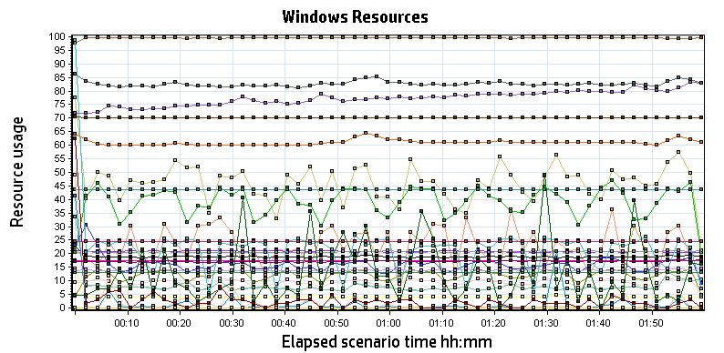

|  |  |  |  |  |  |  |
| --- | --- | --- | --- | --- | --- | --- |
| **Color** | **Scale** | **Measurement** | **Minimum** | **Average** | **Maximum** | **Std. Deviation** |
|  | 10 | % Disk Time (PhysicalDisk \_Total):localhost | 0.273 | 0.810 | 62.116 | 1.491 |
|  | 1 | % Idle Time (PhysicalDisk \_Total):localhost | 61.523 | 99.520 | 99.993 | 1.028 |
|  | 1000 | % Interrupt Time (Processor \_Total):localhost | 0.000 | 0.023 | 0.390 | 0.054 |
|  | 100 | % Privileged Time (Processor \_Total):localhost | 0.000 | 0.464 | 5.050 | 0.628 |
|  | **1** | **% Processor Time (Processor \_Total):localhost** | **0.000** | **9.329** | **44.687** | **11.384** |
|  | 0.01 | Available MBytes (Memory):localhost | 1,960.000 | 2,083.313 | 2,475.000 | 47.261 |
|  | 0.001 | Avg. Disk Bytes/Transfer (PhysicalDisk \_Total):localhost | 3,706.435 | 4,270.284 | 88,755.892 | 3,210.409 |
|  | 1000 | Avg. Disk Queue Length (PhysicalDisk \_Total):localhost | 0.003 | 0.008 | 0.621 | 0.015 |
|  | 1 | Bytes Total/sec (Server):localhost | 0.000 | 0.000 | 0.000 | 0.000 |
|  | 1E-06 | Cache Bytes (Memory):localhost | 71,229,440.000 | 77,265,587.179 | 83,582,976.000 | 2,716,540.701 |
|  | 1E-08 | Committed Bytes (Memory):localhost | 1,680,584,704.000 | 2,068,641,558.770 | 2,192,621,568.000 | 48,219,694.049 |
|  | 0.01 | Context Switches/sec (System):localhost | 419.507 | 3,902.302 | 27,027.481 | 4,670.088 |
|  | 1 | Disk Transfers/sec (PhysicalDisk \_Total):localhost | 10.628 | 18.907 | 78.239 | 5.589 |
|  | 0.01 | File Data Operations/sec (System):localhost | 17.253 | 1,207.313 | 5,839.308 | 1,660.627 |
|  | 0.0001 | Free Megabytes (LogicalDisk \_Total):localhost | 434,672.000 | 434,676.308 | 434,703.000 | 3.547 |
|  | 0.01 | Interrupts/sec (Processor \_Total):localhost | 239.143 | 1,612.032 | 8,570.202 | 1,621.895 |
|  | 0.01 | Page Faults/sec (Memory):localhost | 7.307 | 2,237.007 | 53,079.386 | 6,650.622 |
|  | 100 | Page Reads/sec (Memory):localhost | 0.000 | 0.022 | 13.983 | 0.318 |
|  | 10 | Pages/sec (Memory):localhost | 0.000 | 0.175 | 135.504 | 3.383 |
|  | 1E-06 | Pool Nonpaged Bytes (Memory):localhost | 70,115,328.000 | 70,224,934.304 | 70,533,120.000 | 36,373.628 |
|  | 0.0001 | Pool Nonpaged Bytes (Server):localhost | 131,691.000 | 131,691.000 | 131,691.000 | 0.000 |
|  | 1E-07 | Pool Paged Bytes (Memory):localhost | 173,785,088.000 | 174,458,171.797 | 174,985,216.000 | 79,590.391 |
|  | 0.001 | Pool Paged Bytes (Server):localhost | 24,584.000 | 24,584.000 | 24,584.000 | 0.000 |
|  | 1 | Pool Paged Failures (Server):localhost | 0.000 | 0.000 | 0.000 | 0.000 |
|  | 1E-08 | Private Bytes (Process \_Total):localhost | 1,074,601,984.000 | 1,389,368,639.202 | 1,502,666,752.000 | 41,693,387.880 |
|  | 1 | Processes (System):localhost | 59.000 | 60.985 | 65.000 | 1.130 |
|  | **100** | **Processor Queue Length (System):localhost** | **0.000** | **0.127** | **9.000** | **0.571** |
|  | 100 | Split IO/Sec (PhysicalDisk \_Total):localhost | 0.000 | 0.031 | 8.989 | 0.254 |
|  | 1E-06 | System Cache Resident Bytes (Memory):localhost | 71,229,440.000 | 77,265,570.155 | 83,582,976.000 | 2,716,316.159 |
|  | 0.1 | Threads (Objects):localhost | 776.000 | 826.118 | 885.000 | 11.424 |
|  | 1E-08 | Working Set (Process \_Total):localhost | 1,235,419,136.000 | 1,716,784,101.613 | 1,859,145,728.000 | 55,797,119.168 |

C:\Users\Administrator\Desktop\DK\Performance_20170722_2\Report\dot_trans.gifFollow this information we can get that:

The CPU usage do not exist bottleneck, the average process time is9.3% and value is between 5% and 10%. The average value is less than 80%.The average process queue length is 0.127 and max value is 9, so the CPU resource is enough.

The memory available value is 2G and the system use 0.5 G. The memory do not has bottleneck as current testing stress.

## Test Conclusion

Follow the test result and collect information, we can get the conclusion as follow:

The performance of web is passed during current testing works. All transactions` response time is less than 5 seconds. We compared the result between current and B07 version:



After the tuning works, the web operations performance is very good! The tuning operations are worked well.

About the PS services performance also has optimized. The transaction passed counts are increased and error counts are low. The dead locks in database are reduced.

*B05 version*

*Transactions: Total Passed: 90,627 Total Failed: 1,202 Total Stopped: 0*

*Current version*

*Transactions: Total Passed: 71,039 Total Failed: 312 Total Stopped: 2*



However, there are still some errors happened during the testing works:

|  |  |  |
| --- | --- | --- |
| No | Description | Counts |
| 1 | please reference the service is works well or not. The accn is A20170722184551292 | 293 |
| 2 | Terminal print film failed | 15 |
| 3 | Terminal print report failed | 11 |
|  |  |  |

Test error analysis:

1. The error is happed in service “NotifyReportFile”, the service do not response the true as result. The script made as errors and pop up the error message as No 1. We query the return accession number from database, it exist in it but blocked in the table afp\_AFP\_MessageQueue which used by the integration services. That means the integration service do not process the request and timeout. We find that there are many errors in log file:

*2017-07-22 17:01:53,944 ERROR - Exam A20170722164655639 of patient P20170722164655639 is invalidate in RIS, it will be ignored at:NotifyService.NotifyService.NotifyReportInfo-Line:0*

1. There are 15 error cause by terminal print films, follow the errors detail log, we find that happened in line 58 and 208 in script.

Line 28 script code is to update the film records in database, it happened 7 times. We should add some logs to monitor it caused by test tool or database.

Line 208 script code is to verify the print task successfully or not. It happened 8 times. We query the failed print film records in database and result is follow:

SN PatientID TerminalID Status

4615726 P20170722152040282 K2\_7 3

4614936 P20170722152040282 K2\_7 3

4614140 P20170722152040282 K2\_7 3

4613537 P20170722152246940 K2\_1 3

4613393 P20170722152040282 K2\_7 3

4612578 P20170722152040282 K2\_7 3

4611783 P20170722152040282 K2\_7 3

4611001 P20170722152040282 K2\_7 3

We find that the record of ‘P20170722152040282’ is an error data, the record do not have the film information, so the printed cannot print it out. So this is not an error.

1. There are 11 errors caused by terminal print reports, follow the errors detail log, we find it happened in the line 411 in script and happened for 11 times. We query the failed transaction from the database and detail information as follow:

SN PatientID TerminalID Status

4615733 P20170722160435969 Terminal14 3

4615511 P20170722155726442 Terminal4 3

4615506 P20170722155429916 Terminal5 3

4615502 P20170722160424460 Terminal15 3

4615202 P20170722160232556 Terminal21 3

4613903 P20170722160533395 Terminal10 3

4613902 P20170722160544872 Terminal1 3

4613886 P20170722155426214 Terminal5 3

4613795 P20170722160435969 Terminal14 3

4613793 P20170722155827911 Terminal36 3

4613326 P20170722160556207 Terminal1 3

These transactions are really failed during the testing works. We should find out the reasons and fixed it.

So the really test error during the testing works as follow:

|  |  |  |
| --- | --- | --- |
| No | Description | Counts |
| 1 | please reference the service is works well or not. The accn is A20170722184551292 | 293 |
| 2 | Terminal print film failed | 7(15-8) |
| 3 | Terminal print report failed | 11 |
|  |  |  |

The transaction execute during the testing work in 2 hours.(From database)

|  |  |  |
| --- | --- | --- |
| Transactions | Passed | Failed |
| Paper report achieved | 9903 | N/A |
| Film achieved | 528 | N/A |
| Print Task | 5711 | 19 |

During the testing works, we find that there still some dead locks. We find out some SQL statement during testing works. Maybe they will help team to fix the issues:



Other issues are that the integration requests are blocked by integrations services. Many requests are blocked in table *wggc.dbo.AFP\_MessageQueue* in database and the process operations are slow. The integrations service process 1 requests with 2-4 seconds. It is a risk for our system. The integration process rule should be enhanced. Please do not start the service in the SQL statement and add some index in the integration table in database.

The performance for Print service has great enhanced. The Developer team has made a great job on it. The performance for web site is all passed for the requirements. There are some dead locks and integration risk need team to fixed. We are closed to the performance target. We will continue to enhance the system and meet the requirement as finally.

# Testing work （Phase 5）

## Strategy and Scenario Setting

1. Use automation tool simulate the doctor print film work. Simulate 8 GX Platform by using QTP and PDSender tool. Each client prints one film which size is 10MB every 30 seconds.(Two QTP client environment is not ready cause by the errors of server.)
2. Use LR tool simulate 8 K2/K3 terminals to print film. Each client prints one film which size is 10MB random 5 to 30 seconds.
3. Use LR tool simulate 45 PUMA terminals to print paper reports. Each client prints report random 5 to 30 seconds.
4. Use LR tool simulate 45 users to do PUMA report archive operations. Each client archive report in random 5 to 30 seconds and size is random with 100kb and 4Mb.
5. The OCR setting is not has rule for GX platforms in step1 and other setting are set as default. The OCR service will under the strong stress without configure the rule.
6. Monitor the transaction response time.
7. Monitor the hardware resource usage on PS.
8. Monitor the resource usage for database on PS.
9. Start/Stop 2 virtual users every 10 seconds and run the scenario for 2 hours.

## Background Data

We use SQL command statement to add large data in the database, the detail information as follow:

|  |  |
| --- | --- |
| **Table Name** | **Data Volume (records)** |
| printer.dbo.DeliveryJob | 899813 |
| printer.dbo.ImageBox | 997879 |
| printer.dbo.Page | 997813 |
| printer.dbo.Session | 1001132 |
| wggc.dbo.Patient | 1029777 |
| wggc.dbo.Study | 1029789 |
| wggc.dbo.AFP\_PrintTerminalInfo | 62 |
| wggc.dbo.Series | 1029735 |
| wggc.dbo.Image | 1029738 |
| wggc.dbo.AFP\_FilmInfo | 1343592 |
| wggc.dbo.AFP\_ReportInfo | 1436761 |
| wggc.dbo.AFP\_ExamInfo | 2897005 |
| wggc.dbo.AFP\_PrintTask | 4396324 |
| wggc.dbo.T\_Integration\_ExamInfo | 159292 |
| AFP\_PrintMode | 87883 |
| wggc.dbo.vi\_KIOSK\_ExamInfo\_Order | 219331 |

Figure 7.2.1 Background Data

## Other Setting:

### Database setting

Memory: Set the min and max memory size to 8GB.

Index fill factor: 80.

File: Increase the data and log files size and the rule is increase 500Mb as fixed size.

### IIS setting

Connection: Keep the settings as default.

## Test Object version

KIOSK Platform 3.0.0.1 B10 + New integration package + tuning works for Integration

## Test result

### Test Statistic Report

|  |  |
| --- | --- |
| Analysis Summary | Period: 2017/8/15 15:16 - 2017/8/15 17:33 |

|  |  |
| --- | --- |
| **Scenario Name:** | E:\ECS\Performance\Script\208\ScenarioPUMA\_Reliability.lrs |
| **Results in Session:** | C:\Users\Administrator\AppData\Local\Temp\res\res.lrr |
| **Duration:** | 2 hours, 16 minutes and 35 seconds. |

|  |
| --- |
| Statistics Summary |

|  |  |  |
| --- | --- | --- |
| [**Maximum Running Vusers:**](file:///E:\PerformanceResult\Phase3\Performance_20170815_2\VuserStateGraph) |  | 98 |
| [**Total Throughput (bytes):**](file:///E:\PerformanceResult\Phase3\Performance_20170815_2\Throughput) | [Show SLA Results](slarules:total_throughput) | 49,648,315 |
| [**Average Throughput (bytes/second):**](file:///E:\PerformanceResult\Phase3\Performance_20170815_2\Throughput) | [Show SLA Results](slarules:average_throughput) | 6,058 |
| [**Total Hits:**](file:///E:\PerformanceResult\Phase3\Performance_20170815_2\HitsperSecond) | [Show SLA Results](slarules:total_hits) | 50,852 |
| [**Average Hits per Second:**](file:///E:\PerformanceResult\Phase3\Performance_20170815_2\HitsperSecond) | [Show SLA Results](slarules:average_hits) | 6.204 | [**View HTTP Responses Summary**](file:///E:\PerformanceResult\Phase3\Performance_20170815_2\Performance_20170815_2.html#1) |

|  |  |  |
| --- | --- | --- |
| |  | | --- | | You can define SLA data using the [SLA configuration wizard](slaconfig:) | | You can analyze transaction behavior using the [Analyze Transaction mechanism](analyze:) | |

|  |
| --- |
| Transaction Summary |

|  |  |  |  |  |
| --- | --- | --- | --- | --- |
| [**Transactions:**](file:///E:\PerformanceResult\Phase3\Performance_20170815_2\TransactionSummary) | Total Passed: 55,784 | Total Failed: 0 | Total Stopped: 0 | [**Average Response Time**](file:///E:\PerformanceResult\Phase3\Performance_20170815_2\ResponseTime) |

|  |  |  |  |  |  |  |  |  |  |
| --- | --- | --- | --- | --- | --- | --- | --- | --- | --- |
| **Transaction Name** | **SLA Status** | **Minimum** | **Average** | **Maximum** | **Std. Deviation** | **90 Percent** | **Pass** | **Fail** | **Stop** |
| [Create New Patient](file:///E:\PerformanceResult\Phase3\Performance_20170815_2\ResponseTime0000(Create%20New%20Patient)0000) | [Show SLA Results](slarules:transaction_response_time_CreateNewPatient) | 0.107 | 0.175 | 0.849 | 0.063 | 0.253 | 4,209 | 0 | 0 |
| [Film Create\_PrintTask](file:///E:\PerformanceResult\Phase3\Performance_20170815_2\ResponseTime0000(Film%20Create_PrintTask)0000) | [Show SLA Results](slarules:transaction_response_time_FilmCreate_PrintTask) | 0.019 | 0.871 | 2.473 | 0.186 | 1.083 | 958 | 0 | 0 |
| [Film PrintTask](file:///E:\PerformanceResult\Phase3\Performance_20170815_2\ResponseTime0000(Film%20PrintTask)0000) | [Show SLA Results](slarules:transaction_response_time_FilmPrintTask) | 0.034 | 0.13 | 1.42 | 0.094 | 0.246 | 958 | 0 | 0 |
| [Film PrintTask\_Result\_Correct](file:///E:\PerformanceResult\Phase3\Performance_20170815_2\ResponseTime0000(Film%20PrintTask_Result_Correct)0000) | [Show SLA Results](slarules:transaction_response_time_FilmPrintTask_Result_Correct) | 0 | 0 | 0.001 | 0 | 0 | 957 | 0 | 0 |
| [Film TerminalStatus](file:///E:\PerformanceResult\Phase3\Performance_20170815_2\ResponseTime0000(Film%20TerminalStatus)0000) | [Show SLA Results](slarules:transaction_response_time_FilmTerminalStatus) | 0.015 | 0.068 | 0.866 | 0.055 | 0.13 | 1,916 | 0 | 0 |
| [Film\_PrintStatus\_CheckService](file:///E:\PerformanceResult\Phase3\Performance_20170815_2\ResponseTime0000(Film_PrintStatus_CheckService)0000) | [Show SLA Results](slarules:transaction_response_time_Film_PrintStatus_CheckService) | 0.015 | 0.067 | 0.515 | 0.049 | 0.13 | 2,654 | 0 | 0 |
| [Notify File 100k](file:///E:\PerformanceResult\Phase3\Performance_20170815_2\ResponseTime0000(Notify%20File%20100k)0000) | [Show SLA Results](slarules:transaction_response_time_NotifyFile100k) | 0.07 | 0.184 | 1.03 | 0.102 | 0.316 | 4,107 | 0 | 0 |
| [Notify File 4M](file:///E:\PerformanceResult\Phase3\Performance_20170815_2\ResponseTime0000(Notify%20File%204M)0000) | [Show SLA Results](slarules:transaction_response_time_NotifyFile4M) | 0.125 | 0.307 | 0.899 | 0.142 | 0.506 | 98 | 0 | 0 |
| [Report Print Task Correct](file:///E:\PerformanceResult\Phase3\Performance_20170815_2\ResponseTime0000(Report%20%20Print%20Task%20Correct)0000) | [Show SLA Results](slarules:transaction_response_time_ReportPrintTaskCorrect) | 0 | 0 | 0.001 | 0 | 0 | 4,433 | 0 | 0 |
| [Report Create\_PrintTask](file:///E:\PerformanceResult\Phase3\Performance_20170815_2\ResponseTime0000(Report%20Create_PrintTask)0000) | [Show SLA Results](slarules:transaction_response_time_ReportCreate_PrintTask) | 0.018 | 0.473 | 2.856 | 0.419 | 0.961 | 4,437 | 0 | 0 |
| [Report PrintTask](file:///E:\PerformanceResult\Phase3\Performance_20170815_2\ResponseTime0000(Report%20PrintTask)0000) | [Show SLA Results](slarules:transaction_response_time_ReportPrintTask) | 0.034 | 0.127 | 0.814 | 0.088 | 0.247 | 4,437 | 0 | 0 |
| [Report PrintTask Status Check](file:///E:\PerformanceResult\Phase3\Performance_20170815_2\ResponseTime0000(Report%20PrintTask%20Status%20Check)0000) | [Show SLA Results](slarules:transaction_response_time_ReportPrintTaskStatusCheck) | 0.015 | 0.068 | 0.726 | 0.05 | 0.129 | 4,435 | 0 | 0 |
| [Report QueryFilmReportInfo](file:///E:\PerformanceResult\Phase3\Performance_20170815_2\ResponseTime0000(Report%20QueryFilmReportInfo)0000) | [Show SLA Results](slarules:transaction_response_time_ReportQueryFilmReportInfo) | 1.325 | 1.618 | 3.631 | 0.232 | 1.92 | 4,437 | 0 | 0 |
| [Report TerminalStatus](file:///E:\PerformanceResult\Phase3\Performance_20170815_2\ResponseTime0000(Report%20TerminalStatus)0000) | [Show SLA Results](slarules:transaction_response_time_ReportTerminalStatus) | 0.014 | 0.067 | 0.698 | 0.051 | 0.132 | 8,874 | 0 | 0 |
| [Report Update PrintTask](file:///E:\PerformanceResult\Phase3\Performance_20170815_2\ResponseTime0000(Report%20Update%20PrintTask)0000) | [Show SLA Results](slarules:transaction_response_time_ReportUpdatePrintTask) | 0.047 | 0.195 | 1.555 | 0.137 | 0.385 | 4,437 | 0 | 0 |
| [Report Update report printer info](file:///E:\PerformanceResult\Phase3\Performance_20170815_2\ResponseTime0000(Report%20Update%20report%20printer%20info)0000) | [Show SLA Results](slarules:transaction_response_time_ReportUpdatereportprinterinfo) | 0.034 | 0.131 | 0.722 | 0.09 | 0.253 | 4,437 | 0 | 0 |

|  |  |  |  |  |  |  |
| --- | --- | --- | --- | --- | --- | --- |
| **Service Level Agreement Legend:** | E:\PerformanceResult\Phase3\Performance_20170815_2\led_ok.gif | Pass | E:\PerformanceResult\Phase3\Performance_20170815_2\led_error.gif | Fail | E:\PerformanceResult\Phase3\Performance_20170815_2\led_no_data.gif | No Data |

|  |
| --- |
| HTTP Responses Summary |

|  |  |  |
| --- | --- | --- |
| **HTTP Responses** | **Total** | **Per second** |
| [HTTP\_200](file:///E:\PerformanceResult\Phase3\Performance_20170815_2\HttpReturnCodes0001(HTTP_200)0001) | 50,852 | 6.204 |

Follow the summary report we can get the result as follow: all transactions are executed well during the testing works.

### Transaction summary result (Service)

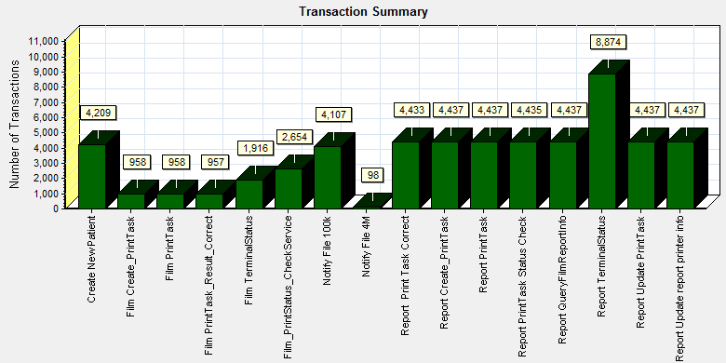

|  |  |  |
| --- | --- | --- |
| **Color** | **Scale** | **Measurement** |
|  | 1 | Pass |

E:\PerformanceResult\Phase3\Performance_20170815_2\Report\dot_trans.gif

|  |
| --- |
| **Description:**Displays the number of transactions that passed, failed, stopped, or ended with errors. |
|  |

|  |
| --- |
|  |
|  |

All transactions are passed during testing work.

### Transaction response time result (Service)

We can get the transaction response time information from the figure as follow:

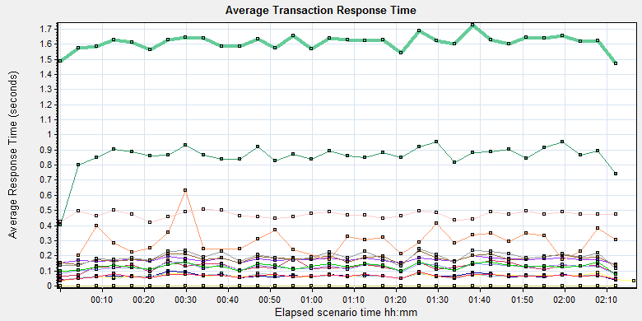

|  |  |  |  |  |  |  |  |  |  |  |  |  |  |  |  |  |  |  |  |  |  |  |  |  |  |  |  |  |  |  |  |  |  |  |  |  |  |  |  |  |  |  |  |  |  |  |  |  |  |  |  |  |  |  |  |  |  |  |  |  |  |  |  |  |  |  |  |  |  |  |  |  |  |  |  |  |  |  |  |  |  |  |  |  |  |  |  |  |  |  |  |  |  |  |  |  |  |  |  |  |  |  |  |  |  |  |  |  |  |  |  |  |  |  |  |  |  |  |  |  |  |  |  |  |  |  |  |  |  |  |  |  |  |  |  |  |
| --- | --- | --- | --- | --- | --- | --- | --- | --- | --- | --- | --- | --- | --- | --- | --- | --- | --- | --- | --- | --- | --- | --- | --- | --- | --- | --- | --- | --- | --- | --- | --- | --- | --- | --- | --- | --- | --- | --- | --- | --- | --- | --- | --- | --- | --- | --- | --- | --- | --- | --- | --- | --- | --- | --- | --- | --- | --- | --- | --- | --- | --- | --- | --- | --- | --- | --- | --- | --- | --- | --- | --- | --- | --- | --- | --- | --- | --- | --- | --- | --- | --- | --- | --- | --- | --- | --- | --- | --- | --- | --- | --- | --- | --- | --- | --- | --- | --- | --- | --- | --- | --- | --- | --- | --- | --- | --- | --- | --- | --- | --- | --- | --- | --- | --- | --- | --- | --- | --- | --- | --- | --- | --- | --- | --- | --- | --- | --- | --- | --- | --- | --- | --- | --- | --- | --- | --- |
| |  |  |  |  |  |  |  |  | | --- | --- | --- | --- | --- | --- | --- | --- | | **Color** | **Scale** | **Measurement** | **Graph's Minimum** | **Graph's Average** | **Graph's Maximum** | **Graph's Median** | **Graph's Std. Deviation** | |  | 1 | Create New Patient | 0.14 | 0.174 | 0.204 | 0.173 | 0.013 | |  | 1 | Film Create\_PrintTask | 0.401 | 0.857 | 0.952 | 0.868 | 0.093 | |  | 1 | Film PrintTask | 0.067 | 0.127 | 0.187 | 0.128 | 0.027 | |  | 1 | Film PrintTask\_Result\_Correct | 0 | 0 | 0 | 0 | 0 | |  | 1 | Film TerminalStatus | 0.038 | 0.067 | 0.1 | 0.065 | 0.013 | |  | 1 | Film\_PrintStatus\_CheckService | 0.037 | 0.066 | 0.083 | 0.067 | 0.01 | |  | 1 | Notify File 100k | 0.138 | 0.181 | 0.237 | 0.184 | 0.022 | |  | 1 | Notify File 4M | 0.176 | 0.305 | 0.632 | 0.303 | 0.089 | |  | 1 | Report Print Task Correct | 0 | 0 | 0 | 0 | 0 | |  | 1 | Report Create\_PrintTask | 0.422 | 0.472 | 0.508 | 0.473 | 0.022 | |  | 1 | Report PrintTask | 0.079 | 0.125 | 0.159 | 0.13 | 0.02 | |  | 1 | Report PrintTask Status Check | 0.033 | 0.065 | 0.088 | 0.065 | 0.013 | |  | 1 | Report QueryFilmReportInfo | 1.469 | 1.611 | 1.727 | 1.625 | 0.05 | |  | 1 | Report TerminalStatus | 0.039 | 0.066 | 0.092 | 0.068 | 0.011 | |  | 1 | Report Update PrintTask | 0.116 | 0.191 | 0.243 | 0.191 | 0.033 | |  | 1 | Report Update report printer info | 0.077 | 0.129 | 0.16 | 0.131 | 0.02 | |
|  |
|  |
| E:\PerformanceResult\Phase3\Performance_20170815_2\Report\dot_trans.gif |
|  |
| |  | | --- | | **Description:**Displays the average time taken to perform transactions during each second of the load test. This graph helps you determine whether the performance of the server is within acceptable minimum and maximum transaction performance time ranges defined for your system. | |

We can see that the transaction response time are all less than 3 seconds.

## Performance bottleneck analysis (Service)

### Hardware usage analysis

During the testing work, we use the test tool to monitor the server hardware usage include the CPU, Memory, hard disk and etc.

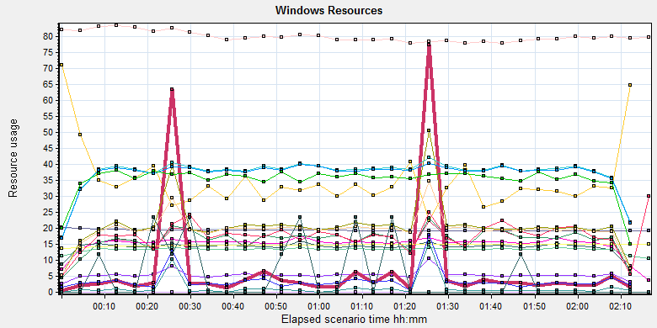

|  |
| --- |
|  |
|  |
|  |
| C:\Users\Administrator\Desktop\DK\Performance_20170722_2\Report\dot_trans.gif |
|  |
| |  | | --- | |  | |
| |  |  |  |  |  |  |  | | --- | --- | --- | --- | --- | --- | --- | | **Color** | **Scale** | **Measurement** | **Minimum** | **Average** | **Maximum** | **Std. Deviation** | |  | 10 | % Disk Read Time (PhysicalDisk \_Total):10.184.129.208 | 0 | 0.714 | 117.425 | 5.509 | |  | 0.1 | % Disk Time (PhysicalDisk \_Total):10.184.129.208 | 11.682 | 162.061 | 904.475 | 97.743 | |  | 0.1 | % Disk Write Time (PhysicalDisk \_Total):10.184.129.208 | 11.682 | 161.347 | 857.079 | 96.593 | |  | 1 | % Idle Time (PhysicalDisk \_Total):10.184.129.208 | 0 | 34.927 | 89.847 | 18.428 | |  | 0.1 | % Processor Time (Process sqlservr):10.184.129.208 | 20.313 | 151.775 | 495.855 | 52.54 | |  | 1 | % Processor Time (Process sqlwriter):10.184.129.208 | 0 | 0 | 0 | 0 | |  | 1 | % Processor Time (Processor \_Total):10.184.129.208 | 2.607 | 14.056 | 43.394 | 4.532 | |  | 0.001 | Available MBytes (Memory):10.184.129.208 | 19184 | 19396.715 | 20484 | 216.376 | |  | 0.0001 | Avg. Disk Bytes/Transfer (PhysicalDisk \_Total):10.184.129.208 | 4291.048 | 53740.213 | 529420.642 | 66717.67 | |  | 10 | Avg. Disk Queue Length (PhysicalDisk \_Total):10.184.129.208 | 0.117 | 1.621 | 9.045 | 0.977 | |  | 1000 | Avg. Disk Read Queue Length (PhysicalDisk \_Total):10.184.129.208 | 0 | 0.007 | 1.174 | 0.055 | |  | 1E-06 | Cache Bytes (Memory):10.184.129.208 | 75423744 | 79893911.042 | 85340160 | 1785088.332 | |  | 1E-09 | Committed Bytes (Memory):10.184.129.208 | 13367152640 | 14707264678.278 | 14996398080 | 304889175.989 | |  | 0.001 | Context Switches/sec (System):10.184.129.208 | 7649.336 | 13377.172 | 45956.292 | 2114.57 | |  | 10 | Current Disk Queue Length (PhysicalDisk \_Total):10.184.129.208 | 0 | 1.719 | 19 | 2.135 | |  | 1E-05 | Disk Bytes/sec (PhysicalDisk \_Total):10.184.129.208 | 24565.39 | 2079017.629 | 30193658.233 | 2942339.308 | |  | 1E-05 | Disk Read Bytes/sec (PhysicalDisk \_Total):10.184.129.208 | 0 | 137251.627 | 14628466.959 | 985466.17 | |  | 10 | Disk Reads/sec (PhysicalDisk \_Total):10.184.129.208 | 0 | 0.357 | 15.284 | 1.626 | |  | 1 | Disk Transfers/sec (PhysicalDisk \_Total):10.184.129.208 | 4.998 | 37.278 | 124.888 | 14.116 | |  | 1E-05 | Disk Write Bytes/sec (PhysicalDisk \_Total):10.184.129.208 | 24565.39 | 1941766.002 | 18587480.972 | 2398992.634 | |  | 1 | Disk Writes/sec (PhysicalDisk \_Total):10.184.129.208 | 4.998 | 36.921 | 120.599 | 13.913 | |  | 0.01 | Page Faults/sec (Memory):10.184.129.208 | 25.912 | 3499.91 | 24897.466 | 3633.484 | |  | 1000 | Processor Queue Length (System):10.184.129.208 | 0 | 0.005 | 2 | 0.086 |   C:\Users\Administrator\AppData\Local\Temp\Report\dot_trans.gif   |  | | --- | | **Description:**Displays a summary of the System Resources usage for each Windows based host. | |  | |

Follow this information we can get that:

The CPU usage do not exist bottleneck, the average process time is 14% and value is between 15% and 43%. The average value is less than 80%.The average process queue length is 0.005 and values are between 0 and 2, it less than 24(CPU count \* 2), so the CPU resource is enough.

The memory available value is 19.4G and the system use 1.3 G. The memory do not has bottleneck as current testing stress.

The disk transfer is 53740.213 Bytes every second, it less than the disk normal ability 20Mb/s.

The hardware do not exist the bottle neck.

### SQL Server resource usage analysis

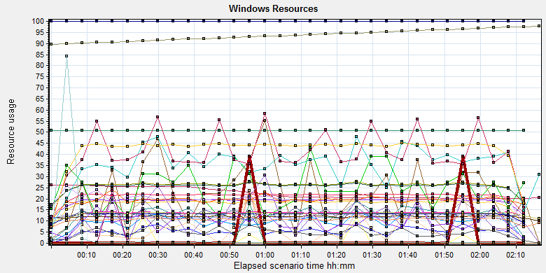

|  |  |  |  |  |  |  |  |  |  |  |  |  |  |  |  |  |  |  |  |  |  |  |  |  |  |  |  |  |  |  |  |  |  |  |  |  |  |  |  |  |  |  |  |  |  |  |  |  |  |  |  |  |  |  |  |  |  |  |  |  |  |  |  |  |  |  |  |  |  |  |  |  |  |  |  |  |  |  |  |  |  |  |  |  |  |  |  |  |  |  |  |  |  |  |  |  |  |  |  |  |  |  |  |  |  |  |  |  |  |  |  |  |  |  |  |  |  |  |  |  |  |  |  |  |  |  |  |  |  |  |  |  |  |  |  |  |  |  |  |  |  |  |  |  |  |  |  |  |  |  |  |  |  |  |  |  |  |  |  |  |  |  |  |  |  |  |  |  |  |  |  |  |  |  |  |  |  |  |  |  |  |  |  |  |  |  |  |  |  |  |  |  |  |  |  |  |  |  |  |  |  |  |  |  |  |  |  |  |  |  |  |  |  |  |  |  |  |  |  |  |  |  |  |  |  |  |  |  |  |  |  |  |  |  |  |  |  |  |  |  |  |  |  |  |  |  |  |  |  |  |  |  |  |  |  |  |  |  |  |  |  |  |  |  |  |  |  |  |  |  |  |  |  |  |  |  |  |  |  |  |  |  |  |  |  |  |  |  |  |  |  |  |  |  |  |  |  |  |  |  |  |  |  |  |  |  |  |  |  |  |  |  |  |  |  |
| --- | --- | --- | --- | --- | --- | --- | --- | --- | --- | --- | --- | --- | --- | --- | --- | --- | --- | --- | --- | --- | --- | --- | --- | --- | --- | --- | --- | --- | --- | --- | --- | --- | --- | --- | --- | --- | --- | --- | --- | --- | --- | --- | --- | --- | --- | --- | --- | --- | --- | --- | --- | --- | --- | --- | --- | --- | --- | --- | --- | --- | --- | --- | --- | --- | --- | --- | --- | --- | --- | --- | --- | --- | --- | --- | --- | --- | --- | --- | --- | --- | --- | --- | --- | --- | --- | --- | --- | --- | --- | --- | --- | --- | --- | --- | --- | --- | --- | --- | --- | --- | --- | --- | --- | --- | --- | --- | --- | --- | --- | --- | --- | --- | --- | --- | --- | --- | --- | --- | --- | --- | --- | --- | --- | --- | --- | --- | --- | --- | --- | --- | --- | --- | --- | --- | --- | --- | --- | --- | --- | --- | --- | --- | --- | --- | --- | --- | --- | --- | --- | --- | --- | --- | --- | --- | --- | --- | --- | --- | --- | --- | --- | --- | --- | --- | --- | --- | --- | --- | --- | --- | --- | --- | --- | --- | --- | --- | --- | --- | --- | --- | --- | --- | --- | --- | --- | --- | --- | --- | --- | --- | --- | --- | --- | --- | --- | --- | --- | --- | --- | --- | --- | --- | --- | --- | --- | --- | --- | --- | --- | --- | --- | --- | --- | --- | --- | --- | --- | --- | --- | --- | --- | --- | --- | --- | --- | --- | --- | --- | --- | --- | --- | --- | --- | --- | --- | --- | --- | --- | --- | --- | --- | --- | --- | --- | --- | --- | --- | --- | --- | --- | --- | --- | --- | --- | --- | --- | --- | --- | --- | --- | --- | --- | --- | --- | --- | --- | --- | --- | --- | --- | --- | --- | --- | --- | --- | --- | --- | --- | --- | --- | --- | --- | --- | --- | --- | --- | --- | --- | --- | --- | --- | --- | --- | --- | --- | --- | --- | --- | --- | --- | --- | --- | --- | --- | --- | --- | --- | --- | --- | --- | --- | --- | --- | --- | --- |
| |  |  |  |  |  |  |  | | --- | --- | --- | --- | --- | --- | --- | | **Color** | **Scale** | **Measurement** | **Minimum** | **Average** | **Maximum** | **Std. Deviation** | |  | 0.1 | Batch Requests/sec (MSSQL$GCPACSWS|SQL Statistics):10.184.129.208 | 77.426 | 189.108 | 298.049 | 36.953 | |  | 1 | Buffer cache hit ratio (MSSQL$GCPACSWS|Buffer Manager):10.184.129.208 | 99.999 | 100 | 100 | 0.001 | |  | 1 | Cache Hit Ratio (MSSQL$GCPACSWS|Catalog Metadata WGGC):10.184.129.208 | 50.779 | 50.788 | 50.797 | 0.005 | |  | 0.0001 | Cursor memory usage (MSSQL$GCPACSWS|Cursor Manager by Type \_Total):10.184.129.208 | 200096 | 225860.45 | 264312 | 24216.051 | |  | 10 | Cursor Requests/sec (MSSQL$GCPACSWS|Cursor Manager by Type \_Total):10.184.129.208 | 0 | 1.774 | 4.651 | 0.748 | |  | 1 | Database Cache Size (MB) (Database svchost):10.184.129.208 | 0 | 0 | 0 | 0 | |  | 100 | Distributed Query (MSSQL$GCPACSWS|Exec Statistics Average execution time (ms)):10.184.129.208 | 0 | 0.219 | 6 | 0.705 | |  | 1000 | Distributed Query (MSSQL$GCPACSWS|Exec Statistics Cumulative execution time (ms) per second):10.184.129.208 | 0 | 0.001 | 1 | 0.027 | |  | 1 | Distributed Query (MSSQL$GCPACSWS|Exec Statistics Execs in progress):10.184.129.208 | 0 | 0 | 0 | 0 | |  | 1E-16 | Distributed Query (MSSQL$GCPACSWS|Exec Statistics Execs started per second):10.184.129.208 | 0 | 1.35538163656941E+16 | 1.84467440737095E+19 | 4.99840050197998E+17 | |  | 10 | Errors/sec (MSSQL$GCPACSWS|SQL Errors \_Total):10.184.129.208 | 0 | 1.156 | 5.982 | 0.658 | |  | 1000 | Errors/sec (MSSQL$GCPACSWS|SQL Errors User Errors):10.184.129.208 | 0 | 0.001 | 0.664 | 0.02 | |  | 1 | Extended Procedures (MSSQL$GCPACSWS|Exec Statistics Average execution time (ms)):10.184.129.208 | 0 | 0 | 0 | 0 | |  | 0.1 | Full Scans/sec (MSSQL$GCPACSWS|Access Methods):10.184.129.208 | 14.327 | 211.888 | 475.483 | 117.652 | |  | 0.001 | Index Searches/sec (MSSQL$GCPACSWS|Access Methods):10.184.129.208 | 3043.855 | 14033.359 | 81715.35 | 10186.566 | |  | 1000 | Latch waits/sec (MSOLAP$GCPACSWS|Locks):10.184.129.208 | 0 | 0.025 | 0.665 | 0.089 | |  | 1 | Lazy writes/sec (MSSQL$GCPACSWS|Buffer Manager):10.184.129.208 | 0 | 0 | 0 | 0 | |  | 0.0001 | Lock Requests/sec (MSSQL$GCPACSWS|Locks \_Total):10.184.129.208 | 85570.448 | 258945.247 | 496774.486 | 55085.35 | |  | 10 | Lock Timeouts/sec (MSSQL$GCPACSWS|Locks \_Total):10.184.129.208 | 0 | 1.254 | 6.313 | 1.073 | |  | 0.1 | Lock Wait Time (ms) (MSSQL$GCPACSWS|Locks \_Total):10.184.129.208 | 0 | 54.586 | 5901.976 | 156.519 | |  | 1 | Lock waits (MSSQL$GCPACSWS|Wait Statistics Average wait time (ms)):10.184.129.208 | 0 | 35.233 | 176 | 25.178 | |  | 100 | Lock waits (MSSQL$GCPACSWS|Wait Statistics Waits in progress):10.184.129.208 | 0 | 0.055 | 6 | 0.287 | |  | 10 | Lock Waits/sec (MSSQL$GCPACSWS|Locks \_Total):10.184.129.208 | 0 | 0.95 | 5.649 | 0.901 | |  | 1 | Log write waits (MSSQL$GCPACSWS|Wait Statistics Average wait time (ms)):10.184.129.208 | 0 | 12.038 | 15 | 0.982 | |  | 0.1 | Logical Connections (MSSQL$GCPACSWS|General Statistics):10.184.129.208 | 93 | 135.573 | 148 | 9.019 | |  | 100 | Logins/sec (MSSQL$GCPACSWS|General Statistics):10.184.129.208 | 0 | 0.197 | 2.659 | 0.272 | |  | 100 | Logouts/sec (MSSQL$GCPACSWS|General Statistics):10.184.129.208 | 0 | 0.195 | 3.974 | 0.276 | |  | 1 | Lookups/sec (MSOLAP$GCPACSWS|Cache):10.184.129.208 | 0 | 0 | 0 | 0 | |  | 10000 | Number of Deadlocks/sec (MSSQL$GCPACSWS|Locks \_Total):10.184.129.208 | 0 | 0 | 0.332 | 0.009 | |  | 100 | OLEDB calls (MSSQL$GCPACSWS|Exec Statistics Average execution time (ms)):10.184.129.208 | 0 | 0.117 | 6 | 0.444 | |  | 1 | Page IO latch waits (MSSQL$GCPACSWS|Wait Statistics Average wait time (ms)):10.184.129.208 | 0 | 4.942 | 424 | 17.503 | |  | 1000 | Page latch waits (MSSQL$GCPACSWS|Wait Statistics Waits in progress):10.184.129.208 | 0 | 0.001 | 1 | 0.027 | |  | 0.001 | Page life expectancy (MSSQL$GCPACSWS|Buffer Manager):10.184.129.208 | 89530 | 93626.253 | 97723 | 2365.84 | |  | 0.0001 | Page lookups/sec (MSSQL$GCPACSWS|Buffer Manager):10.184.129.208 | 83929.015 | 255555.808 | 475770.878 | 55885.683 | |  | 10 | Page Reads/sec (Memory):10.184.129.208 | 0 | 1.297 | 32.996 | 4.775 | |  | 100 | Page reads/sec (MSSQL$GCPACSWS|Buffer Manager):10.184.129.208 | 0 | 0.097 | 3.655 | 0.377 | |  | 10 | Page Writes/sec (Memory):10.184.129.208 | 0 | 0.055 | 28.581 | 1.011 | |  | 10 | Page writes/sec (MSSQL$GCPACSWS|Buffer Manager):10.184.129.208 | 0 | 4.036 | 140.877 | 17.513 | |  | 10 | Safe Auto-Params/sec (MSSQL$GCPACSWS|SQL Statistics):10.184.129.208 | 0 | 4.177 | 10.296 | 1.617 | |  | 0.1 | SQL Compilations/sec (MSSQL$GCPACSWS|SQL Statistics):10.184.129.208 | 70.202 | 129.172 | 197.236 | 17.689 | |  | 100 | SQL Re-Compilations/sec (MSSQL$GCPACSWS|SQL Statistics):10.184.129.208 | 0 | 0.031 | 50.471 | 0.973 | |  | 1 | Total deadlocks detected (MSOLAP$GCPACSWS|Locks):10.184.129.208 | 0 | 0 | 0 | 0 | |  | 1 | Transactions (MSSQL$GCPACSWS|Transactions):10.184.129.208 | 6 | 10.698 | 42 | 3.698 | |  | 0.1 | User Connections (MSSQL$GCPACSWS|General Statistics):10.184.129.208 | 91 | 133.889 | 146 | 8.943 | |
|  |
|  |
| C:\Users\Administrator\AppData\Local\Temp\Report\dot_trans.gif |
|  |
| |  | | --- | | **Description:**Displays a summary of the System Resources usage for each Windows based host. | |  | |

Figure 7.6.2.1 Database result

Follow the SQL server monitor resource, we can find the Database has some issues that make the system performance not well:

There are cursors operations exist in the database:

Current version:

|  |  |  |  |  |  |  |
| --- | --- | --- | --- | --- | --- | --- |
|  | 0.0001 | Cursor memory usage (MSSQL$GCPACSWS|Cursor Manager by Type \_Total):10.184.129.208 | 200096 | 225860.45 | 264312 | 24216.051 |
|  | 10 | Cursor Requests/sec (MSSQL$GCPACSWS|Cursor Manager by Type \_Total):10.184.129.208 | 0 | 1.774 | 4.651 | 0.748 |

B08P02 version:

|  |  |  |  |  |  |  |
| --- | --- | --- | --- | --- | --- | --- |
|  | 0.0001 | Cursor memory usage (MSSQL$GCPACSWS|Cursor Manager by Type \_Total):10.184.129.208 | 118400 | 236222.503 | 594216 | 164195.345 |
|  | 10 | Cursor Requests/sec (MSSQL$GCPACSWS|Cursor Manager by Type \_Total):10.184.129.208 | 0 | 6.26 | 35.424 | 5.592 |

Database does the cursor operations every 1.774 seconds. SQL server suggests users to do the operation base on column data. Please indentify the SQL statement and do some enhance works. Compare with the B08P02 version, this issue has enhanced and has the good effected.

There are some error happens during the testing work:

Current version

|  |  |  |  |  |  |  |
| --- | --- | --- | --- | --- | --- | --- |
|  | 10 | Errors/sec (MSSQL$GCPACSWS|SQL Errors \_Total):10.184.129.208 | 0 | 1.156 | 5.982 | 0.658 |
|  | 1000 | Errors/sec (MSSQL$GCPACSWS|SQL Errors User Errors):10.184.129.208 | 0 | 0.001 | 0.664 | 0.02 |

B08P02 version:

|  |  |  |  |  |  |  |
| --- | --- | --- | --- | --- | --- | --- |
|  | 1 | Errors/sec (MSSQL$GCPACSWS|SQL Errors \_Total):10.184.129.208 | 0 | 10.861 | 99.83 | 4.017 |
|  | 10 | Errors/sec (MSSQL$GCPACSWS|SQL Errors User Errors):10.184.129.208 | 0 | 7.529 | 16.664 | 2.472 |

Database has 1.156 errors every second and 0.001 records are user errors. It maybe caused by the system or data base itself. Compare with B08P02 version, the numbers and frequency has reduced. It can accepted by the design.

There are too many full scans operations exist in the database:

Current version:

|  |  |  |  |  |  |  |
| --- | --- | --- | --- | --- | --- | --- |
|  | 0.1 | Full Scans/sec (MSSQL$GCPACSWS|Access Methods):10.184.129.208 | 14.327 | 211.888 | 475.483 | 117.652 |

B08P02 version:

|  |  |  |  |  |  |  |
| --- | --- | --- | --- | --- | --- | --- |
|  | 0.1 | Full Scans/sec (MSSQL$GCPACSWS|Access Methods):10.184.129.208 | 9.645 | 311.977 | 864.434 | 138.73 |

Database has full scans issues and average value is 211/sec. This issue will affect the SQL statement executes slowly because it does not use the index. Some operations will cause the full scans such as select count (\*), use <> and! =, use like fuzzy query, select from view etc. Please enhance the SQL statement performance ASAP.

There are very little locks and deadlocks issues exist in the database:

Current version:

|  |  |  |  |  |  |  |
| --- | --- | --- | --- | --- | --- | --- |
|  | 10 | Lock Timeouts/sec (MSSQL$GCPACSWS|Locks \_Total):10.184.129.208 | 0 | 1.254 | 6.313 | 1.073 |
|  | 0.1 | Lock Wait Time (ms) (MSSQL$GCPACSWS|Locks \_Total):10.184.129.208 | 0 | 54.586 | 5901.976 | 156.519 |
|  | 1 | Lock waits (MSSQL$GCPACSWS|Wait Statistics Average wait time (ms)):10.184.129.208 | 0 | 35.233 | 176 | 25.178 |
|  | 100 | Lock waits (MSSQL$GCPACSWS|Wait Statistics Waits in progress):10.184.129.208 | 0 | 0.055 | 6 | 0.287 |
|  | 10 | Lock Waits/sec (MSSQL$GCPACSWS|Locks \_Total):10.184.129.208 | 0 | 0.95 | 5.649 | 0.901 |
|  | 10000 | Number of Deadlocks/sec (MSSQL$GCPACSWS|Locks \_Total):10.184.129.208 | 0 | 0 | 0.332 | 0.009 |

B08P02 version:

|  |  |  |  |  |  |  |
| --- | --- | --- | --- | --- | --- | --- |
|  | 1 | Lock Timeouts/sec (MSSQL$GCPACSWS|Locks \_Total):10.184.129.208 | 0 | 25.839 | 130.898 | 23.282 |
|  | 0.001 | Lock Wait Time (ms) (MSSQL$GCPACSWS|Locks \_Total):10.184.129.208 | 0 | 35963.485 | 822942.765 | 63478.402 |
|  | 0.01 | Lock waits (MSSQL$GCPACSWS|Wait Statistics Average wait time (ms)):10.184.129.208 | 0 | 1311.452 | 14517 | 1588.782 |
|  | 1 | Lock waits (MSSQL$GCPACSWS|Wait Statistics Waits in progress):10.184.129.208 | 0 | 30.406 | 347 | 40.627 |
|  | 1 | Lock Waits/sec (MSSQL$GCPACSWS|Locks \_Total):10.184.129.208 | 0 | 16.622 | 133.582 | 19.992 |
|  | 10 | Number of Deadlocks/sec (MSSQL$GCPACSWS|Locks \_Total):10.184.129.208 | 0 | 1.11 | 9.554 | 1.648 |

We can see that the average lock waits time is 0.054 seconds and timeouts average value is 1.2 every second. There are 0.95 locks and 0 deadlocks every second. The database design is better than B08P02. During the testing works, the deadlocks numbers is almost 0.

## Test Conclusion

During the testing work, we use the new integration service which offered by the integration teams. But it also caused the transactions failed and deadlocks issues in database. The errors are like ‘cannot find the patient in RIS’ or ‘Some files are used by other processes’. We suggest the integration team use the log4net to organize the log module. It fixed the dead lock issues in database. But some transactions still failed caused by the integration service. We monitor the issue and change the index of table ‘T\_Integration\_ExamInfo’:

*USE [WGGC]*

*GO*

*/\*\*\*\*\*\* Object: Index [NonClusteredIndex-20170814-125818] Script Date: 2017/8/17 10:11:17 \*\*\*\*\*\*/*

*CREATE NONCLUSTERED INDEX [NonClusteredIndex-ACCN] ON [dbo].[T\_Integration\_ExamInfo]*

*(*

*[AccessionNumber] ASC*

*)WITH (PAD\_INDEX = OFF, STATISTICS\_NORECOMPUTE = OFF, SORT\_IN\_TEMPDB = OFF, DROP\_EXISTING = OFF, ONLINE = OFF, ALLOW\_ROW\_LOCKS = ON, ALLOW\_PAGE\_LOCKS = ON) ON [PRIMARY]*

*GO*

*USE [WGGC]*

*GO*

*/\*\*\*\*\*\* Object: Index [NonClusteredIndex-20170814-125842] Script Date: 2017/8/17 10:11:41 \*\*\*\*\*\*/*

*CREATE NONCLUSTERED INDEX [NonClusteredIndex-PID] ON [dbo].[T\_Integration\_ExamInfo]*

*(*

*[PatientID] ASC*

*)WITH (PAD\_INDEX = OFF, STATISTICS\_NORECOMPUTE = OFF, SORT\_IN\_TEMPDB = OFF, DROP\_EXISTING = OFF, ONLINE = OFF, ALLOW\_ROW\_LOCKS = ON, ALLOW\_PAGE\_LOCKS = ON) ON [PRIMARY]*

*GO*

*USE [WGGC]*

*GO*

*/\*\*\*\*\*\* Object: Index [NonClusteredIndex-20170814-125910] Script Date: 2017/8/17 10:11:55 \*\*\*\*\*\*/*

*CREATE NONCLUSTERED INDEX [NonClusteredIndex-Date\_Flag] ON [dbo].[T\_Integration\_ExamInfo]*

*(*

*[CreateDT] DESC,*

*[FilmPrintFlag] ASC,*

*[ReportPrintFlag] ASC*

*)WITH (PAD\_INDEX = OFF, STATISTICS\_NORECOMPUTE = OFF, SORT\_IN\_TEMPDB = OFF, DROP\_EXISTING = OFF, ONLINE = OFF, ALLOW\_ROW\_LOCKS = ON, ALLOW\_PAGE\_LOCKS = ON) ON [PRIMARY]*

*GO*

After the tuning works, the PS system performance has big enhanced and all transactions are passed.

We suggest the team to do some enhance works in the real client environment. Change the timeout value from default 30 seconds to 120 seconds for ABO connect object. The integration will meet a complex environment in the client. Some 3rd interface response will slowly for our query operations. We should define a timeout value to synchronize the request from integration and PS module to avoid the issues. The integration service performance needs to enhance except the concurrency ability. Now the PS performance risk is on the integration services.

In current testing works, the all transactions execute information as follows:

|  |  |  |  |
| --- | --- | --- | --- |
| Transactions | All | Pass | Failed |
| Report archived | 4205 | 4205 | 0 |
| Film print | 957 | 957 | 0 |
| Paper report print | 4433 | 4433 | 0 |

There are 4205 reports archived, print 957 films and 4433 paper reports printed during the 2.3 hours. We estimated the work time is 8 hours, so the PS can archive 14,626 reports, print 3,328 films and print 15,419 paper reports a day with the current settings.

Follow the test result and collect information, we can get the conclusion as follow:

During the current testing works, all transactions` service response time is less than 3 seconds. There is no deadlocks happened during the testing works. There is no bottle neck for hardware and software during the testing works. The test result meets the requirements.

The performance for Print service has great enhanced. The Developer team has made a great job on it.

# Testing work （Phase 6）

Test environment：We use the follow machine to do our performance testing work.

|  |  |  |  |  |  |  |  |  |  |  |  |
| --- | --- | --- | --- | --- | --- | --- | --- | --- | --- | --- | --- |
| **Server Name** | **Type** | **CPU** | | **Hard Disk** | | **RAM** | | **OS** | | **Required Software** | |
| PS Server | Hyper-v virtual machine | Intel Xeon E5-2620 v3 2.40GHz \*12 | 2T SCSI Disk  Seagate MD3002 | | 12G | | Windows 2012 R2 | | SQL 2008  IIS 7.5 | |
| QTP script machine | Hyper-v virtual machine | Intel Xeon E5-2403 v2 1.80GHz \*4 | 80G Virtual Disk | | 2.5G | | Windows 2012 R2 | | QTP 11 demo | |
| Performance control | Dell optiplex 9020 | Intel core(TM) i7-4790 3.6GHZ\*6 | 1T SATA Disk | | 8G | | Win7 64bit | | Load runner | |

Figure 1.1 Hardware List

## Strategy and Scenario Setting

1. Use automation tool simulate the doctor print film work. Simulate 8 GX Platform by using QTP and PDSender tool. Each client prints one film which size is 10MB every 30 seconds.(Two QTP client environment is not ready cause by the errors of server.)
2. Use LR tool simulate 8 K2/K3 terminals to print film. Each client prints one film which size is 10MB random 5 to 30 seconds.
3. Use LR tool simulate 45 PUMA terminals to print paper reports. Each client prints report random 5 to 30 seconds.
4. Use LR tool simulate 45 users to do PUMA report archive operations. Each client archive report in random 5 to 30 seconds and size is random with 100kb and 4Mb.
5. The OCR setting is not has rule for GX platforms in step1 and other setting are set as default. The OCR service will under the strong stress without configure the rule.
6. Monitor the transaction response time.
7. Monitor the hardware resource usage on PS.
8. Monitor the resource usage for database on PS.
9. Start/Stop 2 virtual users every 10 seconds and run the scenario for 2 hours.

## Background Data

We use SQL command statement to add large data in the database, the detail information as follow:

|  |  |
| --- | --- |
| **Table Name** | **Data Volume (records)** |
| printer.dbo.DeliveryJob | 1899813 |
| printer.dbo.ImageBox | 1997879 |
| printer.dbo.Page | 1997813 |
| printer.dbo.Session | 1701132 |
| wggc.dbo.Patient | 2029777 |
| wggc.dbo.Study | 2029789 |
| wggc.dbo.AFP\_PrintTerminalInfo | 162 |
| wggc.dbo.Series | 1029735 |
| wggc.dbo.Image | 1029738 |
| wggc.dbo.AFP\_FilmInfo | 1743592 |
| wggc.dbo.AFP\_ReportInfo | 1576761 |
| wggc.dbo.AFP\_ExamInfo | 2927005 |
| wggc.dbo.AFP\_PrintTask | 4396324 |
| wggc.dbo.T\_Integration\_ExamInfo | 159292 |
| AFP\_PrintMode | 185294 |
| wggc.dbo.vi\_KIOSK\_ExamInfo\_Order | 619331 |

Figure 8.2.1 Background Data

## Other Setting:

### Database setting

Memory: Set the min and max memory size to 4GB.

Index fill factor: 80.

File: Increase the data and log files size and the rule is increase 500Mb as fixed size.

### IIS setting

Connection: Keep the settings as default.

## Test Object version

KIOSK Platform 3.0.0.2 B14 upgrade from PandaB16P01 + New integration package + tuning works for Integration

## Test result

### Test Statistic Report

|  |  |
| --- | --- |
| Analysis Summary | Period: 2017/10/10 15:32 - 2017/10/10 17:51 |

|  |  |
| --- | --- |
| **Scenario Name:** | E:\ECS\Performance\Script\208\ScenarioPUMA\_Reliability\_171.lrs |
| **Results in Session:** | C:\Users\Administrator\AppData\Local\Temp\res\res.lrr |
| **Duration:** | 2 hours, 18 minutes and 5 seconds. |

|  |
| --- |
| Statistics Summary |

|  |  |  |
| --- | --- | --- |
| [**Maximum Running Vusers:**](file:///E:\PerformanceResult\Upgrade_20171010\VuserStateGraph) |  | 98 |
| [**Total Throughput (bytes):**](file:///E:\PerformanceResult\Upgrade_20171010\Throughput) | [Show SLA Results](slarules:total_throughput) | 56,236,749 |
| [**Average Throughput (bytes/second):**](file:///E:\PerformanceResult\Upgrade_20171010\Throughput) | [Show SLA Results](slarules:average_throughput) | 6,787 |
| [**Total Hits:**](file:///E:\PerformanceResult\Upgrade_20171010\HitsperSecond) | [Show SLA Results](slarules:total_hits) | 50,925 |
| [**Average Hits per Second:**](file:///E:\PerformanceResult\Upgrade_20171010\HitsperSecond) | [Show SLA Results](slarules:average_hits) | 6.146 | [**View HTTP Responses Summary**](file:///E:\PerformanceResult\Upgrade_20171010\Upgrade_20171010.html#1) |
| [**Total Errors:**](file:///E:\PerformanceResult\Upgrade_20171010\TotalErrorsPerSecond) | [Show SLA Results](slarules:errors_per_second) | 17 |  |

|  |  |  |
| --- | --- | --- |
| |  | | --- | | You can define SLA data using the [SLA configuration wizard](slaconfig:) | | You can analyze transaction behavior using the [Analyze Transaction mechanism](analyze:) | |

|  |
| --- |
| Transaction Summary |

|  |  |  |  |  |
| --- | --- | --- | --- | --- |
| [**Transactions:**](file:///E:\PerformanceResult\Upgrade_20171010\TransactionSummary) | Total Passed: 81,282 | Total Failed: 17 | Total Stopped: 0 | [**Average Response Time**](file:///E:\PerformanceResult\Upgrade_20171010\ResponseTime) |

|  |  |  |  |  |  |  |  |  |  |
| --- | --- | --- | --- | --- | --- | --- | --- | --- | --- |
| **Transaction Name** | **SLA Status** | **Minimum** | **Average** | **Maximum** | **Std. Deviation** | **90 Percent** | **Pass** | **Fail** | **Stop** |
| [Create New Patient](file:///E:\PerformanceResult\Upgrade_20171010\ResponseTime0000(Create%20New%20Patient)0000) | [Show SLA Results](slarules:transaction_response_time_CreateNewPatient) | 0.138 | 0.266 | 14.76 | 0.278 | 0.405 | 17,126 | 0 | 0 |
| [Film Create\_PrintTask](file:///E:\PerformanceResult\Upgrade_20171010\ResponseTime0000(Film%20Create_PrintTask)0000) | [Show SLA Results](slarules:transaction_response_time_FilmCreate_PrintTask) | 0.117 | 0.264 | 3.35 | 0.211 | 0.29 | 586 | 0 | 0 |
| [Film PrintTask](file:///E:\PerformanceResult\Upgrade_20171010\ResponseTime0000(Film%20PrintTask)0000) | [Show SLA Results](slarules:transaction_response_time_FilmPrintTask) | 0.067 | 0.164 | 2.792 | 0.21 | 0.305 | 586 | 0 | 0 |
| [Film PrintTask\_Result\_Correct](file:///E:\PerformanceResult\Upgrade_20171010\ResponseTime0000(Film%20PrintTask_Result_Correct)0000) | [Show SLA Results](slarules:transaction_response_time_FilmPrintTask_Result_Correct) | 0 | 0 | 0.001 | 0 | 0 | 579 | 0 | 0 |
| [Film PrintTask\_Result\_Fail](file:///E:\PerformanceResult\Upgrade_20171010\ResponseTime0000(Film%20PrintTask_Result_Fail)0000) | [Show SLA Results](slarules:transaction_response_time_FilmPrintTask_Result_Fail) | 0 | 0 | 0 | 0 | 0 | 0 | 7 | 0 |
| [Film TerminalStatus](file:///E:\PerformanceResult\Upgrade_20171010\ResponseTime0000(Film%20TerminalStatus)0000) | [Show SLA Results](slarules:transaction_response_time_FilmTerminalStatus) | 0.013 | 0.208 | 3.092 | 0.122 | 0.227 | 1,172 | 0 | 0 |
| [Film\_PrintStatus\_CheckService](file:///E:\PerformanceResult\Upgrade_20171010\ResponseTime0000(Film_PrintStatus_CheckService)0000) | [Show SLA Results](slarules:transaction_response_time_Film_PrintStatus_CheckService) | 0.014 | 0.187 | 2.763 | 0.17 | 0.239 | 3,962 | 0 | 0 |
| [Notify File 100k](file:///E:\PerformanceResult\Upgrade_20171010\ResponseTime0000(Notify%20File%20100k)0000) | [Show SLA Results](slarules:transaction_response_time_NotifyFile100k) | 0.083 | 0.482 | 24.777 | 1.078 | 0.625 | 16,789 | 2 | 0 |
| [Notify File 4M](file:///E:\PerformanceResult\Upgrade_20171010\ResponseTime0000(Notify%20File%204M)0000) | [Show SLA Results](slarules:transaction_response_time_NotifyFile4M) | 0.205 | 0.734 | 12.716 | 1.619 | 0.84 | 335 | 0 | 0 |
| [Report Print Task Correct](file:///E:\PerformanceResult\Upgrade_20171010\ResponseTime0000(Report%20%20Print%20Task%20Correct)0000) | [Show SLA Results](slarules:transaction_response_time_ReportPrintTaskCorrect) | 0 | 0 | 0.001 | 0 | 0 | 4,459 | 0 | 0 |
| [Report Create\_PrintTask](file:///E:\PerformanceResult\Upgrade_20171010\ResponseTime0000(Report%20Create_PrintTask)0000) | [Show SLA Results](slarules:transaction_response_time_ReportCreate_PrintTask) | 0.016 | 0.25 | 6.412 | 0.298 | 0.265 | 4,459 | 0 | 0 |
| [Report PrintTask](file:///E:\PerformanceResult\Upgrade_20171010\ResponseTime0000(Report%20PrintTask)0000) | [Show SLA Results](slarules:transaction_response_time_ReportPrintTask) | 0.054 | 0.174 | 7.76 | 0.28 | 0.303 | 4,459 | 0 | 0 |
| [Report PrintTask Status Check](file:///E:\PerformanceResult\Upgrade_20171010\ResponseTime0000(Report%20PrintTask%20Status%20Check)0000) | [Show SLA Results](slarules:transaction_response_time_ReportPrintTaskStatusCheck) | 0.035 | 0.17 | 8.746 | 0.245 | 0.202 | 4,459 | 0 | 0 |
| [Report QueryFilmReportInfo](file:///E:\PerformanceResult\Upgrade_20171010\ResponseTime0000(Report%20QueryFilmReportInfo)0000) | [Show SLA Results](slarules:transaction_response_time_ReportQueryFilmReportInfo) | 0.175 | 0.464 | 5.785 | 0.397 | 0.627 | 4,460 | 4 | 0 |
| [Report QueryFilmReportInfo Fail](file:///E:\PerformanceResult\Upgrade_20171010\ResponseTime0000(Report%20QueryFilmReportInfo%20Fail)0000) | [Show SLA Results](slarules:transaction_response_time_ReportQueryFilmReportInfoFail) | 0 | 0 | 0 | 0 | 0 | 0 | 4 | 0 |
| [Report TerminalStatus](file:///E:\PerformanceResult\Upgrade_20171010\ResponseTime0000(Report%20TerminalStatus)0000) | [Show SLA Results](slarules:transaction_response_time_ReportTerminalStatus) | 0.012 | 0.211 | 9.385 | 0.232 | 0.233 | 8,928 | 0 | 0 |
| [Report Update PrintTask](file:///E:\PerformanceResult\Upgrade_20171010\ResponseTime0000(Report%20Update%20PrintTask)0000) | [Show SLA Results](slarules:transaction_response_time_ReportUpdatePrintTask) | 0.05 | 0.196 | 6.505 | 0.323 | 0.315 | 4,459 | 0 | 0 |
| [Report Update report printer info](file:///E:\PerformanceResult\Upgrade_20171010\ResponseTime0000(Report%20Update%20report%20printer%20info)0000) | [Show SLA Results](slarules:transaction_response_time_ReportUpdatereportprinterinfo) | 0.203 | 0.442 | 6.559 | 0.227 | 0.421 | 4,464 | 0 | 0 |

|  |  |  |  |  |  |  |
| --- | --- | --- | --- | --- | --- | --- |
| **Service Level Agreement Legend:** | E:\PerformanceResult\Upgrade_20171010\led_ok.gif | Pass | E:\PerformanceResult\Upgrade_20171010\led_error.gif | Fail | E:\PerformanceResult\Upgrade_20171010\led_no_data.gif | No Data |

|  |
| --- |
| HTTP Responses Summary |

|  |  |  |
| --- | --- | --- |
| **HTTP Responses** | **Total** | **Per second** |
| [HTTP\_200](file:///E:\PerformanceResult\Upgrade_20171010\HttpReturnCodes0001(HTTP_200)0001) | 50,925 | 6.146 |

Follow the summary report we can get the result as follow: There are some transactions failed.

The Film PrintTask\_Result\_Failtransactions caused by the virtual film printer lost the network. It is not an error.

The [Report QueryFilmReportInfo](file:///E:\PerformanceResult\Upgrade_20171010\ResponseTime0000(Report%20QueryFilmReportInfo)0000) and [Report QueryFilmReportInfo Fail](file:///E:\PerformanceResult\Upgrade_20171010\ResponseTime0000(Report%20QueryFilmReportInfo%20Fail)0000) are caused by the test tool, it`s not errors.

The [Notify File 100k](file:///E:\PerformanceResult\Upgrade_20171010\ResponseTime0000(Notify%20File%20100k)0000) are caused by the test tool, it`s not errors.

### Transaction summary result (Service)

|  |
| --- |
|  |
| Transaction Summary Graph |
|  |
| |  |  |  | | --- | --- | --- | | **Color** | **Scale** | **Measurement** | |  | 1 | Pass | |  | 1 | Fail | |
|  |
|  |
| E:\PerformanceResult\Upgrade_20171010\Report\dot_trans.gif |
|  |
| |  | | --- | | **Description:**Displays the number of transactions that passed, failed, stopped, or ended with errors. | |
|  |
|  |
|  |

### Transaction response time result (Service)

We can get the transaction response time information from the figure as follow:

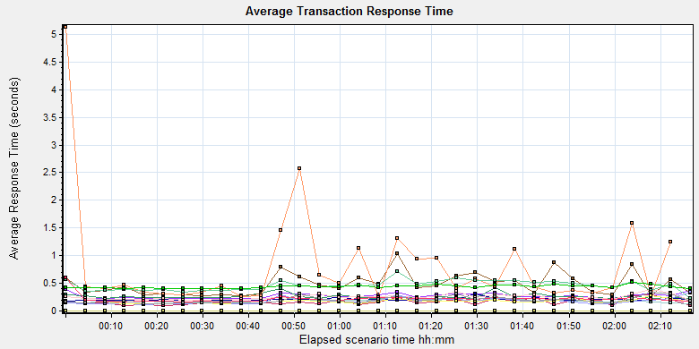

|  |  |  |  |  |  |  |  |
| --- | --- | --- | --- | --- | --- | --- | --- |
| **Color** | **Scale** | **Measurement** | **Graph's Minimum** | **Graph's Average** | **Graph's Maximum** | **Graph's Median** | **Graph's Std. Deviation** |
|  | 1 | Create New Patient | 0.223 | 0.272 | 0.392 | 0.262 | 0.045 |
|  | 1 | Film Create\_PrintTask | 0.219 | 0.263 | 0.426 | 0.249 | 0.047 |
|  | 1 | Film PrintTask | 0.101 | 0.162 | 0.293 | 0.146 | 0.051 |
|  | 1 | Film PrintTask\_Result\_Correct | 0 | 0 | 0 | 0 | 0 |
|  | 1 | Film TerminalStatus | 0.173 | 0.208 | 0.301 | 0.2 | 0.023 |
|  | 1 | Film\_PrintStatus\_CheckService | 0.122 | 0.184 | 0.274 | 0.182 | 0.032 |
|  | 1 | Notify File 100k | 0.271 | 0.482 | 1.041 | 0.441 | 0.197 |
|  | 1 | Notify File 4M | 0.264 | 0.812 | 5.129 | 0.431 | 0.928 |
|  | 1 | Report Print Task Correct | 0 | 0 | 0 | 0 | 0 |
|  | 1 | Report Create\_PrintTask | 0.187 | 0.251 | 0.382 | 0.244 | 0.046 |
|  | 1 | Report PrintTask | 0.118 | 0.179 | 0.343 | 0.165 | 0.052 |
|  | 1 | Report PrintTask Status Check | 0.127 | 0.171 | 0.271 | 0.165 | 0.034 |
|  | 1 | Report QueryFilmReportInfo | 0.234 | 0.46 | 0.712 | 0.458 | 0.094 |
|  | 1 | Report TerminalStatus | 0.16 | 0.219 | 0.595 | 0.209 | 0.072 |
|  | 1 | Report Update PrintTask | 0.132 | 0.197 | 0.346 | 0.177 | 0.056 |
|  | 1 | Report Update report printer info | 0.406 | 0.441 | 0.521 | 0.436 | 0.028 |

E:\PerformanceResult\Upgrade_20171010\Report\dot_trans.gif

|  |
| --- |
| **Description:**Displays the average time taken to perform transactions during each second of the load test. This graph helps you determine whether the performance of the server is within acceptable minimum and maximum transaction performance time ranges defined for your system. |
|  |

We can see that the transaction average response times are all less than 3 seconds.

## Performance bottleneck analysis (Service)

### Hardware usage analysis

During the testing work, we use the test tool to monitor the server hardware usage include the CPU, Memory, hard disk and etc.

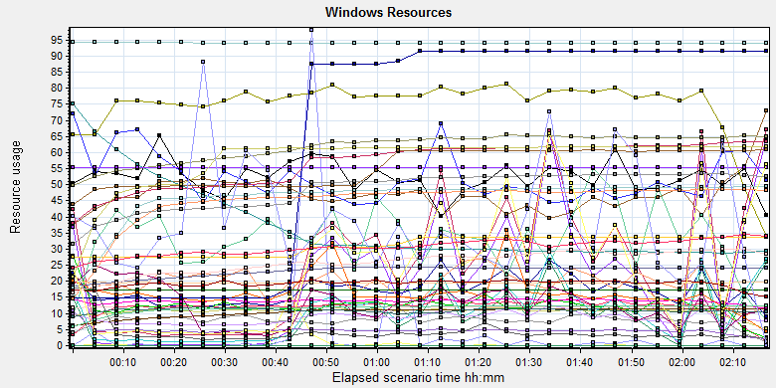

|  |  |  |  |  |  |  |  |  |  |  |  |  |  |  |  |  |  |  |  |  |  |  |  |  |  |  |  |  |  |  |  |  |  |  |  |  |  |  |  |  |  |  |  |  |  |  |  |  |  |  |  |  |  |  |  |  |  |  |  |  |  |  |  |  |  |  |  |  |  |  |  |  |  |  |  |  |  |  |  |  |  |  |  |  |  |  |  |  |  |  |  |  |  |  |  |  |  |  |  |  |  |  |  |  |  |  |  |  |  |  |  |  |  |  |  |  |  |  |  |  |  |  |  |  |  |  |  |  |  |  |  |  |  |  |  |  |  |  |  |  |  |  |  |  |  |  |  |  |  |  |  |  |  |  |  |  |  |  |  |  |  |  |  |  |  |  |  |  |  |  |  |  |  |  |  |  |  |  |  |  |  |  |  |  |  |  |  |  |  |  |  |  |  |  |  |  |  |  |  |  |  |  |  |  |  |  |  |  |  |  |  |  |  |  |  |  |  |  |  |  |  |  |  |  |  |  |  |  |  |  |  |  |  |  |  |  |  |  |  |  |  |  |  |  |  |  |  |  |  |  |  |  |  |  |  |  |  |  |  |  |  |  |  |  |  |  |  |  |  |  |  |  |  |  |  |  |  |  |  |  |  |  |  |  |  |  |  |  |  |  |  |  |  |  |  |  |  |  |  |  |  |  |  |  |  |  |  |  |  |  |  |  |  |  |  |  |  |  |  |  |  |  |  |  |  |  |  |  |  |  |  |  |  |  |  |  |  |  |  |  |  |  |  |  |  |  |  |  |  |  |  |  |  |  |  |  |  |
| --- | --- | --- | --- | --- | --- | --- | --- | --- | --- | --- | --- | --- | --- | --- | --- | --- | --- | --- | --- | --- | --- | --- | --- | --- | --- | --- | --- | --- | --- | --- | --- | --- | --- | --- | --- | --- | --- | --- | --- | --- | --- | --- | --- | --- | --- | --- | --- | --- | --- | --- | --- | --- | --- | --- | --- | --- | --- | --- | --- | --- | --- | --- | --- | --- | --- | --- | --- | --- | --- | --- | --- | --- | --- | --- | --- | --- | --- | --- | --- | --- | --- | --- | --- | --- | --- | --- | --- | --- | --- | --- | --- | --- | --- | --- | --- | --- | --- | --- | --- | --- | --- | --- | --- | --- | --- | --- | --- | --- | --- | --- | --- | --- | --- | --- | --- | --- | --- | --- | --- | --- | --- | --- | --- | --- | --- | --- | --- | --- | --- | --- | --- | --- | --- | --- | --- | --- | --- | --- | --- | --- | --- | --- | --- | --- | --- | --- | --- | --- | --- | --- | --- | --- | --- | --- | --- | --- | --- | --- | --- | --- | --- | --- | --- | --- | --- | --- | --- | --- | --- | --- | --- | --- | --- | --- | --- | --- | --- | --- | --- | --- | --- | --- | --- | --- | --- | --- | --- | --- | --- | --- | --- | --- | --- | --- | --- | --- | --- | --- | --- | --- | --- | --- | --- | --- | --- | --- | --- | --- | --- | --- | --- | --- | --- | --- | --- | --- | --- | --- | --- | --- | --- | --- | --- | --- | --- | --- | --- | --- | --- | --- | --- | --- | --- | --- | --- | --- | --- | --- | --- | --- | --- | --- | --- | --- | --- | --- | --- | --- | --- | --- | --- | --- | --- | --- | --- | --- | --- | --- | --- | --- | --- | --- | --- | --- | --- | --- | --- | --- | --- | --- | --- | --- | --- | --- | --- | --- | --- | --- | --- | --- | --- | --- | --- | --- | --- | --- | --- | --- | --- | --- | --- | --- | --- | --- | --- | --- | --- | --- | --- | --- | --- | --- | --- | --- | --- | --- | --- | --- | --- | --- | --- | --- | --- | --- | --- | --- | --- | --- | --- | --- | --- | --- | --- | --- | --- | --- | --- | --- | --- | --- | --- | --- | --- | --- | --- | --- | --- | --- | --- | --- | --- | --- | --- | --- | --- | --- | --- | --- | --- | --- | --- | --- | --- | --- | --- | --- | --- |
| |  |  |  |  |  |  |  | | --- | --- | --- | --- | --- | --- | --- | | **Color** | **Scale** | **Measurement** | **Minimum** | **Average** | **Maximum** | **Std. Deviation** | |  | 0.1 | % Disk Read Time (LogicalDisk \_Total):10.184.129.171 | 0 | 205.624 | 9560.274 | 969.917 | |  | 0.01 | % Disk Read Time (PhysicalDisk \_Total):10.184.129.171 | 0 | 829.405 | 38241.072 | 3892.089 | |  | 0.1 | % Disk Time (LogicalDisk \_Total):10.184.129.171 | 4.458 | 248.71 | 9814.922 | 1008.203 | |  | 0.01 | % Disk Time (PhysicalDisk \_Total):10.184.129.171 | 17.832 | 1002.636 | 39259.664 | 4048.202 | |  | 0.1 | % Disk Write Time (PhysicalDisk \_Total):10.184.129.171 | 17.832 | 173.231 | 1777.189 | 198.596 | |  | 1 | % Free Space (LogicalDisk \_Total):10.184.129.171 | 93.944 | 94.085 | 94.222 | 0.081 | |  | 1 | % Idle Time (PhysicalDisk \_Total):10.184.129.171 | 0 | 46.667 | 90.859 | 22.429 | |  | 1000 | % Interrupt Time (Processor \_Total):10.184.129.171 | 0 | 0.02 | 0.256 | 0.027 | |  | 10 | % Privileged Time (Processor \_Total):10.184.129.171 | 0.091 | 1.075 | 6.553 | 0.426 | |  | 0.01 | % Processor Time (Process \_Total):10.184.129.171 | 643.841 | 1195.477 | 1223.723 | 17.858 | |  | 100 | % Processor Time (Process w3wp#1):10.184.129.171 | 0 | 0.047 | 36.996 | 0.998 | |  | 10 | % Processor Time (Process w3wp#2):10.184.129.171 | 0 | 0.07 | 74.725 | 1.791 | |  | 100 | % Processor Time (Process w3wp#3):10.184.129.171 | 0 | 0.334 | 4.569 | 0.53 | |  | 1 | % Processor Time (Process w3wp#4):10.184.129.171 | 0 | 11.917 | 81.387 | 6.832 | |  | 10 | % Processor Time (Process w3wp#5):10.184.129.171 | 0 | 0.79 | 10.545 | 0.816 | |  | 10 | % Processor Time (Process w3wp#6):10.184.129.171 | 0 | 1.242 | 68.644 | 1.831 | |  | 100 | % Processor Time (Process w3wp):10.184.129.171 | 0 | 0.525 | 16.41 | 2.012 | |  | 10 | % Processor Time (Processor \_Total):10.184.129.171 | 1.199 | 7.531 | 50.833 | 2.522 | |  | 0.01 | Available MBytes (Memory):10.184.129.171 | 2839 | 3720.524 | 8274 | 1243.085 | |  | 0.001 | Avg. Disk Bytes/Transfer (PhysicalDisk \_Total):10.184.129.171 | 3259.733 | 52258.423 | 684568.381 | 44819.768 | |  | 1 | Avg. Disk Queue Length (PhysicalDisk \_Total):10.184.129.171 | 0.178 | 10.026 | 392.597 | 40.48 | |  | 0.001 | Bytes Total/sec (Server):10.184.129.171 | 17881.154 | 19570.145 | 28781.335 | 539.601 | |  | 1E-07 | Cache Bytes (Memory):10.184.129.171 | 44351488 | 116552601.886 | 131260416 | 13617276.906 | |  | 1E-09 | Committed Bytes (Memory):10.184.129.171 | 5327769600 | 10440952489.394 | 11610894336 | 1399020539.03 | |  | 0.001 | Context Switches/sec (System):10.184.129.171 | 4605.946 | 13860.898 | 78705.393 | 6982.548 | |  | 0.1 | Disk Transfers/sec (PhysicalDisk \_Total):10.184.129.171 | 10.499 | 85.823 | 577.616 | 82.907 | |  | 0.01 | File Data Operations/sec (System):10.184.129.171 | 39.263 | 1656.514 | 52443.094 | 2021.544 | |  | 1E-05 | Free Megabytes (LogicalDisk \_Total):10.184.129.171 | 1731573 | 1734163.94 | 1736690 | 1498.58 | |  | 0.01 | Interrupts/sec (Processor \_Total):10.184.129.171 | 732.078 | 1931.007 | 8251.324 | 914.298 | |  | 0.001 | Page Faults/sec (Memory):10.184.129.171 | 129.447 | 4769.948 | 110955.562 | 5152.005 | |  | 1 | Page Reads/sec (Memory):10.184.129.171 | 0 | 4.191 | 181.894 | 10.939 | |  | 0.1 | Pages/sec (Memory):10.184.129.171 | 0 | 128.323 | 2025.054 | 258.801 | |  | 1E-06 | Pool Nonpaged Bytes (Memory):10.184.129.171 | 44322816 | 61657517.45 | 67686400 | 4317365.88 | |  | 1E-05 | Pool Nonpaged Bytes (Server):10.184.129.171 | 750683 | 1096926.046 | 1251395 | 68293.853 | |  | 1E-07 | Pool Paged Bytes (Memory):10.184.129.171 | 181514240 | 231532230.979 | 245817344 | 16900843.646 | |  | 0.001 | Pool Paged Bytes (Server):10.184.129.171 | 55435 | 55435 | 55435 | 0 | |  | 1 | Pool Paged Failures (Server):10.184.129.171 | 0 | 0 | 0 | 0 | |  | 1E-08 | Private Bytes (Process \_Total):10.184.129.171 | 3325669376 | 5660648748.615 | 6439649280 | 698209414.718 | |  | 1E-07 | Private Bytes (Process w3wp#1):10.184.129.171 | 274776064 | 311153937.894 | 336584704 | 27765533.228 | |  | 1E-07 | Private Bytes (Process w3wp#2):10.184.129.171 | 148914176 | 649659452.123 | 914726912 | 357814448.536 | |  | 1E-07 | Private Bytes (Process w3wp#3):10.184.129.171 | 157216768 | 460102275.221 | 495480832 | 69375846.195 | |  | 1E-07 | Private Bytes (Process w3wp#4):10.184.129.171 | 388923392 | 554773155.668 | 615464960 | 58416416.946 | |  | 1E-07 | Private Bytes (Process w3wp#5):10.184.129.171 | 8626176 | 448783519.161 | 485842944 | 71730382.972 | |  | 1E-07 | Private Bytes (Process w3wp#6):10.184.129.171 | 8744960 | 582452547.343 | 619646976 | 79313367.653 | |  | 1E-07 | Private Bytes (Process w3wp):10.184.129.171 | 152399872 | 260128433.983 | 308379648 | 35568825.654 | |  | 100 | Processor Queue Length (System):10.184.129.171 | 0 | 0.388 | 19 | 1.269 | |  | 1 | Split IO/Sec (PhysicalDisk \_Total):10.184.129.171 | 0 | 23.685 | 541.311 | 83.89 | |  | 1E-07 | System Cache Resident Bytes (Memory):10.184.129.171 | 44351488 | 116552676.324 | 131256320 | 13616947.251 | |  | 0.01 | Threads (Objects):10.184.129.171 | 2220 | 3056.025 | 3647 | 242.579 | |  | 1E-08 | Working Set (Process \_Total):10.184.129.171 | 2833584128 | 4855718580.846 | 5427777536 | 590854555.311 | |
|  |
|  |
| E:\PerformanceResult\Upgrade_20171010\Report\dot_trans.gif |
|  |
| |  | | --- | | **Description:**Displays a summary of the System Resources usage for each Windows based host. | |

Follow this information we can get that:

The CPU usage do not exist bottleneck, the average process time is 7.5% and max value is 50%. The average value is less than 80%.The average process queue length is 0.388 and max value is 19, it less than 24(CPU count \* 2), so the CPU resource is enough.

The memory available value is 3.72G and the system use 5.4 G. The memory do not has bottleneck as current testing stress.

The disk transfer is 52258 Bytes every second, it less than the disk normal ability 20Mb/s.

The hardware do not exist the bottle neck.

### SQL Server resource usage analysis

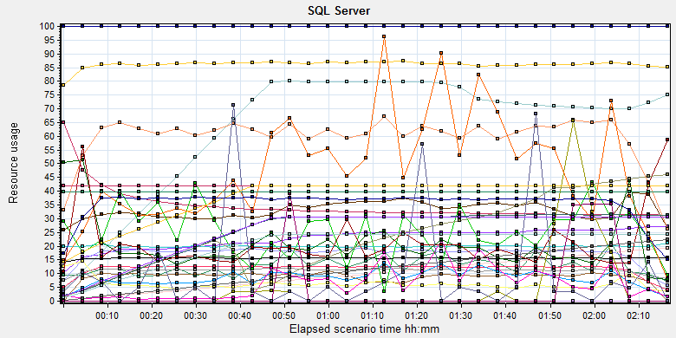

|  |  |  |  |  |  |  |  |  |  |  |  |  |  |  |  |  |  |  |  |  |  |  |  |  |  |  |  |  |  |  |  |  |  |  |  |  |  |  |  |  |  |  |  |  |  |  |  |  |  |  |  |  |  |  |  |  |  |  |  |  |  |  |  |  |  |  |  |  |  |  |  |  |  |  |  |  |  |  |  |  |  |  |  |  |  |  |  |  |  |  |  |  |  |  |  |  |  |  |  |  |  |  |  |  |  |  |  |  |  |  |  |  |  |  |  |  |  |  |  |  |  |  |  |  |  |  |  |  |  |  |  |  |  |  |  |  |  |  |  |  |  |  |  |  |  |  |  |  |  |  |  |  |  |  |  |  |  |  |  |  |  |  |  |  |  |  |  |  |  |  |  |  |  |  |  |  |  |  |  |  |  |  |  |  |  |  |  |  |  |  |  |  |  |  |  |  |  |  |  |  |  |  |  |  |  |  |  |  |  |  |  |  |  |  |  |  |  |  |  |  |  |  |  |  |  |  |  |  |  |  |  |  |  |  |  |  |  |  |  |  |  |  |  |  |  |  |  |  |  |  |  |  |  |  |  |  |  |  |  |  |  |  |  |  |  |  |  |  |  |  |  |  |  |  |  |  |  |  |  |  |  |  |  |  |  |  |  |  |  |  |  |  |  |  |
| --- | --- | --- | --- | --- | --- | --- | --- | --- | --- | --- | --- | --- | --- | --- | --- | --- | --- | --- | --- | --- | --- | --- | --- | --- | --- | --- | --- | --- | --- | --- | --- | --- | --- | --- | --- | --- | --- | --- | --- | --- | --- | --- | --- | --- | --- | --- | --- | --- | --- | --- | --- | --- | --- | --- | --- | --- | --- | --- | --- | --- | --- | --- | --- | --- | --- | --- | --- | --- | --- | --- | --- | --- | --- | --- | --- | --- | --- | --- | --- | --- | --- | --- | --- | --- | --- | --- | --- | --- | --- | --- | --- | --- | --- | --- | --- | --- | --- | --- | --- | --- | --- | --- | --- | --- | --- | --- | --- | --- | --- | --- | --- | --- | --- | --- | --- | --- | --- | --- | --- | --- | --- | --- | --- | --- | --- | --- | --- | --- | --- | --- | --- | --- | --- | --- | --- | --- | --- | --- | --- | --- | --- | --- | --- | --- | --- | --- | --- | --- | --- | --- | --- | --- | --- | --- | --- | --- | --- | --- | --- | --- | --- | --- | --- | --- | --- | --- | --- | --- | --- | --- | --- | --- | --- | --- | --- | --- | --- | --- | --- | --- | --- | --- | --- | --- | --- | --- | --- | --- | --- | --- | --- | --- | --- | --- | --- | --- | --- | --- | --- | --- | --- | --- | --- | --- | --- | --- | --- | --- | --- | --- | --- | --- | --- | --- | --- | --- | --- | --- | --- | --- | --- | --- | --- | --- | --- | --- | --- | --- | --- | --- | --- | --- | --- | --- | --- | --- | --- | --- | --- | --- | --- | --- | --- | --- | --- | --- | --- | --- | --- | --- | --- | --- | --- | --- | --- | --- | --- | --- | --- | --- | --- | --- | --- | --- | --- | --- | --- | --- | --- | --- | --- | --- | --- | --- | --- | --- | --- | --- | --- | --- | --- | --- | --- | --- | --- | --- | --- | --- | --- | --- | --- | --- | --- | --- |
| |  |  |  |  |  |  |  | | --- | --- | --- | --- | --- | --- | --- | | **Color** | **Scale** | **Measurement** | **Minimum** | **Average** | **Maximum** | **Std. Deviation** | |  | 1 | Active Temp Tables (MSSQL$GCPACSWS|General Statistics):10.184.129.171 | 0 | 22.767 | 27 | 3.911 | |  | 10 | Active Transactions (MSSQL$GCPACSWS|Databases \_Total):10.184.129.171 | 0 | 1.292 | 19 | 2.079 | |  | 1 | Buffer cache hit ratio (MSSQL$GCPACSWS|Buffer Manager):10.184.129.171 | 96.934 | 99.996 | 100 | 0.067 | |  | 1 | Cache Hit Ratio (MSSQL$GCPACSWS|Catalog Metadata \_Total):10.184.129.171 | 31.24 | 34.781 | 90.496 | 6.722 | |  | 1 | Cache Hit Ratio (MSSQL$GCPACSWS|Plan Cache \_Total):10.184.129.171 | 54.588 | 86.122 | 95.223 | 3.788 | |  | 0.1 | Cached Cursor Counts (MSSQL$GCPACSWS|Cursor Manager by Type \_Total):10.184.129.171 | 3 | 631.137 | 809 | 219.583 | |  | 1 | Checkpoint pages/sec (MSSQL$GCPACSWS|Buffer Manager):10.184.129.171 | 0 | 8.87 | 191.927 | 27.2 | |  | 0.01 | Connection Memory (KB) (MSSQL$GCPACSWS|Memory Manager):10.184.129.171 | 1648 | 3319.825 | 4640 | 371.862 | |  | 10 | CPU usage % (MSSQL$GCPACSWS|Workload Group Stats default):10.184.129.171 | 1.259 | 6.008 | 27.966 | 1.992 | |  | 1 | Current connections (MSOLAP$GCPACSWS|Connection):10.184.129.171 | 0 | 0 | 0 | 0 | |  | 0.0001 | Cursor memory usage (MSSQL$GCPACSWS|Cursor Manager by Type \_Total):10.184.129.171 | 392 | 97036.623 | 193232 | 55819.38 | |  | 10 | Cursor Requests/sec (MSSQL$GCPACSWS|Cursor Manager by Type \_Total):10.184.129.171 | 0 | 1.738 | 7.225 | 0.704 | |  | 10 | Errors/sec (MSSQL$GCPACSWS|SQL Errors \_Total):10.184.129.171 | 0 | 0.629 | 34.095 | 1.042 | |  | 1 | Failures/sec (MSOLAP$GCPACSWS|Connection):10.184.129.171 | 0 | 0 | 0 | 0 | |  | 0.1 | Full Scans/sec (MSSQL$GCPACSWS|Access Methods):10.184.129.171 | 1.431 | 118.997 | 295.677 | 37.928 | |  | 0.001 | Index Searches/sec (MSSQL$GCPACSWS|Access Methods):10.184.129.171 | 1180.531 | 11173.605 | 32388.83 | 6805.832 | |  | 1000 | Latch waits/sec (MSOLAP$GCPACSWS|Locks):10.184.129.171 | 0 | 0.025 | 0.467 | 0.078 | |  | 0.01 | Latch Waits/sec (MSSQL$GCPACSWS|Latches):10.184.129.171 | 763.769 | 1562.34 | 2300.155 | 202.341 | |  | 1000 | Lazy writes/sec (MSSQL$GCPACSWS|Buffer Manager):10.184.129.171 | 0 | 0.005 | 1.863 | 0.059 | |  | 1 | Lock denials/sec (MSOLAP$GCPACSWS|Locks):10.184.129.171 | 0 | 0 | 0 | 0 | |  | 100 | Lock grants/sec (MSOLAP$GCPACSWS|Locks):10.184.129.171 | 0 | 0.2 | 0.409 | 0.114 | |  | 100 | Lock requests/sec (MSOLAP$GCPACSWS|Locks):10.184.129.171 | 0 | 0.2 | 0.409 | 0.114 | |  | 1 | Lock Timeouts (timeout > 0)/sec (MSSQL$GCPACSWS|Locks \_Total):10.184.129.171 | 0 | 0 | 0 | 0 | |  | 10 | Lock Timeouts/sec (MSSQL$GCPACSWS|Locks \_Total):10.184.129.171 | 0 | 0.843 | 21.958 | 1.112 | |  | 0.1 | Lock Wait Time (ms) (MSSQL$GCPACSWS|Locks \_Total):10.184.129.171 | 0 | 65.381 | 6405.122 | 327.81 | |  | 1 | Lock waits/sec (MSOLAP$GCPACSWS|Locks):10.184.129.171 | 0 | 0 | 0 | 0 | |  | 100 | Lock Waits/sec (MSSQL$GCPACSWS|Locks \_Total):10.184.129.171 | 0 | 0.481 | 11.952 | 0.802 | |  | 100 | Logins/sec (MSSQL$GCPACSWS|General Statistics):10.184.129.171 | 0 | 0.209 | 16.931 | 0.477 | |  | 100 | Logouts/sec (MSSQL$GCPACSWS|General Statistics):10.184.129.171 | 0 | 0.205 | 14.16 | 0.531 | |  | 1E-05 | Max memory (KB) (MSSQL$GCPACSWS|Resource Pool Stats default):10.184.129.171 | 3984584 | 3984584 | 3984584 | 0 | |  | 0.01 | Number of active cursor plans (MSSQL$GCPACSWS|Cursor Manager by Type \_Total):10.184.129.171 | 4 | 1128.565 | 2245 | 648.103 | |  | 10000 | Number of Deadlocks/sec (MSSQL$GCPACSWS|Locks \_Total):10.184.129.171 | 0 | 0 | 0.258 | 0.01 | |  | 0.01 | Page life expectancy (MSSQL$GCPACSWS|Buffer Manager):10.184.129.171 | 5 | 2341.669 | 8487 | 1365.492 | |  | 0.001 | SQL Cache Memory (KB) (MSSQL$GCPACSWS|Memory Manager):10.184.129.171 | 1768 | 25367.21 | 31576 | 9196.247 | |  | 1000 | SQL Re-Compilations/sec (MSSQL$GCPACSWS|SQL Statistics):10.184.129.171 | 0 | 0.01 | 1.869 | 0.098 | |  | 0.0001 | Stolen pages (MSSQL$GCPACSWS|Buffer Manager):10.184.129.171 | 10295 | 252768.323 | 307575 | 87993.441 | |  | 1E-05 | Target memory (KB) (MSSQL$GCPACSWS|Resource Pool Stats default):10.184.129.171 | 3984584 | 3984584 | 3984584 | 0 | |  | 1E-05 | Target Server Memory (KB) (MSSQL$GCPACSWS|Memory Manager):10.184.129.171 | 4194304 | 4194304 | 4194304 | 0 | |  | 1E-05 | Total Server Memory (KB) (MSSQL$GCPACSWS|Memory Manager):10.184.129.171 | 702336 | 3739522.949 | 4194304 | 806292.64 | |  | 0.1 | Transactions/sec (MSSQL$GCPACSWS|Databases \_Total):10.184.129.171 | 30.216 | 356.038 | 694.142 | 73.91 | |  | 1E-05 | Used memory (KB) (MSSQL$GCPACSWS|Resource Pool Stats default):10.184.129.171 | 70104 | 2001880.828 | 2438928 | 702815.893 | |
|  |
|  |
| E:\PerformanceResult\Upgrade_20171010\Report\dot_trans.gif |
|  |
| |  | | --- | | **Description:**Displays a summary of SQL Server Resources. | |

Figure 8.6.2.1 Database result

Follow the SQL server monitor resource, we can find the Database has some issues that make the system performance not well:

There are cursors operations exist in the database:

|  |  |  |  |  |  |  |
| --- | --- | --- | --- | --- | --- | --- |
|  | 10 | Cursor Requests/sec (MSSQL$GCPACSWS|Cursor Manager by Type \_Total):10.184.129.171 | 0 | 1.738 | 7.225 | 0.704 |
|  | 0.0001 | Cursor memory usage (MSSQL$GCPACSWS|Cursor Manager by Type \_Total):10.184.129.171 | 392 | 97036.623 | 193232 | 55819.38 |

Database does the cursor operations every 1.738 seconds. SQL server suggests users to do the operation base on column data. Please indentify the SQL statement and do some enhance works.

There are some error happens during the testing work:

|  |  |  |  |  |  |  |
| --- | --- | --- | --- | --- | --- | --- |
|  | 10 | Errors/sec (MSSQL$GCPACSWS|SQL Errors \_Total):10.184.129.171 | 0 | 0.629 | 34.095 | 1.042 |

Database has 0.629 errors every second. It may be caused by the system or data base itself.

There are too many full scans operations exist in the database:

|  |  |  |  |  |  |  |
| --- | --- | --- | --- | --- | --- | --- |
|  | 0.1 | Full Scans/sec (MSSQL$GCPACSWS|Access Methods):10.184.129.171 | 1.431 | 118.997 | 295.677 | 37.928 |

Database has full scans issues and average value is 211/sec. This issue will affect the SQL statement executes slowly because it does not use the index. Some operations will cause the full scans such as select count (\*), use <> and! =, use like fuzzy query, select from view etc. Please enhance the SQL statement performance ASAP.

There are very little locks issues exist in the database:

|  |  |  |  |  |  |  |
| --- | --- | --- | --- | --- | --- | --- |
|  | 1000 | Latch waits/sec (MSOLAP$GCPACSWS|Locks):10.184.129.171 | 0 | 0.025 | 0.467 | 0.078 |
|  | 0.01 | Latch Waits/sec (MSSQL$GCPACSWS|Latches):10.184.129.171 | 763.769 | 1562.34 | 2300.155 | 202.341 |
|  | 1000 | Lazy writes/sec (MSSQL$GCPACSWS|Buffer Manager):10.184.129.171 | 0 | 0.005 | 1.863 | 0.059 |
|  | 1 | Lock denials/sec (MSOLAP$GCPACSWS|Locks):10.184.129.171 | 0 | 0 | 0 | 0 |
|  | 100 | Lock grants/sec (MSOLAP$GCPACSWS|Locks):10.184.129.171 | 0 | 0.2 | 0.409 | 0.114 |
|  | 100 | Lock requests/sec (MSOLAP$GCPACSWS|Locks):10.184.129.171 | 0 | 0.2 | 0.409 | 0.114 |
|  | 1 | Lock Timeouts (timeout > 0)/sec (MSSQL$GCPACSWS|Locks \_Total):10.184.129.171 | 0 | 0 | 0 | 0 |
|  | 10 | Lock Timeouts/sec (MSSQL$GCPACSWS|Locks \_Total):10.184.129.171 | 0 | 0.843 | 21.958 | 1.112 |
|  | 0.1 | Lock Wait Time (ms) (MSSQL$GCPACSWS|Locks \_Total):10.184.129.171 | 0 | 65.381 | 6405.122 | 327.81 |
|  | 1 | Lock waits/sec (MSOLAP$GCPACSWS|Locks):10.184.129.171 | 0 | 0 | 0 | 0 |
|  | 100 | Lock Waits/sec (MSSQL$GCPACSWS|Locks \_Total):10.184.129.171 | 0 | 0.481 | 11.952 | 0.802 |
|  | 10000 | Number of Deadlocks/sec (MSSQL$GCPACSWS|Locks \_Total):10.184.129.171 | 0 | 0 | 0.258 | 0.01 |

We can see that the average lock waits time is 0.065 seconds and timeouts average value is 0.8 every second.

The SQL server cache usage is low:

|  |  |  |  |  |  |  |
| --- | --- | --- | --- | --- | --- | --- |
|  | 1 | Buffer cache hit ratio (MSSQL$GCPACSWS|Buffer Manager):10.184.129.171 | 96.934 | 99.996 | 100 | 0.067 |
|  | 1 | Cache Hit Ratio (MSSQL$GCPACSWS|Catalog Metadata \_Total):10.184.129.171 | 31.24 | 34.781 | 90.496 | 6.722 |
|  | 1 | Cache Hit Ratio (MSSQL$GCPACSWS|Plan Cache \_Total):10.184.129.171 | 54.588 | 86.122 | 95.223 | 3.788 |

The meta data cache hit ratio is only 34% and plan cache plan is only 86%. Some SQL statement is do not use the cached execute plan and recompiles.

## Test Conclusion

During the testing work, we find that the PS system has the ability to process the main workflow under the strong stress. The almost transactions can passed very well. But we find that there are some errors will caused the transaction failed such as: expand the second level information in worklist, some operations in statistic module, query information from QC log.

If we do these operations, the systems will popup 500 errors which is the inner errors from EntityCommandExcutionExceptions. The performance of SQL statement which executed by this framework is low. When these errors happened, it will make other web service failed.

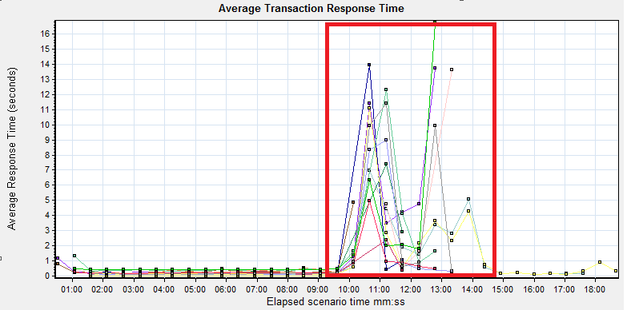

Follow the picture, we can see when the error happens, the transactions response time will increase and some of them will fail.

QA team has submitted the defect for these issues and list the operations which will cause them. Team need fixed the issues as soon as fast.

# Testing work （Phase 7）

We find some issues exist in testing work phase6. We plan to do the same testing work in different test environment. In phase6, we use the low configuration hardware which memory is 12GB and software is upgrade from panda system. In this phase, we will use the puma standard hardware and independent install version. We will focus the result that whether the same issue exists in the independent or not.

Test environment：We use the follow machine to do our performance testing work.

|  |  |  |  |  |  |  |  |  |  |  |  |
| --- | --- | --- | --- | --- | --- | --- | --- | --- | --- | --- | --- |
| **Server Name** | **Type** | **CPU** | | **Hard Disk** | | **RAM** | | **OS** | | **Required Software** | |
| PS Server | Hyper-v virtual machine | Intel Xeon E5-2620 v3 2.40GHz \*12 | 2T SCSI Disk  Seagate MD3002 | | 12G | | Windows 2012 R2 | | SQL 2008  IIS 7.5 | |
| QTP script machine | Hyper-v virtual machine | Intel Xeon E5-2403 v2 1.80GHz \*4 | 80G Virtual Disk | | 2.5G | | Windows 2012 R2 | | QTP 11 demo | |
| Performance control | Dell optiplex 9020 | Intel core(TM) i7-4790 3.6GHZ\*6 | 1T SATA Disk | | 8G | | Win7 64bit | | Load runner | |

Figure 1.1 Hardware List

## Strategy and Scenario Setting

1. Use automation tool simulate the doctor print film work. Simulate 8 GX Platform by using QTP and PDSender tool. Each client prints one film which size is 10MB every 30 seconds.(Two QTP client environment is not ready cause by the errors of server.)
2. Use LR tool simulate 8 K2/K3 terminals to print film. Each client prints one film which size is 10MB random 5 to 30 seconds.
3. Use LR tool simulate 45 PUMA terminals to print paper reports. Each client prints report random 5 to 30 seconds.
4. Use LR tool simulate 45 users to do PUMA report archive operations. Each client archive report in random 5 to 30 seconds and size is random with 100kb and 4Mb.
5. The OCR setting is not has rule for GX platforms in step1 and other setting are set as default. The OCR service will under the strong stress without configure the rule.
6. Monitor the transaction response time.
7. Monitor the hardware resource usage on PS.
8. Monitor the resource usage for database on PS.
9. Start/Stop 2 virtual users every 10 seconds and run the scenario for 2 hours.

## Background Data

We use SQL command statement to add large data in the database, the detail information as follow:

|  |  |
| --- | --- |
| **Table Name** | **Data Volume (records)** |
| printer.dbo.DeliveryJob | 1899813 |
| printer.dbo.ImageBox | 1997879 |
| printer.dbo.Page | 1997813 |
| printer.dbo.Session | 1701132 |
| wggc.dbo.Patient | 2029777 |
| wggc.dbo.Study | 2029789 |
| wggc.dbo.AFP\_PrintTerminalInfo | 162 |
| wggc.dbo.Series | 1029735 |
| wggc.dbo.Image | 1029738 |
| wggc.dbo.AFP\_FilmInfo | 1743592 |
| wggc.dbo.AFP\_ReportInfo | 1576761 |
| wggc.dbo.AFP\_ExamInfo | 2927005 |
| wggc.dbo.AFP\_PrintTask | 4396324 |
| wggc.dbo.T\_Integration\_ExamInfo | 159292 |
| AFP\_PrintMode | 185294 |
| wggc.dbo.vi\_KIOSK\_ExamInfo\_Order | 619331 |

Figure 9.2.1 Background Data

## Other Setting:

### Database setting

Memory: Set the min and max memory size to 8GB.

Index fill factor: 80.

File: Increase the data and log files size and the rule is increase 500Mb as fixed size.

### IIS setting

Connection: Keep the settings as default.

## Test Object version

KIOSK Platform 3.0.0.2 B15+ New integration package + tuning works for Integration

## Test result

### Test Statistic Report

|  |
| --- |
| The issues “100042973”still exist in the system. The result is same as phase 6. |

### Transaction summary result (Service)

|  |
| --- |
|  |
|  |
|  |
| The issues “100042973”still exist in the system. The result is same as phase 6. |
|  |
|  |
|  |

### Transaction response time result (Service)

|  |
| --- |
| The issues “100042973”still exist in the system. The result is same as phase 6. |

## Performance bottleneck analysis (Service)

|  |
| --- |
| The issues “100042973”still exist in the system. The result is same as phase 6. |

### Hardware usage analysis

|  |
| --- |
| The issues “100042973”still exist in the system. The result is same as phase 6. |

### SQL Server resource usage analysis

|  |
| --- |
| The issues “100042973”still exist in the system. The result is same as phase 6. |

## Test Conclusion

We find some issues happened in phase6 testing works:

*There are some errors will caused the transaction failed such as: expand the second level information in worklist, some operations in statistic module, query information from QC log. If we do these operations, the systems will popup 500 errors which is the inner errors from EntityCommandExcutionExceptions. The performance of SQL statement which executed by this framework*

In last testing works, the PUMA system is upgrade from PANDA and the hardware is low configuration. The SQL server max memory is only 4GB.

We plan to do the same testing work to verify whether the issues exist in the high configuration and new version PUMA system.

Follow the testing work, we find that the issues still exist in the system. QA team record and submit a defect in QC which id is “100042973”. From the test result, we get that this issue is not caused by hardware and SQL server configuration. The root reason is the workflow from Entity framework. The SQL statements which transform it will caused the SQL do not use the index and lock some main workflow table. Develop team should monitor the issue and fix it as soon as possible.

# Testing work （Phase 8）

Test environment：We use the follow machine to do our performance testing work.

|  |  |  |  |  |  |  |  |  |  |  |  |
| --- | --- | --- | --- | --- | --- | --- | --- | --- | --- | --- | --- |
| **Server Name** | **Type** | **CPU** | | **Hard Disk** | | **RAM** | | **OS** | | **Required Software** | |
| PS Server | Hyper-v virtual machine | Intel Xeon E5-2620 v3 2.40GHz \*12 | 2T SCSI Disk  Seagate MD3002 | | 12G | | Windows 2012 R2 | | SQL 2008  IIS 7.5 | |
| QTP script machine | Hyper-v virtual machine | Intel Xeon E5-2403 v2 1.80GHz \*4 | 80G Virtual Disk | | 2.5G | | Windows 2012 R2 | | QTP 11 demo | |
| Performance control | Dell optiplex 9020 | Intel core(TM) i7-4790 3.6GHZ\*6 | 1T SATA Disk | | 8G | | Win7 64bit | | Load runner | |

Figure 1.1 Hardware List

## Strategy and Scenario Setting

1. Use automation tool simulate the doctor print film work. Simulate 6 GX Platform by using QTP and PDSender tool. Each client prints one film which size is 10MB every 30 seconds.(Two QTP client environment is not ready cause by the errors of server.)
2. Use LR tool simulate 8 K2/K3 terminals to print film. Each client prints one film which size is 10MB random 5 to 30 seconds.
3. Use LR tool simulate 45 PUMA terminals to print paper reports. Each client prints report random 5 to 30 seconds.
4. Use LR tool simulate 45 users to do PUMA report archive operations. Each client archive report in random 5 to 30 seconds and size is random with 100kb and 4Mb.
5. The OCR setting is not has rule for GX platforms in step1 and other setting are set as default. The OCR service will under the strong stress without configure the rule.
6. Simulate 20 users to do the query information, view monitor page, query reconciliation films and report, expand the record, change the status, set holding time and other operations in worklist.
7. Simulate 1 user to do the statistic operations with latest month data in web. The operations will execute every 110 seconds.
8. Monitor the transaction response time.
9. Monitor the hardware resource usage on PS.
10. Monitor the resource usage for database on PS.
11. Start/Stop 2 virtual users every 10 seconds and run the scenario for 2 hours.

## Background Data

We use SQL command statement to add large data in the database, the detail information as follow:

|  |  |
| --- | --- |
| **Table Name** | **Data Volume (records)** |
| printer.dbo.DeliveryJob | 1999813 |
| printer.dbo.ImageBox | 1997879 |
| printer.dbo.Page | 1997813 |
| printer.dbo.Session | 1901132 |
| wggc.dbo.Patient | 2229777 |
| wggc.dbo.Study | 2229789 |
| wggc.dbo.AFP\_PrintTerminalInfo | 162 |
| wggc.dbo.Series | 1129735 |
| wggc.dbo.Image | 1129738 |
| wggc.dbo.AFP\_FilmInfo | 1843592 |
| wggc.dbo.AFP\_ReportInfo | 1676761 |
| wggc.dbo.AFP\_ExamInfo | 2957005 |
| wggc.dbo.AFP\_PrintTask | 4496324 |
| wggc.dbo.T\_Integration\_ExamInfo | 169292 |
| AFP\_PrintMode | 195294 |
| wggc.dbo.vi\_KIOSK\_ExamInfo\_Order | 629331 |

Figure 10.2.1 Background Data

## Other Setting:

### Database setting

Memory: Set the min and max memory size to 8GB.

Index fill factor: 80.

File: Increase the data and log files size and the rule is increase 200Mb as fixed size.

### IIS setting

Connection: Keep the settings as default.

## Test Object version

KIOSK Platform 3.0.0.2 B18P02 upgrade from PandaB16P081+ New integration package + tuning works for Integration + Stop the monitor and alarm service.

## Test result

### Test Statistic Report - PS

|  |  |
| --- | --- |
| Analysis Summary | Period: 2018/1/10 20:17 - 2018/1/10 22:50 |

|  |  |
| --- | --- |
| **Scenario Name:** | E:\ECS\Performance\Script\208\ScenarioPUMA\_Reliability\_171.lrs |
| **Results in Session:** | c:\Users\Administrator\AppData\Local\Temp\res1\res1.lrr |
| **Duration:** | 2 hours, 32 minutes and 59 seconds. |

|  |
| --- |
| Statistics Summary |

|  |  |  |
| --- | --- | --- |
| [**Maximum Running Vusers:**](file:///\\10.184.129.235\puma\Team\Ralf\Performance\Report\PerformanceResult\Phase8_20180111_1\VuserStateGraph) |  | 98 |
| [**Total Throughput (bytes):**](file:///\\10.184.129.235\puma\Team\Ralf\Performance\Report\PerformanceResult\Phase8_20180111_1\Throughput) | [Show SLA Results](slarules:total_throughput) | 60,954,327 |
| [**Average Throughput (bytes/second):**](file:///\\10.184.129.235\puma\Team\Ralf\Performance\Report\PerformanceResult\Phase8_20180111_1\Throughput) | [Show SLA Results](slarules:average_throughput) | 6,640 |
| [**Total Hits:**](file:///\\10.184.129.235\puma\Team\Ralf\Performance\Report\PerformanceResult\Phase8_20180111_1\HitsperSecond) | [Show SLA Results](slarules:total_hits) | 53,013 |
| [**Average Hits per Second:**](file:///\\10.184.129.235\puma\Team\Ralf\Performance\Report\PerformanceResult\Phase8_20180111_1\HitsperSecond) | [Show SLA Results](slarules:average_hits) | 5.775 | [**View HTTP Responses Summary**](file:///\\10.184.129.235\puma\Team\Ralf\Performance\Report\PerformanceResult\Phase8_20180111_1\Phase9_20180111_1.html#1) |

|  |  |  |
| --- | --- | --- |
| |  | | --- | | You can define SLA data using the [SLA configuration wizard](slaconfig:) | | You can analyze transaction behavior using the [Analyze Transaction mechanism](analyze:) | |

|  |
| --- |
| Transaction Summary |

|  |  |  |  |  |
| --- | --- | --- | --- | --- |
| [**Transactions:**](file:///\\10.184.129.235\puma\Team\Ralf\Performance\Report\PerformanceResult\Phase8_20180111_1\TransactionSummary) | Total Passed: 62,535 | Total Failed: 0 | Total Stopped: 1 | [**Average Response Time**](file:///\\10.184.129.235\puma\Team\Ralf\Performance\Report\PerformanceResult\Phase8_20180111_1\ResponseTime) |

|  |  |  |  |  |  |  |  |  |  |
| --- | --- | --- | --- | --- | --- | --- | --- | --- | --- |
| **Transaction Name** | **SLA Status** | **Minimum** | **Average** | **Maximum** | **Std. Deviation** | **90 Percent** | **Pass** | **Fail** | **Stop** |
| [Create New Patient](file:///\\10.184.129.235\puma\Team\Ralf\Performance\Report\PerformanceResult\Phase8_20180111_1\ResponseTime0000(Create%20New%20Patient)0000) | [Show SLA Results](slarules:transaction_response_time_CreateNewPatient) | 0.153 | 0.455 | 9.345 | 0.278 | 0.607 | 4,438 | 0 | 0 |
| [Film Create\_PrintTask](file:///\\10.184.129.235\puma\Team\Ralf\Performance\Report\PerformanceResult\Phase8_20180111_1\ResponseTime0000(Film%20Create_PrintTask)0000) | [Show SLA Results](slarules:transaction_response_time_FilmCreate_PrintTask) | 0.656 | 1.148 | 2.328 | 0.291 | 1.531 | 648 | 0 | 0 |
| [Film PrintTask](file:///\\10.184.129.235\puma\Team\Ralf\Performance\Report\PerformanceResult\Phase8_20180111_1\ResponseTime0000(Film%20PrintTask)0000) | [Show SLA Results](slarules:transaction_response_time_FilmPrintTask) | 0.065 | 0.218 | 1.033 | 0.073 | 0.218 | 648 | 0 | 0 |
| [Film PrintTask\_Result\_Correct](file:///\\10.184.129.235\puma\Team\Ralf\Performance\Report\PerformanceResult\Phase8_20180111_1\ResponseTime0000(Film%20PrintTask_Result_Correct)0000) | [Show SLA Results](slarules:transaction_response_time_FilmPrintTask_Result_Correct) | 0 | 0 | 0.001 | 0 | 0 | 648 | 0 | 0 |
| [Film TerminalStatus](file:///\\10.184.129.235\puma\Team\Ralf\Performance\Report\PerformanceResult\Phase8_20180111_1\ResponseTime0000(Film%20TerminalStatus)0000) | [Show SLA Results](slarules:transaction_response_time_FilmTerminalStatus) | 0 | 0.212 | 1.828 | 0.096 | 0.227 | 1,296 | 0 | 0 |
| [Film\_PrintStatus\_CheckService](file:///\\10.184.129.235\puma\Team\Ralf\Performance\Report\PerformanceResult\Phase8_20180111_1\ResponseTime0000(Film_PrintStatus_CheckService)0000) | [Show SLA Results](slarules:transaction_response_time_Film_PrintStatus_CheckService) | 0 | 0.188 | 5.298 | 0.149 | 0.234 | 4,051 | 0 | 0 |
| [Notify File 100k](file:///\\10.184.129.235\puma\Team\Ralf\Performance\Report\PerformanceResult\Phase8_20180111_1\ResponseTime0000(Notify%20File%20100k)0000) | [Show SLA Results](slarules:transaction_response_time_NotifyFile100k) | 0.078 | 0.386 | 5.096 | 0.363 | 0.581 | 4,355 | 0 | 0 |
| [Notify File 4M](file:///\\10.184.129.235\puma\Team\Ralf\Performance\Report\PerformanceResult\Phase8_20180111_1\ResponseTime0000(Notify%20File%204M)0000) | [Show SLA Results](slarules:transaction_response_time_NotifyFile4M) | 0.159 | 0.514 | 2.521 | 0.369 | 0.954 | 81 | 0 | 0 |
| [Report Print Task Correct](file:///\\10.184.129.235\puma\Team\Ralf\Performance\Report\PerformanceResult\Phase8_20180111_1\ResponseTime0000(Report%20%20Print%20Task%20Correct)0000) | [Show SLA Results](slarules:transaction_response_time_ReportPrintTaskCorrect) | 0 | 0 | 0.001 | 0 | 0 | 4,636 | 0 | 0 |
| [Report Create\_PrintTask](file:///\\10.184.129.235\puma\Team\Ralf\Performance\Report\PerformanceResult\Phase8_20180111_1\ResponseTime0000(Report%20Create_PrintTask)0000) | [Show SLA Results](slarules:transaction_response_time_ReportCreate_PrintTask) | 0.078 | 0.666 | 8.683 | 0.435 | 1.138 | 4,637 | 0 | 0 |
| [Report PrintTask](file:///\\10.184.129.235\puma\Team\Ralf\Performance\Report\PerformanceResult\Phase8_20180111_1\ResponseTime0000(Report%20PrintTask)0000) | [Show SLA Results](slarules:transaction_response_time_ReportPrintTask) | 0.027 | 0.154 | 2.362 | 0.127 | 0.293 | 4,636 | 0 | 0 |
| [Report PrintTask Status Check](file:///\\10.184.129.235\puma\Team\Ralf\Performance\Report\PerformanceResult\Phase8_20180111_1\ResponseTime0000(Report%20PrintTask%20Status%20Check)0000) | [Show SLA Results](slarules:transaction_response_time_ReportPrintTaskStatusCheck) | 0.013 | 0.143 | 6.624 | 0.195 | 0.265 | 4,636 | 0 | 0 |
| [Report QueryFilmReportInfo](file:///\\10.184.129.235\puma\Team\Ralf\Performance\Report\PerformanceResult\Phase8_20180111_1\ResponseTime0000(Report%20QueryFilmReportInfo)0000) | [Show SLA Results](slarules:transaction_response_time_ReportQueryFilmReportInfo) | 0.39 | 0.833 | 8.871 | 0.365 | 1.298 | 9,275 | 0 | 1 |
| [Report TerminalStatus](file:///\\10.184.129.235\puma\Team\Ralf\Performance\Report\PerformanceResult\Phase8_20180111_1\ResponseTime0000(Report%20TerminalStatus)0000) | [Show SLA Results](slarules:transaction_response_time_ReportTerminalStatus) | 0 | 0.21 | 6.966 | 0.112 | 0.23 | 9,276 | 0 | 0 |
| [Report Update PrintTask](file:///\\10.184.129.235\puma\Team\Ralf\Performance\Report\PerformanceResult\Phase8_20180111_1\ResponseTime0000(Report%20Update%20PrintTask)0000) | [Show SLA Results](slarules:transaction_response_time_ReportUpdatePrintTask) | 0.031 | 0.189 | 7.466 | 0.21 | 0.305 | 4,636 | 0 | 0 |
| [Report Update report printer info](file:///\\10.184.129.235\puma\Team\Ralf\Performance\Report\PerformanceResult\Phase8_20180111_1\ResponseTime0000(Report%20Update%20report%20printer%20info)0000) | [Show SLA Results](slarules:transaction_response_time_ReportUpdatereportprinterinfo) | 0.058 | 0.624 | 8.177 | 0.244 | 0.635 | 4,638 | 0 | 0 |

|  |  |  |  |  |  |  |
| --- | --- | --- | --- | --- | --- | --- |
| **Service Level Agreement Legend:** | \\10.184.129.235\puma\Team\Ralf\Performance\Report\PerformanceResult\Phase8_20180111_1\led_ok.gif | Pass | \\10.184.129.235\puma\Team\Ralf\Performance\Report\PerformanceResult\Phase8_20180111_1\led_error.gif | Fail | \\10.184.129.235\puma\Team\Ralf\Performance\Report\PerformanceResult\Phase8_20180111_1\led_no_data.gif | No Data |

|  |
| --- |
| HTTP Responses Summary |

|  |  |  |
| --- | --- | --- |
| **HTTP Responses** | **Total** | **Per second** |
| [HTTP\_200](file:///\\10.184.129.235\puma\Team\Ralf\Performance\Report\PerformanceResult\Phase8_20180111_1\HttpReturnCodes0001(HTTP_200)0001) | 53,013 | 5.775 |

### Test Statistic Report - Web

|  |
| --- |
|  |

|  |  |
| --- | --- |
| Analysis Summary | Period: 10/01/2018 20:38:59 - 10/01/2018 23:05:27 |

|  |  |
| --- | --- |
| **Scenario Name:** | D:\ScenarioPUMA\_Reliability\_171.lrs |
| **Results in Session:** | c:\Users\administrator\appdata\local\temp\res199\res199.lrr |
| **Duration:** | 2 hours, 26 minutes and 28 seconds. |

|  |  |  |  |  |  |  |  |  |  |  |  |  |  |  |  |  |  |  |  |  |  |  |  |  |  |  |  |  |  |  |  |  |  |  |  |  |  |  |  |  |  |  |  |  |  |  |  |  |  |  |  |  |  |  |  |  |  |  |  |  |  |  |  |  |  |  |  |  |  |  |  |  |  |  |  |  |  |  |  |  |  |  |  |  |  |  |  |  |  |  |  |  |  |  |  |  |  |  |  |  |  |  |  |  |  |  |  |  |  |  |  |  |  |  |  |  |  |  |  |  |  |  |  |  |  |  |  |  |  |  |  |  |  |  |  |  |  |  |  |  |  |  |  |  |  |  |  |  |  |  |  |  |  |  |  |  |  |  |  |  |  |  |  |  |  |  |  |  |  |  |  |  |  |  |  |  |  |  |  |  |  |  |  |  |  |  |  |  |  |  |  |  |  |  |  |  |  |  |  |  |  |  |  |  |  |  |  |  |  |  |  |  |  |  |  |  |  |  |  |  |  |  |  |  |  |  |  |  |  |  |  |  |  |  |  |  |  |  |  |  |  |  |  |  |  |  |  |  |  |  |  |  |  |  |  |  |  |  |  |  |  |  |  |  |  |  |  |  |  |  |  |  |  |  |  |  |  |  |  |  |  |  |  |  |  |  |  |  |  |  |  |  |  |  |  |  |  |  |  |  |  |  |  |  |  |  |  |  |  |  |  |  |  |  |  |  |  |  |  |  |  |  |  |  |  |  |  |  |  |  |  |  |  |  |  |  |  |  |  |  |  |  |  |  |  |  |  |  |  |  |  |  |  |  |  |  |  |  |  |  |  |  |  |  |  |  |  |  |  |  |  |  |  |  |  |  |  |  |  |  |  |  |  |  |  |  |  |  |  |  |  |  |  |  |  |  |  |  |  |  |  |  |  |  |  |  |  |  |  |  |  |  |  |  |  |  |  |  |  |  |  |  |  |  |  |  |  |  |  |  |  |  |  |  |  |  |  |  |  |  |  |  |  |  |  |  |  |  |  |  |
| --- | --- | --- | --- | --- | --- | --- | --- | --- | --- | --- | --- | --- | --- | --- | --- | --- | --- | --- | --- | --- | --- | --- | --- | --- | --- | --- | --- | --- | --- | --- | --- | --- | --- | --- | --- | --- | --- | --- | --- | --- | --- | --- | --- | --- | --- | --- | --- | --- | --- | --- | --- | --- | --- | --- | --- | --- | --- | --- | --- | --- | --- | --- | --- | --- | --- | --- | --- | --- | --- | --- | --- | --- | --- | --- | --- | --- | --- | --- | --- | --- | --- | --- | --- | --- | --- | --- | --- | --- | --- | --- | --- | --- | --- | --- | --- | --- | --- | --- | --- | --- | --- | --- | --- | --- | --- | --- | --- | --- | --- | --- | --- | --- | --- | --- | --- | --- | --- | --- | --- | --- | --- | --- | --- | --- | --- | --- | --- | --- | --- | --- | --- | --- | --- | --- | --- | --- | --- | --- | --- | --- | --- | --- | --- | --- | --- | --- | --- | --- | --- | --- | --- | --- | --- | --- | --- | --- | --- | --- | --- | --- | --- | --- | --- | --- | --- | --- | --- | --- | --- | --- | --- | --- | --- | --- | --- | --- | --- | --- | --- | --- | --- | --- | --- | --- | --- | --- | --- | --- | --- | --- | --- | --- | --- | --- | --- | --- | --- | --- | --- | --- | --- | --- | --- | --- | --- | --- | --- | --- | --- | --- | --- | --- | --- | --- | --- | --- | --- | --- | --- | --- | --- | --- | --- | --- | --- | --- | --- | --- | --- | --- | --- | --- | --- | --- | --- | --- | --- | --- | --- | --- | --- | --- | --- | --- | --- | --- | --- | --- | --- | --- | --- | --- | --- | --- | --- | --- | --- | --- | --- | --- | --- | --- | --- | --- | --- | --- | --- | --- | --- | --- | --- | --- | --- | --- | --- | --- | --- | --- | --- | --- | --- | --- | --- | --- | --- | --- | --- | --- | --- | --- | --- | --- | --- | --- | --- | --- | --- | --- | --- | --- | --- | --- | --- | --- | --- | --- | --- | --- | --- | --- | --- | --- | --- | --- | --- | --- | --- | --- | --- | --- | --- | --- | --- | --- | --- | --- | --- | --- | --- | --- | --- | --- | --- | --- | --- | --- | --- | --- | --- | --- | --- | --- | --- | --- | --- | --- | --- | --- | --- | --- | --- | --- | --- | --- | --- | --- | --- | --- | --- | --- | --- | --- | --- | --- | --- | --- | --- | --- | --- | --- | --- | --- | --- | --- | --- | --- | --- | --- | --- | --- | --- | --- | --- | --- | --- | --- | --- | --- | --- | --- | --- | --- | --- | --- | --- | --- | --- | --- | --- | --- | --- | --- | --- | --- | --- | --- | --- | --- | --- | --- | --- | --- | --- | --- | --- | --- | --- | --- | --- | --- | --- | --- | --- | --- | --- | --- | --- | --- | --- | --- | --- | --- | --- | --- | --- | --- | --- | --- | --- | --- | --- | --- | --- | --- | --- | --- | --- | --- | --- | --- |
|  | |  | | --- | | Transaction Summary |  |  |  |  |  |  | | --- | --- | --- | --- | --- | | [**Transactions:**](file:///E:\WebPerformanceresultPhase8_20170111_1\Report\Report3.html) | Total Passed: 3,681 | Total Failed: 0 | Total Stopped: 0 | [**Average Response Time**](file:///E:\WebPerformanceresultPhase8_20170111_1\Report\Report4.html) |  |  |  |  |  | | --- | --- | --- | --- | |  | **Pass** | **Fail** | **Stop** | | Total | 3,681 | 0 | 0 | | None | 3,681 | 0 | 0 |  |  |  |  |  |  |  |  |  |  | | --- | --- | --- | --- | --- | --- | --- | --- | --- | | **Transaction Name** | **Minimum** | **Average** | **Maximum** | **Std. Deviation** | **90 Percent** | **Pass** | **Fail** | **Stop** | | ExpandFilmRecord | 0.061 | 0.42 | 1.18 | 0.274 | 0.822 | 160 | 0 | 0 | | ExpandReportRecord | 0.022 | 0.173 | 0.613 | 0.063 | 0.21 | 169 | 0 | 0 | | Film\_By\_FilmSize | 0.11 | 0.221 | 0.406 | 0.09 | 0.406 | 6 | 0 | 0 | | Film\_By\_ModalityName | 0.385 | 0.404 | 0.41 | 0.008 | 0.41 | 6 | 0 | 0 | | Film\_By\_ModalityType | 0.203 | 0.204 | 0.207 | 0.001 | 0.207 | 6 | 0 | 0 | | Film\_By\_Terminal | 0.369 | 0.658 | 1.024 | 0.228 | 1.024 | 6 | 0 | 0 | | Film\_printed\_By\_CentralPrint | 0.347 | 0.397 | 0.407 | 0.022 | 0.407 | 6 | 0 | 0 | | Film\_Unprinted\_By\_FilmSize | 0.203 | 0.203 | 0.204 | 0 | 0.204 | 6 | 0 | 0 | | GetDepartmentInfo | 0.015 | 0.203 | 1.373 | 0.074 | 0.211 | 326 | 0 | 0 | | OCR\_ModalityName | 0.203 | 0.204 | 0.206 | 0.001 | 0.206 | 6 | 0 | 0 | | OCR\_ModalityType | 0.204 | 0.204 | 0.207 | 0.001 | 0.207 | 6 | 0 | 0 | | Query ALL | 0.404 | 0.725 | 1.174 | 0.28 | 1.174 | 4 | 0 | 0 | | Query ALL\_secondPage | 0.601 | 0.71 | 0.815 | 0.103 | 0.815 | 4 | 0 | 0 | | Query ALL\_ThirdPage | 0.38 | 0.519 | 0.611 | 0.096 | 0.611 | 4 | 0 | 0 | | Reconlication\_Film\_all | 0.615 | 1.18 | 4.902 | 0.525 | 1.652 | 326 | 0 | 0 | | reconlication\_report\_all | 0.196 | 0.828 | 3.868 | 0.386 | 0.958 | 326 | 0 | 0 | | Report\_By\_CentralPrint | 0.406 | 0.409 | 0.419 | 0.004 | 0.419 | 6 | 0 | 0 | | Report\_By\_ModalityType | 0.125 | 0.19 | 0.208 | 0.03 | 0.208 | 6 | 0 | 0 | | Report\_By\_PaperSize | 0.192 | 0.339 | 1.018 | 0.304 | 1.018 | 6 | 0 | 0 | | Report\_By\_Terminal | 2.342 | 2.565 | 2.909 | 0.169 | 2.909 | 6 | 0 | 0 | | SetPrintMode | 0.055 | 0.236 | 3.492 | 0.323 | 0.318 | 326 | 0 | 0 | | SetStatusOfFilmWithExpand\_NOTprinted | 0.12 | 0.498 | 1.036 | 0.257 | 0.865 | 68 | 0 | 0 | | SetStatusOfFilmWithExpand\_printed | 0.142 | 0.556 | 2.244 | 0.398 | 1.017 | 53 | 0 | 0 | | SetStatusOfFilmWithExpand\_unprinted | 0.146 | 0.526 | 2.447 | 0.378 | 0.822 | 45 | 0 | 0 | | SetStatusOfFilmWithoutExpand\_NOTprinte | 0.09 | 0.275 | 3.399 | 0.434 | 0.335 | 55 | 0 | 0 | | SetStatusOfFilmWithoutExpand\_printed | 0.09 | 0.222 | 0.817 | 0.127 | 0.344 | 61 | 0 | 0 | | SetStatusOfFilmWithoutExpand\_unprinted | 0.052 | 0.32 | 3.952 | 0.631 | 0.396 | 59 | 0 | 0 | | SetStatusOfReportWithExpand\_NOTprinted | 0.081 | 0.225 | 0.721 | 0.114 | 0.385 | 67 | 0 | 0 | | SetStatusOfReportWithExpand\_printed | 0.071 | 0.211 | 0.495 | 0.074 | 0.286 | 45 | 0 | 0 | | SetStatusOfReportWithExpand\_unprinted | 0.134 | 0.231 | 0.627 | 0.091 | 0.382 | 47 | 0 | 0 | | SetStatusOfReportWithoutExpand\_NOTprinted | 0.095 | 0.261 | 3.267 | 0.419 | 0.327 | 54 | 0 | 0 | | SetStatusOfReportWithoutExpand\_printed | 0.054 | 0.233 | 0.791 | 0.14 | 0.367 | 60 | 0 | 0 | | SetStatusOfReportWithoutExpand\_unprinted | 0.091 | 0.268 | 3.429 | 0.452 | 0.346 | 53 | 0 | 0 | | SetTheHoldingTime | 0.043 | 0.226 | 4.058 | 0.374 | 0.247 | 326 | 0 | 0 | | Terminal\_monitor | 0.142 | 0.455 | 2.625 | 0.357 | 0.815 | 326 | 0 | 0 | | User\_login | 3.673 | 5.491 | 12.481 | 1.21 | 6.764 | 332 | 0 | 0 | | worklist\_query\_ACC | 0.076 | 0.203 | 0.61 | 0.086 | 0.222 | 29 | 0 | 0 | | worklist\_query\_LastMonth | 0.193 | 0.301 | 0.604 | 0.104 | 0.41 | 43 | 0 | 0 | | worklist\_query\_LastTwoToday | 0.145 | 0.227 | 0.833 | 0.106 | 0.236 | 39 | 0 | 0 | | worklist\_query\_Lastweek | 0.06 | 0.221 | 1.719 | 0.261 | 0.262 | 36 | 0 | 0 | | worklist\_query\_Patient\_PatientName | 0.044 | 0.179 | 0.341 | 0.053 | 0.212 | 38 | 0 | 0 | | worklist\_query\_Patient\_PID | 0.032 | 0.192 | 0.38 | 0.042 | 0.212 | 49 | 0 | 0 | | Worklist\_Query\_Today | 0.361 | 0.454 | 0.859 | 0.117 | 0.604 | 40 | 0 | 0 | | WorlkList\_Query\_randomTime | 0.401 | 0.702 | 1.217 | 0.217 | 1.021 | 39 | 0 | 0 |  |  |  |  |  |  |  |  | | --- | --- | --- | --- | --- | --- | --- | | **Service Level Agreement Legend:** | E:\WebPerformanceresultPhase8_20170111_1\Report\led_ok.gif | Pass | E:\WebPerformanceresultPhase8_20170111_1\Report\led_error.gif | Fail | E:\WebPerformanceresultPhase8_20170111_1\Report\led_no_data.gif | No Data |  |  | | --- | | HTTP Responses Summary |  |  |  |  | | --- | --- | --- | | **HTTP Responses** | **Total** | **Per second** | | HTTP\_200 | 66,918 | 7.614 | | HTTP\_302 | 332 | 0.038 |  |  | | --- | |  | | E:\WebPerformanceresultPhase8_20170111_1\Report\dot_trans.gif | |  | | |  | | --- | | **Filters:**(do not Include Think Time) | |  | | | E:\WebPerformanceresultPhase8_20170111_1\Report\dot_trans.gif | |  | |  |

Follow the summary report we can get the result as follow: There are no transaction failed during the testing works. There is a transaction stop by test scripts, it`s not error.

### Transaction summary result (PS)

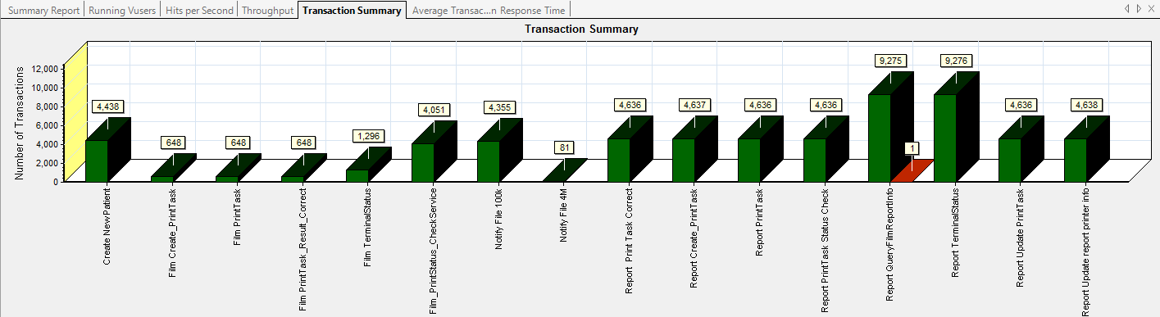

|  |
| --- |
|  |
|  |
|  |
|  |
|  |
|  |
| E:\PerformanceResult\Upgrade_20171010\Report\dot_trans.gif |
|  |
| |  |  |  |  |  |  |  |  |  |  |  |  | | --- | --- | --- | --- | --- | --- | --- | --- | --- | --- | --- | --- | | |  |  |  | | --- | --- | --- | | **Color** | **Scale** | **Measurement** | |  | 1 | Pass | |  | 1 | Stop |   \\10.184.129.235\puma\Team\Ralf\Performance\Report\PerformanceResult\Phase8_20180111_1\Report\dot_trans.gif   |  | | --- | | **Description:**Displays the number of transactions that passed, failed, stopped, or ended with errors. | |  | | |
|  |
|  |
|  |

### Transaction summary result (Web)

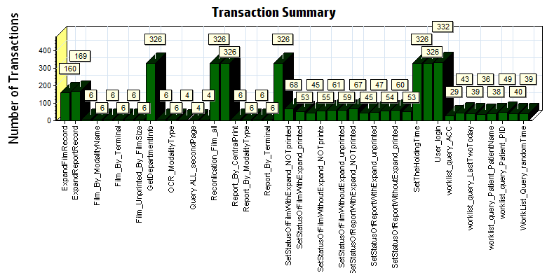

|  |  |  |  |  |  |  |
| --- | --- | --- | --- | --- | --- | --- |
| |  |  |  | | --- | --- | --- | | Color | Scale | Measurement | |  | 1 | Pass | |
|  |
|  |
| E:\WebPerformanceresultPhase8_20170111_1\Report\dot_trans.gif |
|  |
| |  | | --- | | **Description:** Displays the number of transactions that passed, failed, stopped, or ended with errors. | |  | |

### Transaction response time result (PS)

We can get the transaction response time information from the figure as follow:

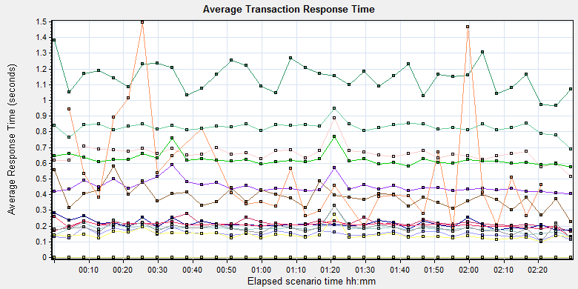

|  |  |  |  |  |  |  |  |
| --- | --- | --- | --- | --- | --- | --- | --- |
| **Color** | **Scale** | **Measurement** | **Graph's Minimum** | **Graph's Average** | **Graph's Maximum** | **Graph's Median** | **Graph's Std. Deviation** |
|  | 1 | Create New Patient | 0.407 | 0.452 | 0.589 | 0.439 | 0.039 |
|  | 1 | Film Create\_PrintTask | 0.969 | 1.146 | 1.382 | 1.159 | 0.09 |
|  | 1 | Film PrintTask | 0.166 | 0.215 | 0.278 | 0.21 | 0.021 |
|  | 1 | Film PrintTask\_Result\_Correct | 0 | 0 | 0 | 0 | 0 |
|  | 1 | Film TerminalStatus | 0.173 | 0.213 | 0.283 | 0.208 | 0.025 |
|  | 1 | Film\_PrintStatus\_CheckService | 0.132 | 0.185 | 0.328 | 0.184 | 0.03 |
|  | 1 | Notify File 100k | 0.228 | 0.385 | 0.578 | 0.381 | 0.069 |
|  | 1 | Notify File 4M | 0.172 | 0.539 | 1.495 | 0.416 | 0.326 |
|  | 1 | Report Print Task Correct | 0 | 0 | 0 | 0 | 0 |
|  | 1 | Report Create\_PrintTask | 0.515 | 0.659 | 0.886 | 0.658 | 0.053 |
|  | 1 | Report PrintTask | 0.111 | 0.152 | 0.196 | 0.149 | 0.02 |
|  | 1 | Report PrintTask Status Check | 0.099 | 0.143 | 0.272 | 0.138 | 0.028 |
|  | 1 | Report QueryFilmReportInfo | 0.691 | 0.828 | 0.948 | 0.835 | 0.037 |
|  | 1 | Report TerminalStatus | 0.128 | 0.208 | 0.258 | 0.209 | 0.019 |
|  | 1 | Report Update PrintTask | 0.104 | 0.187 | 0.33 | 0.189 | 0.035 |
|  | 1 | Report Update report printer info | 0.577 | 0.623 | 0.769 | 0.617 | 0.039 |

\\10.184.129.235\puma\Team\Ralf\Performance\Report\PerformanceResult\Phase8_20180111_1\Report\dot_trans.gif

|  |
| --- |
| **Description:**Displays the average time taken to perform transactions during each second of the load test. This graph helps you determine whether the performance of the server is within acceptable minimum and maximum transaction performance time ranges defined for your system. |
|  |
| E:\PerformanceResult\Upgrade_20171010\Report\dot_trans.gif |
|  |

We can see that the transaction average response times are all less than 3 seconds.

### Transaction response time result (Web)

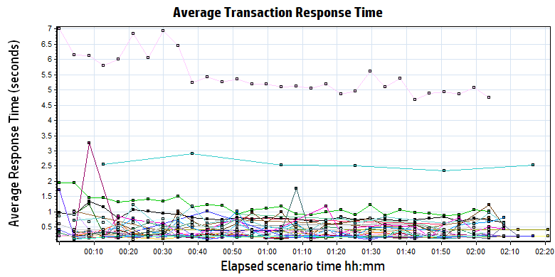

|  |  |  |  |  |  |  |  |  |  |  |  |  |  |  |  |  |  |  |  |  |  |  |  |  |  |  |  |  |  |  |  |  |  |  |  |  |  |  |  |  |  |  |  |  |  |  |  |  |  |  |  |  |  |  |  |  |  |  |  |  |  |  |  |  |  |  |  |  |  |  |  |  |  |  |  |  |  |  |  |  |  |  |  |  |  |  |  |  |  |  |  |  |  |  |  |  |  |  |  |  |  |  |  |  |  |  |  |  |  |  |  |  |  |  |  |  |  |  |  |  |  |  |  |  |  |  |  |  |  |  |  |  |  |  |  |  |  |  |  |  |  |  |  |  |  |  |  |  |  |  |  |  |  |  |  |  |  |  |  |  |  |  |  |  |  |  |  |  |  |  |  |  |  |  |  |  |  |  |  |  |  |  |  |  |  |  |  |  |  |  |  |  |  |  |  |  |  |  |  |  |  |  |  |  |  |  |  |  |  |  |  |  |  |  |  |  |  |  |  |  |  |  |  |  |  |  |  |  |  |  |  |  |  |  |  |  |  |  |  |  |  |  |  |  |  |  |  |  |  |  |  |  |  |  |  |  |  |  |  |  |  |  |  |  |  |  |  |  |  |  |  |  |  |  |  |  |  |  |  |  |  |  |  |  |  |  |  |  |  |  |  |  |  |  |  |  |  |  |  |  |  |  |  |  |  |  |  |  |  |  |  |  |  |  |  |
| --- | --- | --- | --- | --- | --- | --- | --- | --- | --- | --- | --- | --- | --- | --- | --- | --- | --- | --- | --- | --- | --- | --- | --- | --- | --- | --- | --- | --- | --- | --- | --- | --- | --- | --- | --- | --- | --- | --- | --- | --- | --- | --- | --- | --- | --- | --- | --- | --- | --- | --- | --- | --- | --- | --- | --- | --- | --- | --- | --- | --- | --- | --- | --- | --- | --- | --- | --- | --- | --- | --- | --- | --- | --- | --- | --- | --- | --- | --- | --- | --- | --- | --- | --- | --- | --- | --- | --- | --- | --- | --- | --- | --- | --- | --- | --- | --- | --- | --- | --- | --- | --- | --- | --- | --- | --- | --- | --- | --- | --- | --- | --- | --- | --- | --- | --- | --- | --- | --- | --- | --- | --- | --- | --- | --- | --- | --- | --- | --- | --- | --- | --- | --- | --- | --- | --- | --- | --- | --- | --- | --- | --- | --- | --- | --- | --- | --- | --- | --- | --- | --- | --- | --- | --- | --- | --- | --- | --- | --- | --- | --- | --- | --- | --- | --- | --- | --- | --- | --- | --- | --- | --- | --- | --- | --- | --- | --- | --- | --- | --- | --- | --- | --- | --- | --- | --- | --- | --- | --- | --- | --- | --- | --- | --- | --- | --- | --- | --- | --- | --- | --- | --- | --- | --- | --- | --- | --- | --- | --- | --- | --- | --- | --- | --- | --- | --- | --- | --- | --- | --- | --- | --- | --- | --- | --- | --- | --- | --- | --- | --- | --- | --- | --- | --- | --- | --- | --- | --- | --- | --- | --- | --- | --- | --- | --- | --- | --- | --- | --- | --- | --- | --- | --- | --- | --- | --- | --- | --- | --- | --- | --- | --- | --- | --- | --- | --- | --- | --- | --- | --- | --- | --- | --- | --- | --- | --- | --- | --- | --- | --- | --- | --- | --- | --- | --- | --- | --- | --- | --- | --- | --- | --- | --- | --- | --- | --- | --- | --- | --- | --- | --- | --- | --- | --- | --- | --- | --- | --- | --- | --- | --- | --- | --- | --- | --- | --- |
| |  |  |  |  |  |  |  | | --- | --- | --- | --- | --- | --- | --- | | Color | Scale | Measurement | Minimum | Average | Maximum | Std. Deviation | |  | 1 | ExpandFilmRecord | 0.061 | 0.420 | 1.180 | 0.274 | |  | 1 | ExpandReportRecord | 0.022 | 0.173 | 0.613 | 0.063 | |  | 1 | Film\_By\_FilmSize | 0.110 | 0.221 | 0.406 | 0.090 | |  | 1 | Film\_By\_ModalityName | 0.385 | 0.404 | 0.410 | 0.008 | |  | 1 | Film\_By\_ModalityType | 0.203 | 0.204 | 0.207 | 0.001 | |  | 1 | Film\_By\_Terminal | 0.369 | 0.658 | 1.024 | 0.228 | |  | 1 | Film\_printed\_By\_CentralPrint | 0.347 | 0.397 | 0.407 | 0.022 | |  | 1 | Film\_Unprinted\_By\_FilmSize | 0.203 | 0.203 | 0.204 | 0.000 | |  | 1 | GetDepartmentInfo | 0.015 | 0.203 | 1.373 | 0.074 | |  | 1 | OCR\_ModalityName | 0.203 | 0.204 | 0.206 | 0.001 | |  | 1 | OCR\_ModalityType | 0.204 | 0.204 | 0.207 | 0.001 | |  | 1 | Query ALL | 0.404 | 0.725 | 1.174 | 0.280 | |  | 1 | Query ALL\_secondPage | 0.601 | 0.710 | 0.815 | 0.103 | |  | 1 | Query ALL\_ThirdPage | 0.380 | 0.519 | 0.611 | 0.096 | |  | 1 | Reconlication\_Film\_all | 0.615 | 1.180 | 4.902 | 0.525 | |  | 1 | reconlication\_report\_all | 0.196 | 0.828 | 3.868 | 0.386 | |  | 1 | Report\_By\_CentralPrint | 0.406 | 0.409 | 0.419 | 0.004 | |  | 1 | Report\_By\_ModalityType | 0.125 | 0.190 | 0.208 | 0.030 | |  | 1 | Report\_By\_PaperSize | 0.192 | 0.339 | 1.018 | 0.304 | |  | 1 | Report\_By\_Terminal | 2.342 | 2.565 | 2.909 | 0.169 | |  | 1 | SetPrintMode | 0.055 | 0.236 | 3.492 | 0.323 | |  | 1 | SetStatusOfFilmWithExpand\_NOTprinted | 0.120 | 0.498 | 1.036 | 0.257 | |  | 1 | SetStatusOfFilmWithExpand\_printed | 0.142 | 0.556 | 2.244 | 0.398 | |  | 1 | SetStatusOfFilmWithExpand\_unprinted | 0.146 | 0.526 | 2.447 | 0.378 | |  | 1 | SetStatusOfFilmWithoutExpand\_NOTprinte | 0.090 | 0.275 | 3.399 | 0.434 | |  | 1 | SetStatusOfFilmWithoutExpand\_printed | 0.090 | 0.222 | 0.817 | 0.127 | |  | 1 | SetStatusOfFilmWithoutExpand\_unprinted | 0.052 | 0.320 | 3.952 | 0.631 | |  | 1 | SetStatusOfReportWithExpand\_NOTprinted | 0.081 | 0.225 | 0.721 | 0.114 | |  | 1 | SetStatusOfReportWithExpand\_printed | 0.071 | 0.211 | 0.495 | 0.074 | |  | 1 | SetStatusOfReportWithExpand\_unprinted | 0.134 | 0.231 | 0.627 | 0.091 | |  | 1 | SetStatusOfReportWithoutExpand\_NOTprinted | 0.095 | 0.261 | 3.267 | 0.419 | |  | 1 | SetStatusOfReportWithoutExpand\_printed | 0.054 | 0.233 | 0.791 | 0.140 | |  | 1 | SetStatusOfReportWithoutExpand\_unprinted | 0.091 | 0.268 | 3.429 | 0.452 | |  | 1 | SetTheHoldingTime | 0.043 | 0.226 | 4.058 | 0.374 | |  | 1 | Terminal\_monitor | 0.142 | 0.455 | 2.625 | 0.357 | |  | 1 | User\_login | 3.673 | 5.491 | 12.481 | 1.210 | |  | 1 | worklist\_query\_ACC | 0.076 | 0.203 | 0.610 | 0.086 | |  | 1 | worklist\_query\_LastMonth | 0.193 | 0.301 | 0.604 | 0.104 | |  | 1 | worklist\_query\_LastTwoToday | 0.145 | 0.227 | 0.833 | 0.106 | |  | 1 | worklist\_query\_Lastweek | 0.060 | 0.221 | 1.719 | 0.261 | |  | 1 | worklist\_query\_Patient\_PatientName | 0.044 | 0.179 | 0.341 | 0.053 | |  | 1 | worklist\_query\_Patient\_PID | 0.032 | 0.192 | 0.380 | 0.042 | |  | 1 | Worklist\_Query\_Today | 0.361 | 0.454 | 0.859 | 0.117 | |  | 1 | WorlkList\_Query\_randomTime | 0.401 | 0.702 | 1.217 | 0.217 | |
|  |
|  |
| E:\WebPerformanceresultPhase8_20170111_1\Report\dot_trans.gif |
|  |
| |  | | --- | |  | |

We can see that the transaction average response times are can accepted. Only login transaction response time is more than 3 seconds.

## Performance bottleneck analysis (PS)

### Hardware usage analysis

During the testing work, we use the test tool to monitor the server hardware usage include the CPU, Memory, hard disk and etc.

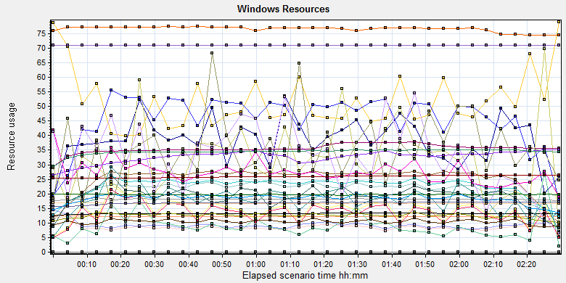

|  |  |  |  |  |  |  |  |  |  |  |  |  |  |  |  |  |  |  |  |  |  |  |  |  |  |  |  |  |  |  |  |  |  |  |  |  |  |  |  |  |  |  |  |  |  |  |  |  |  |  |  |  |  |  |  |  |  |  |  |  |  |  |  |  |  |  |  |  |  |  |  |  |  |  |  |  |  |  |  |  |  |  |  |  |  |  |  |  |  |  |  |  |  |  |  |  |  |  |  |  |  |  |  |  |  |  |  |  |  |  |  |  |  |  |  |  |  |  |  |  |  |  |  |  |  |  |  |  |  |  |  |  |  |  |  |  |  |  |  |  |  |  |  |  |  |  |  |  |  |  |  |  |  |  |  |  |  |  |  |  |  |  |  |  |  |  |  |  |  |  |  |  |  |  |  |  |  |  |  |  |  |  |  |  |  |  |  |  |  |  |  |  |  |  |  |  |  |  |  |  |  |  |  |  |  |  |  |  |  |  |  |  |  |  |  |  |  |  |  |  |  |  |  |  |  |  |  |  |  |  |  |  |  |  |  |  |  |  |  |  |  |  |  |  |  |  |  |  |  |  |  |  |  |  |  |  |  |  |  |  |  |  |  |  |  |  |
| --- | --- | --- | --- | --- | --- | --- | --- | --- | --- | --- | --- | --- | --- | --- | --- | --- | --- | --- | --- | --- | --- | --- | --- | --- | --- | --- | --- | --- | --- | --- | --- | --- | --- | --- | --- | --- | --- | --- | --- | --- | --- | --- | --- | --- | --- | --- | --- | --- | --- | --- | --- | --- | --- | --- | --- | --- | --- | --- | --- | --- | --- | --- | --- | --- | --- | --- | --- | --- | --- | --- | --- | --- | --- | --- | --- | --- | --- | --- | --- | --- | --- | --- | --- | --- | --- | --- | --- | --- | --- | --- | --- | --- | --- | --- | --- | --- | --- | --- | --- | --- | --- | --- | --- | --- | --- | --- | --- | --- | --- | --- | --- | --- | --- | --- | --- | --- | --- | --- | --- | --- | --- | --- | --- | --- | --- | --- | --- | --- | --- | --- | --- | --- | --- | --- | --- | --- | --- | --- | --- | --- | --- | --- | --- | --- | --- | --- | --- | --- | --- | --- | --- | --- | --- | --- | --- | --- | --- | --- | --- | --- | --- | --- | --- | --- | --- | --- | --- | --- | --- | --- | --- | --- | --- | --- | --- | --- | --- | --- | --- | --- | --- | --- | --- | --- | --- | --- | --- | --- | --- | --- | --- | --- | --- | --- | --- | --- | --- | --- | --- | --- | --- | --- | --- | --- | --- | --- | --- | --- | --- | --- | --- | --- | --- | --- | --- | --- | --- | --- | --- | --- | --- | --- | --- | --- | --- | --- | --- | --- | --- | --- | --- | --- | --- | --- | --- | --- | --- | --- | --- | --- | --- | --- | --- | --- | --- | --- | --- | --- | --- | --- | --- | --- | --- | --- | --- | --- | --- | --- | --- | --- | --- | --- | --- | --- | --- | --- |
| |  |  |  |  |  |  |  | | --- | --- | --- | --- | --- | --- | --- | | **Color** | **Scale** | **Measurement** | **Minimum** | **Average** | **Maximum** | **Std. Deviation** | |  | 1 | % Disk Read Time (PhysicalDisk \_Total):10.184.129.108 | 0 | 8.856 | 279.984 | 16.083 | |  | 0.1 | % Disk Time (PhysicalDisk \_Total):10.184.129.108 | 3.798 | 143.377 | 999.722 | 128.276 | |  | 0.1 | % Disk Write Time (PhysicalDisk \_Total):10.184.129.108 | 3.798 | 134.52 | 857.808 | 119.741 | |  | 1 | % Idle Time (PhysicalDisk \_Total):10.184.129.108 | 0 | 51.846 | 97.558 | 25.204 | |  | 1000 | % Interrupt Time (Processor \_Total):10.184.129.108 | 0 | 0.038 | 0.366 | 0.063 | |  | 10 | % Privileged Time (Processor \_Total):10.184.129.108 | 0 | 2.149 | 6.765 | 1.169 | |  | 1 | % Processor Time (Processor \_Total):10.184.129.108 | 1.087 | 25.026 | 67.599 | 10.011 | |  | 0.001 | Available MBytes (Memory):10.184.129.108 | 12058 | 12233.983 | 12978 | 101.622 | |  | 0.001 | Avg. Disk Bytes/Read (PhysicalDisk \_Total):10.184.129.108 | 0 | 32002.216 | 1048576 | 72105.857 | |  | 0.0001 | Avg. Disk Bytes/Transfer (PhysicalDisk \_Total):10.184.129.108 | 910.222 | 86550.433 | 918860.468 | 85921.806 | |  | 0.0001 | Avg. Disk Bytes/Write (PhysicalDisk \_Total):10.184.129.108 | 910.222 | 93805.066 | 1007740.343 | 98052.298 | |  | 10 | Avg. Disk Queue Length (PhysicalDisk \_Total):10.184.129.108 | 0.038 | 1.434 | 9.997 | 1.283 | |  | 100 | Avg. Disk Read Queue Length (PhysicalDisk \_Total):10.184.129.108 | 0 | 0.089 | 2.8 | 0.161 | |  | 10 | Avg. Disk Write Queue Length (PhysicalDisk \_Total):10.184.129.108 | 0.038 | 1.345 | 8.578 | 1.197 | |  | 0.001 | Bytes Total/sec (Server):10.184.129.108 | 5311.729 | 18161.353 | 26543.573 | 1454.431 | |  | 1E-07 | Cache Bytes (Memory):10.184.129.108 | 154980352 | 168954976.095 | 180580352 | 4297169.272 | |  | 1E-09 | Committed Bytes (Memory):10.184.129.108 | 12233117696 | 13197861284.794 | 13487206400 | 163242329.522 | |  | 0.001 | Context Switches/sec (System):10.184.129.108 | 3455.131 | 12482.214 | 46332.218 | 7497.105 | |  | 10 | Current Disk Queue Length (PhysicalDisk \_Total):10.184.129.108 | 0 | 1.808 | 27 | 2.692 | |  | 1 | Disk Transfers/sec (PhysicalDisk \_Total):10.184.129.108 | 2.609 | 45.634 | 121.252 | 19.221 | |  | 0.01 | File Data Operations/sec (System):10.184.129.108 | 320.127 | 2257.766 | 7529.654 | 1068.975 | |  | 1E-05 | Free Megabytes (LogicalDisk \_Total):10.184.129.108 | 1669310 | 1676014.419 | 1682888 | 3805.774 | |  | 0.01 | Interrupts/sec (Processor \_Total):10.184.129.108 | 571.974 | 1834.931 | 7040.289 | 1022.533 | |  | 0.001 | Page Faults/sec (Memory):10.184.129.108 | 101.534 | 10431.113 | 68348.07 | 12270.357 | |  | 10 | Page Reads/sec (Memory):10.184.129.108 | 0 | 2.744 | 56.058 | 5.15 | |  | 1 | Pages/sec (Memory):10.184.129.108 | 0 | 32.703 | 739.086 | 81.245 | |  | 1E-06 | Pool Nonpaged Bytes (Memory):10.184.129.108 | 74256384 | 76615949.74 | 79884288 | 977373.079 | |  | 1E-05 | Pool Nonpaged Bytes (Server):10.184.129.108 | 1895965 | 1977736.943 | 2048037 | 24220.6 | |  | 1E-07 | Pool Paged Bytes (Memory):10.184.129.108 | 253378560 | 259633099.401 | 265506816 | 3834188.309 | |  | 0.001 | Pool Paged Bytes (Server):10.184.129.108 | 70877 | 70877 | 70877 | 0 | |  | 1 | Pool Paged Failures (Server):10.184.129.108 | 0 | 0 | 0 | 0 | |  | 1E-08 | Private Bytes (Process \_Total):10.184.129.108 | 2613391360 | 3558085498.142 | 3836194816 | 158101123.993 | |  | 100 | Processor Queue Length (System):10.184.129.108 | 0 | 0.358 | 19 | 1.044 | |  | 10 | Split IO/Sec (PhysicalDisk \_Total):10.184.129.108 | 0 | 1.907 | 22.52 | 1.873 | |  | 1E-07 | System Cache Resident Bytes (Memory):10.184.129.108 | 154980352 | 168954816.948 | 180580352 | 4296403.981 | |  | 0.01 | Threads (Objects):10.184.129.108 | 2523 | 3271.214 | 3572 | 205.964 | |  | 1E-08 | Working Set (Process \_Total):10.184.129.108 | 2584379392 | 3445837486.825 | 3639640064 | 113941288.006 | |
|  |
|  |
| \\10.184.129.235\puma\Team\Ralf\Performance\Report\PerformanceResult\Phase8_20180111_1\Report\dot_trans.gif |
|  |

Follow this information we can get that:

The CPU usage do not exist bottleneck, the average process time is 25% and max value is 68%. The average value is less than 80%.The average process queue length is 0.358 and max value is 19, it less than 24(CPU count \* 2), so the CPU resource is enough.

The memory available value is 12.2G and the system use 1 G. The memory do not has bottleneck as current testing stress.

The disk transfer is 86550 Bytes every second, it less than the disk normal ability 20Mb/s.

The hardware do not exist the bottle neck.

### SQL Server resource usage analysis

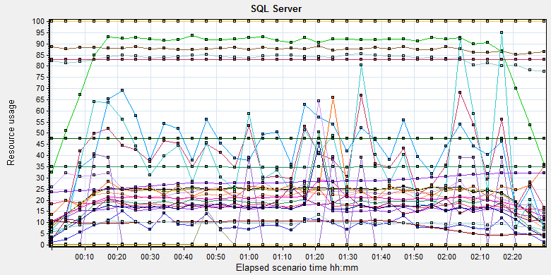

|  |  |  |  |  |  |  |  |  |  |  |  |  |  |  |  |  |  |  |  |  |  |  |  |  |  |  |  |  |  |  |  |  |  |  |  |  |  |  |  |  |  |  |  |  |  |  |  |  |  |  |  |  |  |  |  |  |  |  |  |  |  |  |  |  |  |  |  |  |  |  |  |  |  |  |  |  |  |  |  |  |  |  |  |  |  |  |  |  |  |  |  |  |  |  |  |  |  |  |  |  |  |  |  |  |  |  |  |  |  |  |  |  |  |  |  |  |  |  |  |  |  |  |  |  |  |  |  |  |  |  |  |  |  |  |  |  |  |  |  |  |  |  |  |  |  |  |  |  |  |  |  |  |  |  |  |  |  |  |  |  |  |  |  |  |  |  |  |  |  |  |  |  |  |  |  |  |  |  |  |  |  |  |  |  |  |  |  |  |  |  |  |  |  |  |  |  |  |  |  |  |  |  |  |  |  |  |  |  |  |  |  |  |  |  |  |  |  |  |  |  |  |  |  |  |  |  |  |  |  |  |  |  |  |  |  |  |  |  |  |  |  |  |  |  |  |  |  |  |  |  |  |  |  |  |  |  |  |  |  |  |  |  |  |  |  |  |  |  |  |  |  |  |  |  |  |  |  |  |  |  |  |  |  |  |  |  |  |  |  |  |  |  |  |  |  |  |
| --- | --- | --- | --- | --- | --- | --- | --- | --- | --- | --- | --- | --- | --- | --- | --- | --- | --- | --- | --- | --- | --- | --- | --- | --- | --- | --- | --- | --- | --- | --- | --- | --- | --- | --- | --- | --- | --- | --- | --- | --- | --- | --- | --- | --- | --- | --- | --- | --- | --- | --- | --- | --- | --- | --- | --- | --- | --- | --- | --- | --- | --- | --- | --- | --- | --- | --- | --- | --- | --- | --- | --- | --- | --- | --- | --- | --- | --- | --- | --- | --- | --- | --- | --- | --- | --- | --- | --- | --- | --- | --- | --- | --- | --- | --- | --- | --- | --- | --- | --- | --- | --- | --- | --- | --- | --- | --- | --- | --- | --- | --- | --- | --- | --- | --- | --- | --- | --- | --- | --- | --- | --- | --- | --- | --- | --- | --- | --- | --- | --- | --- | --- | --- | --- | --- | --- | --- | --- | --- | --- | --- | --- | --- | --- | --- | --- | --- | --- | --- | --- | --- | --- | --- | --- | --- | --- | --- | --- | --- | --- | --- | --- | --- | --- | --- | --- | --- | --- | --- | --- | --- | --- | --- | --- | --- | --- | --- | --- | --- | --- | --- | --- | --- | --- | --- | --- | --- | --- | --- | --- | --- | --- | --- | --- | --- | --- | --- | --- | --- | --- | --- | --- | --- | --- | --- | --- | --- | --- | --- | --- | --- | --- | --- | --- | --- | --- | --- | --- | --- | --- | --- | --- | --- | --- | --- | --- | --- | --- | --- | --- | --- | --- | --- | --- | --- | --- | --- | --- | --- | --- | --- | --- | --- | --- | --- | --- | --- | --- | --- | --- | --- | --- | --- | --- | --- | --- | --- | --- | --- | --- | --- | --- | --- | --- | --- | --- | --- | --- | --- | --- | --- | --- | --- | --- | --- | --- | --- | --- | --- | --- | --- | --- | --- | --- | --- | --- | --- | --- | --- | --- | --- | --- | --- | --- | --- | --- | --- |
| |  |  |  |  |  |  |  | | --- | --- | --- | --- | --- | --- | --- | | **Color** | **Scale** | **Measurement** | **Minimum** | **Average** | **Maximum** | **Std. Deviation** | |  | 10 | Active cursors (MSSQL$GCPACSWS|Cursor Manager by Type \_Total):10.184.129.108 | 0 | 1.567 | 11 | 0.808 | |  | 10 | Average Latch Wait Time (ms) (MSSQL$GCPACSWS|Latches):10.184.129.108 | 0.031 | 1.831 | 270.627 | 4.994 | |  | 1 | Average Wait Time (ms) (MSSQL$GCPACSWS|Locks \_Total):10.184.129.108 | 0 | 38.449 | 2896.8 | 105.873 | |  | 1 | AWE stolen maps/sec (MSSQL$GCPACSWS|Buffer Manager):10.184.129.108 | 0 | 0 | 0 | 0 | |  | 1 | Buffer cache hit ratio (MSSQL$GCPACSWS|Buffer Manager):10.184.129.108 | 99.945 | 99.999 | 100 | 0.003 | |  | 1 | Cache Hit Ratio (MSSQL$GCPACSWS|Cursor Manager by Type \_Total):10.184.129.108 | 72.944 | 83.351 | 87.824 | 3.094 | |  | 1 | Cache Hit Ratio (MSSQL$GCPACSWS|Plan Cache \_Total):10.184.129.108 | 78.13 | 87.656 | 96.699 | 3.576 | |  | 1 | CPU usage % (MSSQL$GCPACSWS|Workload Group Stats default):10.184.129.108 | 0.53 | 20.425 | 65.195 | 12.179 | |  | 1 | Current connections (MSOLAP$GCPACSWS|Connection):10.184.129.108 | 0 | 0 | 0 | 0 | |  | 1 | Current KB (MSOLAP$GCPACSWS|Cache):10.184.129.108 | 0 | 0 | 0 | 0 | |  | 1 | Current latch waits (MSOLAP$GCPACSWS|Locks):10.184.129.108 | 0 | 0 | 0 | 0 | |  | 1 | Current lock waits (MSOLAP$GCPACSWS|Locks):10.184.129.108 | 0 | 0 | 0 | 0 | |  | 1 | Current locks (MSOLAP$GCPACSWS|Locks):10.184.129.108 | 0 | 0 | 0 | 0 | |  | 1 | Current user sessions (MSOLAP$GCPACSWS|Connection):10.184.129.108 | 0 | 0 | 0 | 0 | |  | 10 | Errors/sec (MSSQL$GCPACSWS|SQL Errors \_Total):10.184.129.108 | 0 | 1.793 | 44.816 | 1.595 | |  | 1 | Failures/sec (MSOLAP$GCPACSWS|Connection):10.184.129.108 | 0 | 0 | 0 | 0 | |  | 1 | Full Scans/sec (MSSQL$GCPACSWS|Access Methods):10.184.129.108 | 1.993 | 85.151 | 182.351 | 36.185 | |  | 0.001 | Index Searches/sec (MSSQL$GCPACSWS|Access Methods):10.184.129.108 | 0 | 23287.489 | 68299.15 | 10931.811 | |  | 0.0001 | Lock Requests/sec (MSSQL$GCPACSWS|Locks \_Total):10.184.129.108 | 0 | 228563.432 | 811434.06 | 96158.206 | |  | 1 | Lock Timeouts (timeout > 0)/sec (MSSQL$GCPACSWS|Locks \_Total):10.184.129.108 | 0 | 0 | 0 | 0 | |  | 10 | Lock Timeouts/sec (MSSQL$GCPACSWS|Locks \_Total):10.184.129.108 | 0 | 0.854 | 18.941 | 1.501 | |  | 1 | Lock Wait Time (ms) (MSSQL$GCPACSWS|Locks \_Total):10.184.129.108 | 0 | 38.703 | 4810.124 | 183.567 | |  | 1 | Lock waits/sec (MSOLAP$GCPACSWS|Locks):10.184.129.108 | 0 | 0 | 0 | 0 | |  | 100 | Lock Waits/sec (MSSQL$GCPACSWS|Locks \_Total):10.184.129.108 | 0 | 0.429 | 7.305 | 0.579 | |  | 0.1 | Logical Connections (MSSQL$GCPACSWS|General Statistics):10.184.129.108 | 85 | 203.196 | 324 | 35.124 | |  | 100 | Logins/sec (MSSQL$GCPACSWS|General Statistics):10.184.129.108 | 0 | 0.256 | 21.91 | 0.526 | |  | 100 | Logouts/sec (MSSQL$GCPACSWS|General Statistics):10.184.129.108 | 0 | 0.254 | 24.243 | 0.572 | |  | 1E-05 | Maximum Workspace Memory (KB) (MSSQL$GCPACSWS|Memory Manager):10.184.129.108 | 4747080 | 4764167.006 | 4795440 | 6506.335 | |  | 0.001 | Number of active cursor plans (MSSQL$GCPACSWS|Cursor Manager by Type \_Total):10.184.129.108 | 4429 | 9154.575 | 10930 | 2263.364 | |  | 10000 | Number of Deadlocks/sec (MSSQL$GCPACSWS|Locks \_Total):10.184.129.108 | 0 | 0.001 | 0.35 | 0.017 | |  | 1 | Number of SuperLatches (MSSQL$GCPACSWS|Latches):10.184.129.108 | 0 | 0 | 0 | 0 | |  | 10 | Page Deallocations/sec (MSSQL$GCPACSWS|Access Methods):10.184.129.108 | 0 | 1.669 | 49.151 | 4.937 | |  | 1E-05 | Page life expectancy (MSSQL$GCPACSWS|Buffer Manager):10.184.129.108 | 7904 | 77952.858 | 4294967 | 510915.395 | |  | 1 | Rows read/sec (MSOLAP$GCPACSWS|Processing):10.184.129.108 | 0 | 0 | 0 | 0 | |  | 1 | Rows written/sec (MSOLAP$GCPACSWS|Processing):10.184.129.108 | 0 | 0 | 0 | 0 | |  | 0.001 | SQL Cache Memory (KB) (MSSQL$GCPACSWS|Memory Manager):10.184.129.108 | 23760 | 28271.387 | 32144 | 2412.259 | |  | 0.0001 | Stolen pages (MSSQL$GCPACSWS|Buffer Manager):10.184.129.108 | 345074 | 349184.326 | 351250 | 873.798 | |  | 1E-05 | Target Server Memory (KB) (MSSQL$GCPACSWS|Memory Manager):10.184.129.108 | 8290304 | 8290304 | 8290304 | 0 | |  | 1 | Total deadlocks detected (MSOLAP$GCPACSWS|Locks):10.184.129.108 | 0 | 0 | 0 | 0 | |  | 0.01 | Total Latch Wait Time (ms) (MSSQL$GCPACSWS|Latches):10.184.129.108 | 20.598 | 1612.373 | 250711.159 | 4643.745 | |  | 1 | Transactions (MSSQL$GCPACSWS|Transactions):10.184.129.108 | 6 | 9.561 | 150 | 4.848 |   \\10.184.129.235\puma\Team\Ralf\Performance\Report\PerformanceResult\Phase8_20180111_1\Report\dot_trans.gif   |  | | --- | | **Description:**Displays a summary of SQL Server Resources. | |  | |
|  |
|  |
|  |
|  |
|  |

Figure 10.6.2.1 Database result

Follow the SQL server monitor resource, we can find the Database performance is ok. There are some locks but no dead lock and timeout issues. The number of SQL execute plans is little high, we need monitor the issues. There are some full scans caused by the views, we can add some index for them to enhance the performance of database.

## Test Conclusion

During the testing work, we find that the PS system has the ability to process the main workflow under the strong stress. Current configuration can meets the requirements of system. There are still has some issues for database, we should monitor them and try to fix them.

# Testing work （Phase 9）

Test environment：We use the follow machine to do our performance testing work.

|  |  |  |  |  |  |  |  |  |  |  |  |
| --- | --- | --- | --- | --- | --- | --- | --- | --- | --- | --- | --- |
| **Server Name** | **Type** | **CPU** | | **Hard Disk** | | **RAM** | | **OS** | | **Required Software** | |
| PS Server | Hyper-v virtual machine | Intel Xeon E5-2620 v3 2.40GHz \*12 | 2T SCSI Disk  Seagate MD3002 | | 12G | | Windows 2012 R2 | | SQL 2008  IIS 7.5 | |
| QTP script machine | Hyper-v virtual machine | Intel Xeon E5-2403 v2 1.80GHz \*4 | 80G Virtual Disk | | 2.5G | | Windows 2012 R2 | | QTP 11 demo | |
| Performance control | Dell optiplex 9020 | Intel core(TM) i7-4790 3.6GHZ\*6 | 1T SATA Disk | | 8G | | Win7 64bit | | Load runner | |

Figure 1.1 Hardware List

## Strategy and Scenario Setting

1. Use automation tool simulate the doctor print film work. Simulate 6 GX Platform by using QTP and PDSender tool. Each client prints one film which size is 10MB every 30 seconds.(Two QTP client environment is not ready cause by the errors of server.)
2. Use LR tool simulate 8 K2/K3 terminals to print film. Each client prints one film which size is 10MB random 5 to 30 seconds.
3. Use LR tool simulate 45 PUMA terminals to print paper reports. Each client prints report random 5 to 30 seconds.
4. Use LR tool simulate 45 users to do PUMA report archive operations. Each client archive report in random 5 to 30 seconds and size is random with 100kb and 4Mb.
5. The OCR setting is not has rule for GX platforms in step1 and other setting are set as default. The OCR service will under the strong stress without configure the rule.
6. Simulate 20 users to do the query information, view monitor page, query reconciliation films and report, expand the record, change the status, set holding time and other operations in worklist.
7. Simulate 1 user to do the statistic operations with latest month data in web. The operations will execute every 110 seconds.
8. Monitor the transaction response time.
9. Monitor the hardware resource usage on PS.
10. Monitor the resource usage for database on PS.
11. Start/Stop 2 virtual users every 10 seconds and run the scenario for 2 hours.

In this Phase we want to monitor the Database and find why the system performance will be slow after execute the scenario for one hour with the current configuration.

## Background Data

We use SQL command statement to add large data in the database, the detail information as follow:

|  |  |
| --- | --- |
| **Table Name** | **Data Volume (records)** |
| printer.dbo.DeliveryJob | 1999813 |
| printer.dbo.ImageBox | 1997879 |
| printer.dbo.Page | 1997813 |
| printer.dbo.Session | 1901132 |
| wggc.dbo.Patient | 2229777 |
| wggc.dbo.Study | 2229789 |
| wggc.dbo.AFP\_PrintTerminalInfo | 162 |
| wggc.dbo.Series | 1129735 |
| wggc.dbo.Image | 1129738 |
| wggc.dbo.AFP\_FilmInfo | 1843592 |
| wggc.dbo.AFP\_ReportInfo | 1676761 |
| wggc.dbo.AFP\_ExamInfo | 2957005 |
| wggc.dbo.AFP\_PrintTask | 4496324 |
| wggc.dbo.T\_Integration\_ExamInfo | 169292 |
| AFP\_PrintMode | 195294 |
| wggc.dbo.vi\_KIOSK\_ExamInfo\_Order | 629331 |

Figure 11.2.1 Background Data

## Other Setting:

### Database setting

Memory: Set the min and max memory size to4GB.

Index fill factor: 80.

File: Increase the data and log files size and the rule is increase 200Mb as fixed size.

### IIS setting

Connection: Keep the settings as default.

## Test Object version

KIOSK Platform 3.0.0.2 B18P02 upgrade from PandaB16P01 + New integration package + tuning works for Integration + Stop the monitor and alarm service.

## Test result

### Test Statistic Report

N/A

Want to indentify the DB issue, so do not monitor the content.

### Transaction summary result

|  |
| --- |
| N/A  Want to indentify the DB issue, so do not monitor the content. |
|  |
|  |
|  |
|  |
|  |

## Performance bottleneck analysis

### Hardware usage analysis

N/A

Want to indentify the DB issue, so do not monitor the content.

### SQL Server resource usage analysis

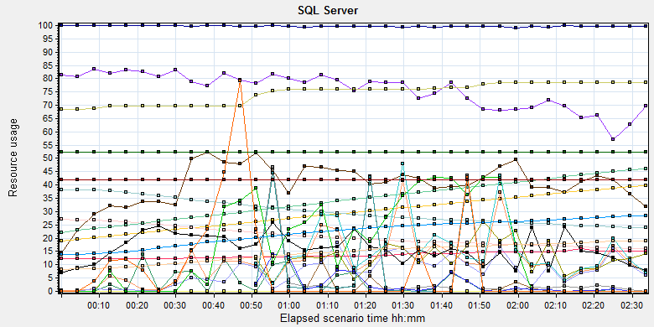

|  |  |  |  |  |  |  |
| --- | --- | --- | --- | --- | --- | --- |
| **Color** | **Scale** | **Measurement** | **Minimum** | **Average** | **Maximum** | **Std. Deviation** |
|  | 1 | Buffer cache hit ratio (MSSQL$GCPACSWS|Buffer Manager):10.184.129.108 | 73.311 | 99.716 | 100 | 0.669 |
|  | 1 | Cache Hit Ratio (MSSQL$GCPACSWS|Cursor Manager by Type \_Total):10.184.129.108 | 55.476 | 75.849 | 88.008 | 7.033 |
|  | 1 | Checkpoint pages/sec (MSSQL$GCPACSWS|Buffer Manager):10.184.129.108 | 0 | 2.597 | 142.155 | 12.412 |
|  | 0.01 | Connection Memory (KB) (MSSQL$GCPACSWS|Memory Manager):10.184.129.108 | 1064 | 4025.622 | 5432 | 811.487 |
|  | 1 | Cursor flushes (MSSQL$GCPACSWS|Cursor Manager Total):10.184.129.108 | 0 | 0 | 0 | 0 |
|  | 0.0001 | Cursor memory usage (MSSQL$GCPACSWS|Cursor Manager by Type \_Total):10.184.129.108 | 187872 | 294041.64 | 397448 | 60644.239 |
|  | 0.0001 | Database pages (MSSQL$GCPACSWS|Buffer Manager):10.184.129.108 | 238915 | 302425.952 | 383864 | 46214.281 |
|  | 100 | Free list stalls/sec (MSSQL$GCPACSWS|Buffer Manager):10.184.129.108 | 0 | 0.006 | 5.314 | 0.157 |
|  | 0.001 | Granted Workspace Memory (KB) (MSSQL$GCPACSWS|Memory Manager):10.184.129.108 | 0 | 11084.709 | 153480 | 17785.114 |
|  | 0.01 | Lock Memory (KB) (MSSQL$GCPACSWS|Memory Manager):10.184.129.108 | 6840 | 7445.474 | 7848 | 374.291 |
|  | 1E-05 | Maximum Workspace Memory (KB) (MSSQL$GCPACSWS|Memory Manager):10.184.129.108 | 1610040 | 2083180.125 | 2712600 | 348046.659 |
|  | 1 | Memory Grants Outstanding (MSSQL$GCPACSWS|Memory Manager):10.184.129.108 | 0 | 7.225 | 45 | 8.157 |
|  | 1 | Memory Grants Pending (MSSQL$GCPACSWS|Memory Manager):10.184.129.108 | 0 | 0 | 0 | 0 |
|  | 0.01 | Number of active cursor plans (MSSQL$GCPACSWS|Cursor Manager by Type \_Total):10.184.129.108 | 2190 | 3419.041 | 4611 | 700.52 |
|  | 0.01 | Optimizer Memory (KB) (MSSQL$GCPACSWS|Memory Manager):10.184.129.108 | 1232 | 1363.88 | 6080 | 164.294 |
|  | 1 | Page Deallocations/sec (MSSQL$GCPACSWS|Access Methods):10.184.129.108 | 0 | 6.972 | 3571.662 | 138.276 |
|  | 1E-05 | Page life expectancy (MSSQL$GCPACSWS|Buffer Manager):10.184.129.108 | 8 | 1637748.59 | 4294958 | 2085563.348 |
|  | 0.0001 | Page lookups/sec (MSSQL$GCPACSWS|Buffer Manager):10.184.129.108 | 0 | 161701.087 | 1118116.086 | 117717.723 |
|  | 0.01 | Page reads/sec (MSSQL$GCPACSWS|Buffer Manager):10.184.129.108 | 0 | 1303.505 | 11300.839 | 1277.283 |
|  | 1 | Page Splits/sec (MSSQL$GCPACSWS|Access Methods):10.184.129.108 | 0 | 5.962 | 1126.517 | 62.199 |
|  | 1 | Page writes/sec (MSSQL$GCPACSWS|Buffer Manager):10.184.129.108 | 0 | 2.861 | 125.879 | 11.232 |
|  | 0.01 | Reserved pages (MSSQL$GCPACSWS|Buffer Manager):10.184.129.108 | 0 | 1651.669 | 18068 | 2207.978 |
|  | 0.001 | SQL Cache Memory (KB) (MSSQL$GCPACSWS|Memory Manager):10.184.129.108 | 8288 | 14302.289 | 19008 | 3458.507 |
|  | 0.0001 | Stolen pages (MSSQL$GCPACSWS|Buffer Manager):10.184.129.108 | 136353 | 220342.193 | 284053 | 46510.669 |
|  | 0.0001 | Target pages (MSSQL$GCPACSWS|Buffer Manager):10.184.129.108 | 524288 | 524288 | 524288 | 0 |
|  | 1E-05 | Target Server Memory (KB) (MSSQL$GCPACSWS|Memory Manager):10.184.129.108 | 4194304 | 4194304 | 4194304 | 0 |
|  | 1000 | Temp Tables Creation Rate (MSSQL$GCPACSWS|General Statistics):10.184.129.108 | 0 | 0.007 | 4.982 | 0.131 |
|  | 0.0001 | Total pages (MSSQL$GCPACSWS|Buffer Manager):10.184.129.108 | 524288 | 524288 | 524288 | 0 |
|  | 1E-05 | Total Server Memory (KB) (MSSQL$GCPACSWS|Memory Manager):10.184.129.108 | 4194304 | 4194304 | 4194304 | 0 |

E:\PerformanceResult\phase9\Report\dot_trans.gif

|  |
| --- |
| **Description:**Displays a summary of SQL Server Resources. |
|  |

## Issue analysis

During the performance testing works, We find an issue like that: If use 4GB for database , the performance test scenario will happens a lot of errors after 1 hour and the database performance will be down. So we will monitor the dataset memory usage and analysis the root reason for the issue.

Compare the result before and after the performance scenario execute, we find that the SQL execute Compiled size increased quickly:

**Before:**

|  |  |  |  |
| --- | --- | --- | --- |
| **cacheobjtype** | **objtype** | **size\_in\_kb** | **cache\_count** |
| Compiled Plan | Adhoc | 32504 | 400 |
| Compiled Plan | Prepared | 6304 | 8 |
| Compiled Plan | Proc | 2752 | 14 |
| Parse Tree | UsrTab | 224 | 1 |
| Parse Tree | View | 5112 | 55 |

**After:**

|  |  |  |  |
| --- | --- | --- | --- |
| **cacheobjtype** | **objtype** | **size\_in\_kb** | **cache\_count** |
| Compiled Plan | Adhoc | 1794392 | 25068 |
| Compiled Plan | Prepared | 216976 | 2577 |
| Compiled Plan | Proc | 56632 | 89 |
| Compiled Plan | Trigger | 13544 | 8 |
| Extended Proc | Proc | 32 | 4 |
| Parse Tree | Check | 128 | 4 |
| Parse Tree | UsrTab | 320 | 4 |
| Parse Tree | View | 6480 | 62 |

Follow the information we can calculate the compiled plan will use 2,081,544 KB disk spaces during the testing works. Follow the content of chapter 11.6.2, all memory are used by the database.

That means there are 2.08GB memory space are store the compiled plan and the usage will increase follow the time. The plan counts are increase from 422 to 27746 in the testing the works and counts still increase if we do not stop the testing works.

Other operations memory usage is normal and do not have issues.

Database manage memory usage (average)

|  |  |
| --- | --- |
| Connection Memory (KB) (MSSQL$GCPACSWS|Memory Manager):10.184.129.108 | 4025.622 |
| Lock Memory (KB) (MSSQL$GCPACSWS|Memory Manager):10.184.129.108 | 7445.474 |
| Cursor memory usage (MSSQL$GCPACSWS|Cursor Manager by Type \_Total):10.184.129.108 | 294041.64 |
| Optimizer Memory (KB) (MSSQL$GCPACSWS|Memory Manager):10.184.129.108 | 1363.88 |
| Granted Workspace Memory (KB) (MSSQL$GCPACSWS|Memory Manager):10.184.129.108 | 11084.709 |
| All | 317,961.3 KB |

Database instance table and index memory usage:

|  |  |  |
| --- | --- | --- |
| **object\_name** | **buffer\_pages** | **Size KB** |
| Wggc | 312032 | 2,496,256 |
| Printer | 38864 | 310,912 |
|  |  | Total : 2,807,168 |

Follow the information, we find that the database need 2.8 GB memory space to store the tables and index for system, need 0.3GB for manage function of itself and complied plan need 2.08 GB to store the plan information. The 4G memory is not enough. It will make the database to stolen and reorganize the memory to page to keep the application works well. It will make the performance of database works abnormal.

So we should to analysis why the complied plan used so much memory. We monitor the related information and get the detail execute plan from the file:

There are many SQL do not use the existed complied plan, they create new one during the testing works. All plans store in the memory and make memory size larger and larger.

For example:

The SQL statement:

*select \* from PrintJob where AppServerName = 'LOCALAPP' and (Status = 0 or (Status = 4 and DeliveredDateTime<= '2018-01-22 17:02:29')) order by Status,RetryCount ASC,Priority,CreatedDateTime*

It has 2715 complied plans in the memory and each plan will use 147456 byte memory space. It will cost 50 MB memory size. Create new complied plan will use some CPU and memory resourse. It will also give the stress for the database. We collect the information after the test scenario finished. There are 24229 count complied plans in the database and cache size is 2.188GB. But the distinct records are only 84 counts and size is 59MB. So if we can make the database use the existed complied plan, database will save a lot of memory and CPU resource.

We can use the ‘execute sql’ command to make the SQL statement to use the existed complied plan. But it need do a lot modify for our systems. Team should discuss the issue and make a decision.

There is another issue that there are many cursor used in system. We also should make a solution to fix it.

## Test Conclusion

During current phase testing, we find some issue which causes the memory usage issues. But it will a big change if we want to fix it. Team should discuss the issue and make a decision. QA team will continue monitor the issue in the follow testing works.

# Testing work （Phase 10）

Test environment：We use the follow machine to do our performance testing work.

|  |  |  |  |  |  |  |  |  |  |  |  |
| --- | --- | --- | --- | --- | --- | --- | --- | --- | --- | --- | --- |
| **Server Name** | **Type** | **CPU** | | **Hard Disk** | | **RAM** | | **OS** | | **Required Software** | |
| PS Server | Hyper-v virtual machine | Intel Xeon E5-2620 v3 2.40GHz \*12 | 2T SCSI Disk  Seagate MD3002 | | 16G | | Windows 2012 R2 | | SQL 2008 workgroup  IIS 7.5 | |
| QTP script machine | Hyper-v virtual machine | Intel Xeon E5-2403 v2 1.80GHz \*4 | 80G Virtual Disk | | 2.5G | | Windows 2012 R2 | | QTP 11 demo | |
| Performance control | Dell optiplex 9020 | Intel core(TM) i7-4790 3.6GHZ\*6 | 1T SATA Disk | | 8G | | Win7 64bit | | Load runner | |

Figure 1.1 Hardware List

## Strategy and Scenario Setting

1. Use automation tool simulate the doctor print film work. Simulate 6 GX Platform by using QTP and PDSender tool. Each client prints one film which size is 10MB every 30 seconds.(Two QTP client environment is not ready cause by the errors of server.)
2. Use LR tool simulate 8 K2/K3 terminals to print film. Each client prints one film which size is 10MB random 5 to 30 seconds.
3. Use LR tool simulate 45 users to do PUMA report archive operations and then print report. Each client archive report in random 5 to 30 seconds and size is random with 100kb and 4Mb.
4. The OCR setting is not has rule for GX platforms in step1 and other setting are set as default. The OCR service will under the strong stress without configure the rule.
5. Simulate 20 users to do the query information, view monitor page, query reconciliation films and report, expand the record, change the status, set holding time and other operations in worklist.
6. Simulate 1 user to do the statistic operations with latest month data in web. The operations will execute every 110 seconds.
7. Monitor the transaction response time.
8. Monitor the hardware resource usage on PS.
9. Monitor the resource usage for database on PS.
10. Start/Stop 2 virtual users every 10 seconds and run the scenario for 2 hours.

## Background Data

We use SQL command statement to add large data in the database, the detail information as follow:

|  |  |
| --- | --- |
| **Table Name** | **Data Volume (records)** |
| printer.dbo.DeliveryJob | 995199 |
| printer.dbo.ImageBox | 3530116 |
| printer.dbo.Page | 314893 |
| printer.dbo.Session | 571212 |
| wggc.dbo.Patient | 1224710 |
| wggc.dbo.Study | 1434574 |
| wggc.dbo.AFP\_PrintTerminalInfo | 70 |
| wggc.dbo.Series | 1434524 |
| wggc.dbo.Image | 1434527 |
| wggc.dbo.AFP\_FilmInfo | 1420905 |
| wggc.dbo.AFP\_ReportInfo | 1232003 |
| wggc.dbo.AFP\_ExamInfo | 2308723 |
| wggc.dbo.AFP\_PrintTask | 4324918 |
| wggc.dbo.T\_Integration\_ExamInfo | 1421769 |
| AFP\_PrintMode | 523684 |
| wggc.dbo.vi\_KIOSK\_ExamInfo\_Order | 838208 |

Figure 12.2.1 Background Data

## Other Setting:

### Database setting

Memory: Set the min and max memory size to 4GB.

Index fill factor: 80.

File: Increase the data and log files size and the rule is increase 200Mb and 100MB as fixed size.

### IIS setting

Connection: Keep the settings as default.

## Test Object version

KIOSK Platform MR1 3.0.3.0.21 upgraded from PUMA B1802 which upgraded from PandaB16P01.

We stop the LRU service during the testing works.

## Test result

### Test Statistic Report

|  |  |
| --- | --- |
| Analysis Summary | Period: 2018/6/6 16:43 - 2018/6/6 18:58 |

|  |  |
| --- | --- |
| **Scenario Name:** | E:\ECS\Performance\Script\208\ScenarioPUMA\_Reliability\_Monitor.lrs |
| **Results in Session:** | D:\Scripts\ReleaseScripts\Reliability\_Terminal\_film\_archive\_print\_web\res\res.lrr |
| **Duration:** | 2 hours, 14 minutes and 55 seconds. |

|  |
| --- |
| Statistics Summary |

|  |  |  |
| --- | --- | --- |
| [**Maximum Running Vusers:**](file:///E:\PerformanceResult\PS%20result\MR1%20Phase1\report2_20180607\VuserStateGraph) |  | 53 |
| [**Total Throughput (bytes):**](file:///E:\PerformanceResult\PS%20result\MR1%20Phase1\report2_20180607\Throughput) | [Show SLA Results](slarules:total_throughput) | 2,533,361 |
| [**Average Throughput (bytes/second):**](file:///E:\PerformanceResult\PS%20result\MR1%20Phase1\report2_20180607\Throughput) | [Show SLA Results](slarules:average_throughput) | 313 |
| [**Total Hits:**](file:///E:\PerformanceResult\PS%20result\MR1%20Phase1\report2_20180607\HitsperSecond) | [Show SLA Results](slarules:total_hits) | 3,009 |
| [**Average Hits per Second:**](file:///E:\PerformanceResult\PS%20result\MR1%20Phase1\report2_20180607\HitsperSecond) | [Show SLA Results](slarules:average_hits) | 0.372 | [**View HTTP Responses Summary**](file:///E:\PerformanceResult\PS%20result\MR1%20Phase1\report2_20180607\report2_20180607.html#1) |
| [**Total Errors:**](file:///E:\PerformanceResult\PS%20result\MR1%20Phase1\report2_20180607\TotalErrorsPerSecond) | [Show SLA Results](slarules:errors_per_second) | 615 |  |

|  |  |  |
| --- | --- | --- |
| |  | | --- | | You can define SLA data using the [SLA configuration wizard](slaconfig:) | | You can analyze transaction behavior using the [Analyze Transaction mechanism](analyze:) | |

|  |
| --- |
| Transaction Summary |

|  |  |  |  |  |
| --- | --- | --- | --- | --- |
| [**Transactions:**](file:///E:\PerformanceResult\PS%20result\MR1%20Phase1\report2_20180607\TransactionSummary) | Total Passed: 19,747 | Total Failed: 190 | Total Stopped: 16 | [**Average Response Time**](file:///E:\PerformanceResult\PS%20result\MR1%20Phase1\report2_20180607\ResponseTime) |

|  |  |  |  |  |  |  |  |  |  |
| --- | --- | --- | --- | --- | --- | --- | --- | --- | --- |
| **Transaction Name** | **SLA Status** | **Minimum** | **Average** | **Maximum** | **Std. Deviation** | **90 Percent** | **Pass** | **Fail** | **Stop** |
| [Create New Patient](file:///E:\PerformanceResult\PS%20result\MR1%20Phase1\report2_20180607\ResponseTime0000(Create%20New%20Patient)0000) | [Show SLA Results](slarules:transaction_response_time_CreateNewPatient) | 0.112 | 0.559 | 15.236 | 0.932 | 1.082 | 1,693 | 0 | 0 |
| [Create Report PrintTask Fail](file:///E:\PerformanceResult\PS%20result\MR1%20Phase1\report2_20180607\ResponseTime0000(Create%20Report%20PrintTask%20Fail)0000) | [Show SLA Results](slarules:transaction_response_time_CreateReportPrintTaskFail) | 0 | 0 | 0 | 0 | 0 | 0 | 45 | 0 |
| [Film Create\_PrintTask](file:///E:\PerformanceResult\PS%20result\MR1%20Phase1\report2_20180607\ResponseTime0000(Film%20Create_PrintTask)0000) | [Show SLA Results](slarules:transaction_response_time_FilmCreate_PrintTask) | 0.1 | 7.038 | 86.371 | 13.026 | 30.522 | 243 | 2 | 0 |
| [Film Create\_PrintTask Fail](file:///E:\PerformanceResult\PS%20result\MR1%20Phase1\report2_20180607\ResponseTime0000(Film%20Create_PrintTask%20Fail)0000) | [Show SLA Results](slarules:transaction_response_time_FilmCreate_PrintTaskFail) | 0 | 0 | 0 | 0 | 0 | 0 | 9 | 0 |
| [Film PrintTask](file:///E:\PerformanceResult\PS%20result\MR1%20Phase1\report2_20180607\ResponseTime0000(Film%20PrintTask)0000) | [Show SLA Results](slarules:transaction_response_time_FilmPrintTask) | 0.196 | 1.005 | 30.178 | 3.635 | 1.037 | 191 | 0 | 0 |
| [Film PrintTask\_Result\_Correct](file:///E:\PerformanceResult\PS%20result\MR1%20Phase1\report2_20180607\ResponseTime0000(Film%20PrintTask_Result_Correct)0000) | [Show SLA Results](slarules:transaction_response_time_FilmPrintTask_Result_Correct) | 0 | 0 | 0.001 | 0 | 0 | 182 | 0 | 0 |
| [Film PrintTask\_Result\_Fail](file:///E:\PerformanceResult\PS%20result\MR1%20Phase1\report2_20180607\ResponseTime0000(Film%20PrintTask_Result_Fail)0000) | [Show SLA Results](slarules:transaction_response_time_FilmPrintTask_Result_Fail) | 0 | 0 | 0 | 0 | 0 | 0 | 9 | 0 |
| [Film TerminalStatus](file:///E:\PerformanceResult\PS%20result\MR1%20Phase1\report2_20180607\ResponseTime0000(Film%20TerminalStatus)0000) | [Show SLA Results](slarules:transaction_response_time_FilmTerminalStatus) | 0.013 | 0.402 | 9.054 | 0.884 | 0.824 | 416 | 0 | 0 |
| [Film\_PrintStatus\_CheckService](file:///E:\PerformanceResult\PS%20result\MR1%20Phase1\report2_20180607\ResponseTime0000(Film_PrintStatus_CheckService)0000) | [Show SLA Results](slarules:transaction_response_time_Film_PrintStatus_CheckService) | 0.013 | 0.471 | 15.696 | 1.253 | 0.787 | 1,483 | 0 | 0 |
| [Fim GetTaskID\_fail](file:///E:\PerformanceResult\PS%20result\MR1%20Phase1\report2_20180607\ResponseTime0000(Fim%20GetTaskID_fail)0000) | [Show SLA Results](slarules:transaction_response_time_FimGetTaskID_fail) | 0 | 0 | 0 | 0 | 0 | 50 | 0 | 0 |
| [Notify File 100k](file:///E:\PerformanceResult\PS%20result\MR1%20Phase1\report2_20180607\ResponseTime0000(Notify%20File%20100k)0000) | [Show SLA Results](slarules:transaction_response_time_NotifyFile100k) | 0.086 | 7.628 | 119.719 | 18.376 | 22.187 | 1,189 | 64 | 0 |
| [Notify File 4M](file:///E:\PerformanceResult\PS%20result\MR1%20Phase1\report2_20180607\ResponseTime0000(Notify%20File%204M)0000) | [Show SLA Results](slarules:transaction_response_time_NotifyFile4M) | 0.188 | 7.955 | 68.722 | 16.316 | 24.301 | 25 | 0 | 0 |
| [Report Print Task Correct](file:///E:\PerformanceResult\PS%20result\MR1%20Phase1\report2_20180607\ResponseTime0000(Report%20%20Print%20Task%20Correct)0000) | [Show SLA Results](slarules:transaction_response_time_ReportPrintTaskCorrect) | 0 | 0 | 0.001 | 0 | 0.001 | 1,121 | 0 | 0 |
| [Report Print Task fail](file:///E:\PerformanceResult\PS%20result\MR1%20Phase1\report2_20180607\ResponseTime0000(Report%20%20Print%20Task%20fail)0000) | [Show SLA Results](slarules:transaction_response_time_ReportPrintTaskfail) | 0 | 0 | 0 | 0 | 0 | 0 | 16 | 0 |
| [Report Create\_PrintTask](file:///E:\PerformanceResult\PS%20result\MR1%20Phase1\report2_20180607\ResponseTime0000(Report%20Create_PrintTask)0000) | [Show SLA Results](slarules:transaction_response_time_ReportCreate_PrintTask) | 0.461 | 1.58 | 33.978 | 3.112 | 2.332 | 1,137 | 45 | 3 |
| [Report GetReportID\_fail](file:///E:\PerformanceResult\PS%20result\MR1%20Phase1\report2_20180607\ResponseTime0000(Report%20GetReportID_fail)0000) | [Show SLA Results](slarules:transaction_response_time_ReportGetReportID_fail) | 0 | 0 | 0 | 0 | 0 | 203 | 0 | 0 |
| [Report GetReportPath\_fail](file:///E:\PerformanceResult\PS%20result\MR1%20Phase1\report2_20180607\ResponseTime0000(Report%20GetReportPath_fail)0000) | [Show SLA Results](slarules:transaction_response_time_ReportGetReportPath_fail) | 0 | 0 | 0 | 0 | 0 | 922 | 0 | 0 |
| [Report PrintTask](file:///E:\PerformanceResult\PS%20result\MR1%20Phase1\report2_20180607\ResponseTime0000(Report%20PrintTask)0000) | [Show SLA Results](slarules:transaction_response_time_ReportPrintTask) | 0.036 | 0.425 | 13.046 | 1.036 | 0.92 | 1,137 | 0 | 0 |
| [Report PrintTask Status Check](file:///E:\PerformanceResult\PS%20result\MR1%20Phase1\report2_20180607\ResponseTime0000(Report%20PrintTask%20Status%20Check)0000) | [Show SLA Results](slarules:transaction_response_time_ReportPrintTaskStatusCheck) | 0.014 | 0.351 | 15.258 | 0.846 | 0.64 | 1,341 | 0 | 0 |
| [Report QueryFilmReportInfo](file:///E:\PerformanceResult\PS%20result\MR1%20Phase1\report2_20180607\ResponseTime0000(Report%20QueryFilmReportInfo)0000) | [Show SLA Results](slarules:transaction_response_time_ReportQueryFilmReportInfo) | 0.008 | 13.743 | 79.035 | 20.016 | 47.056 | 3,519 | 0 | 13 |
| [Report TerminalStatus](file:///E:\PerformanceResult\PS%20result\MR1%20Phase1\report2_20180607\ResponseTime0000(Report%20TerminalStatus)0000) | [Show SLA Results](slarules:transaction_response_time_ReportTerminalStatus) | 0.032 | 0.526 | 17.166 | 1.305 | 0.966 | 2,505 | 0 | 0 |
| [Report Update PrintTask](file:///E:\PerformanceResult\PS%20result\MR1%20Phase1\report2_20180607\ResponseTime0000(Report%20Update%20PrintTask)0000) | [Show SLA Results](slarules:transaction_response_time_ReportUpdatePrintTask) | 0.043 | 0.496 | 18.425 | 1.229 | 1.158 | 1,137 | 0 | 0 |
| [Report Update report printer info](file:///E:\PerformanceResult\PS%20result\MR1%20Phase1\report2_20180607\ResponseTime0000(Report%20Update%20report%20printer%20info)0000) | [Show SLA Results](slarules:transaction_response_time_ReportUpdatereportprinterinfo) | 0.203 | 0.808 | 19.293 | 1.311 | 1.443 | 1,253 | 0 | 0 |

|  |  |  |  |  |  |  |
| --- | --- | --- | --- | --- | --- | --- |
| **Service Level Agreement Legend:** | E:\PerformanceResult\PS result\MR1 Phase1\report2_20180607\led_ok.gif | Pass | E:\PerformanceResult\PS result\MR1 Phase1\report2_20180607\led_error.gif | Fail | E:\PerformanceResult\PS result\MR1 Phase1\report2_20180607\led_no_data.gif | No Data |

|  |
| --- |
| HTTP Responses Summary |

|  |  |  |
| --- | --- | --- |
| **HTTP Responses** | **Total** | **Per second** |
| [HTTP\_200](file:///E:\PerformanceResult\PS%20result\MR1%20Phase1\report2_20180607\HttpReturnCodes0001(HTTP_200)0001) | 2,999 | 0.37 |
| [HTTP\_500](file:///E:\PerformanceResult\PS%20result\MR1%20Phase1\report2_20180607\HttpReturnCodes0001(HTTP_500)0001) | 10 | 0.001 |
|  |  |  |

### Transaction summary result

|  |  |  |  |  |  |  |  |  |  |  |  |  |  |  |  |  |  |  |  |  |  |  |  |  |  |  |  |  |  |  |  |  |  |  |  |  |  |  |  |  |  |  |  |  |  |  |  |  |  |  |  |  |  |  |  |  |  |  |  |  |  |  |  |  |  |  |  |  |  |  |  |  |  |  |  |  |  |  |  |  |  |  |  |  |  |  |  |  |  |  |  |  |  |  |  |  |  |  |  |  |  |  |  |  |  |  |  |  |  |  |  |  |  |  |  |  |  |  |  |  |  |  |  |  |  |  |  |  |  |  |  |  |  |  |  |  |  |  |  |  |  |  |  |  |  |  |  |  |  |  |  |  |  |  |  |  |  |  |  |  |  |  |  |  |  |  |  |  |  |  |  |  |  |  |  |  |  |  |  |  |  |  |  |  |  |  |
| --- | --- | --- | --- | --- | --- | --- | --- | --- | --- | --- | --- | --- | --- | --- | --- | --- | --- | --- | --- | --- | --- | --- | --- | --- | --- | --- | --- | --- | --- | --- | --- | --- | --- | --- | --- | --- | --- | --- | --- | --- | --- | --- | --- | --- | --- | --- | --- | --- | --- | --- | --- | --- | --- | --- | --- | --- | --- | --- | --- | --- | --- | --- | --- | --- | --- | --- | --- | --- | --- | --- | --- | --- | --- | --- | --- | --- | --- | --- | --- | --- | --- | --- | --- | --- | --- | --- | --- | --- | --- | --- | --- | --- | --- | --- | --- | --- | --- | --- | --- | --- | --- | --- | --- | --- | --- | --- | --- | --- | --- | --- | --- | --- | --- | --- | --- | --- | --- | --- | --- | --- | --- | --- | --- | --- | --- | --- | --- | --- | --- | --- | --- | --- | --- | --- | --- | --- | --- | --- | --- | --- | --- | --- | --- | --- | --- | --- | --- | --- | --- | --- | --- | --- | --- | --- | --- | --- | --- | --- | --- | --- | --- | --- | --- | --- | --- | --- | --- | --- | --- | --- | --- | --- | --- | --- | --- | --- | --- | --- | --- | --- | --- | --- | --- | --- | --- | --- |
| Transaction Summary Graph   |  |  |  |  |  |  |  |  |  |  |  |  |  | | --- | --- | --- | --- | --- | --- | --- | --- | --- | --- | --- | --- | --- | | |  |  |  | | --- | --- | --- | | **Color** | **Scale** | **Measurement** | |  | **1** | **Pass** | |  | **1** | **Fail** | |  | **1** | **Stop** | | |  | |  | | E:\PerformanceResult\PS result\MR1 Phase1\report2_20180607\Report\dot_trans.gif | |  | | |  |  |  |  |  |  |  |  |  |  |  |  |  |  |  |  |  |  |  |  |  |  |  |  |  |  |  |  |  |  |  |  |  |  |  |  |  |  |  |  |  |  |  |  |  |  |  |  |  |  |  |  |  |  |  |  |  |  |  |  |  |  |  |  |  |  |  |  |  |  |  |  |  |  |  |  |  |  |  |  |  |  |  |  |  |  |  |  |  |  |  |  |  |  |  |  |  |  |  |  |  |  |  |  |  |  |  |  |  |  |  |  |  |  |  |  |  |  |  |  |  |  |  |  |  |  |  |  |  |  |  |  |  |  |  |  |  |  |  |  |  |  |  |  |  |  |  |  |  |  |  |  |  |  |  |  |  |  |  |  |  |  |  |  |  |  |  |  | | --- | --- | --- | --- | --- | --- | --- | --- | --- | --- | --- | --- | --- | --- | --- | --- | --- | --- | --- | --- | --- | --- | --- | --- | --- | --- | --- | --- | --- | --- | --- | --- | --- | --- | --- | --- | --- | --- | --- | --- | --- | --- | --- | --- | --- | --- | --- | --- | --- | --- | --- | --- | --- | --- | --- | --- | --- | --- | --- | --- | --- | --- | --- | --- | --- | --- | --- | --- | --- | --- | --- | --- | --- | --- | --- | --- | --- | --- | --- | --- | --- | --- | --- | --- | --- | --- | --- | --- | --- | --- | --- | --- | --- | --- | --- | --- | --- | --- | --- | --- | --- | --- | --- | --- | --- | --- | --- | --- | --- | --- | --- | --- | --- | --- | --- | --- | --- | --- | --- | --- | --- | --- | --- | --- | --- | --- | --- | --- | --- | --- | --- | --- | --- | --- | --- | --- | --- | --- | --- | --- | --- | --- | --- | --- | --- | --- | --- | --- | --- | --- | --- | --- | --- | --- | --- | --- | --- | --- | --- | --- | --- | --- | --- | --- | --- | --- | --- | --- | | **Description: Displays the number of transactions that passed, failed, stopped, or ended with errors.** Transaction response time result (PS) We can get the transaction response time information from the figure as follow:  Average Transaction Response Time Graph   |  |  |  |  |  |  |  |  |  |  |  |  |  |  |  |  |  |  |  |  |  |  |  |  |  |  |  |  |  |  |  |  |  |  |  |  |  |  |  |  |  |  |  |  |  |  |  |  |  |  |  |  |  |  |  |  |  |  |  |  |  |  |  |  |  |  |  |  |  |  |  |  |  |  |  |  |  |  |  |  |  |  |  |  |  |  |  |  |  |  |  |  |  |  |  |  |  |  |  |  |  |  |  |  |  |  |  |  |  |  |  |  |  |  |  |  |  |  |  |  |  |  |  |  |  |  |  |  |  |  |  |  |  |  |  |  |  |  |  |  |  |  |  |  |  |  |  |  |  |  |  |  |  |  |  |  |  |  |  |  |  | | --- | --- | --- | --- | --- | --- | --- | --- | --- | --- | --- | --- | --- | --- | --- | --- | --- | --- | --- | --- | --- | --- | --- | --- | --- | --- | --- | --- | --- | --- | --- | --- | --- | --- | --- | --- | --- | --- | --- | --- | --- | --- | --- | --- | --- | --- | --- | --- | --- | --- | --- | --- | --- | --- | --- | --- | --- | --- | --- | --- | --- | --- | --- | --- | --- | --- | --- | --- | --- | --- | --- | --- | --- | --- | --- | --- | --- | --- | --- | --- | --- | --- | --- | --- | --- | --- | --- | --- | --- | --- | --- | --- | --- | --- | --- | --- | --- | --- | --- | --- | --- | --- | --- | --- | --- | --- | --- | --- | --- | --- | --- | --- | --- | --- | --- | --- | --- | --- | --- | --- | --- | --- | --- | --- | --- | --- | --- | --- | --- | --- | --- | --- | --- | --- | --- | --- | --- | --- | --- | --- | --- | --- | --- | --- | --- | --- | --- | --- | --- | --- | --- | --- | --- | --- | --- | --- | --- | --- | --- | --- | --- | | |  |  |  |  |  |  |  |  | | --- | --- | --- | --- | --- | --- | --- | --- | | **Color** | **Scale** | **Measurement** | **Graph's Minimum** | **Graph's Average** | **Graph's Maximum** | **Graph's Median** | **Graph's Std. Deviation** | |  | 1 | Create New Patient | 0.22 | 0.639 | 1.724 | 0.453 | 0.463 | |  | 1 | Film Create\_PrintTask | 0.613 | 7.645 | 38.774 | 5.117 | 9.696 | |  | 1 | Film PrintTask | 0.205 | 1.941 | 24.463 | 0.271 | 5.016 | |  | 1 | Film PrintTask\_Result\_Correct | 0 | 0 | 0 | 0 | 0 | |  | 1 | Film TerminalStatus | 0.088 | 0.418 | 1.546 | 0.376 | 0.309 | |  | 1 | Film\_PrintStatus\_CheckService | 0.125 | 0.463 | 1.547 | 0.357 | 0.391 | |  | 1 | Fim GetTaskID\_fail | 0 | 0 | 0 | 0 | 0 | |  | 1 | Notify File 100k | 0.309 | 21.494 | 91.977 | 4.905 | 30.605 | |  | 1 | Notify File 4M | 0.265 | 10.12 | 68.722 | 1.645 | 19.355 | |  | 1 | Report Print Task Correct | 0 | 0 | 0 | 0 | 0 | |  | 1 | Report Create\_PrintTask | 0.682 | 1.876 | 6.083 | 1.069 | 1.591 | |  | 1 | Report GetReportID\_fail | 0 | 0 | 0 | 0 | 0 | |  | 1 | Report GetReportPath\_fail | 0 | 0 | 0 | 0 | 0 | |  | 1 | Report PrintTask | 0.126 | 0.612 | 2.746 | 0.428 | 0.593 | |  | 1 | Report PrintTask Status Check | 0.143 | 0.545 | 3.11 | 0.27 | 0.616 | |  | 1 | Report QueryFilmReportInfo | 0.77 | 13.088 | 44.347 | 6.096 | 15.242 | |  | 1 | Report TerminalStatus | 0.127 | 0.648 | 2.789 | 0.407 | 0.583 | |  | 1 | Report Update PrintTask | 0.125 | 0.86 | 4.827 | 0.538 | 0.961 | |  | 1 | Report Update report printer info | 0.409 | 1.08 | 3.547 | 0.68 | 0.851 | | |  | |  | | E:\PerformanceResult\PS result\MR1 Phase1\report2_20180607\Report\dot_trans.gif | |  | | |  | | --- | |  | | | | |
|  |
|  |
|  |
|  |
|  |

We can see some transaction response time increased after the scenario execute for 1 hour. The system is instability under this stress after run for one hour. Some transactions failed or timeout.

## Performance bottleneck analysis

### Hardware usage analysis

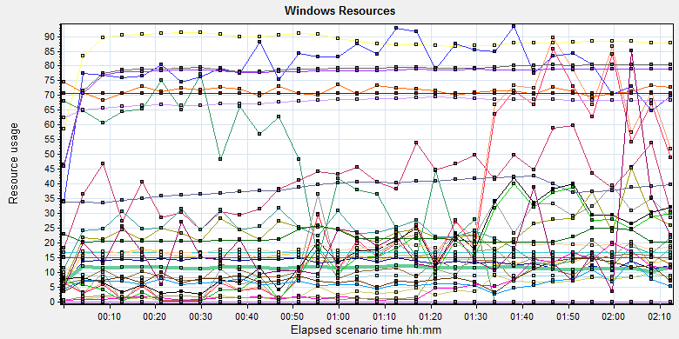

|  |  |  |  |  |  |  |  |  |  |  |  |  |  |  |  |  |  |  |  |  |  |  |  |  |  |  |  |  |  |  |  |  |  |  |  |  |  |  |  |  |  |  |  |  |  |  |  |  |  |  |  |  |  |  |  |  |  |  |  |  |  |  |  |  |  |  |  |  |  |  |  |  |  |  |  |  |  |  |  |  |  |  |  |  |  |  |  |  |  |  |  |  |  |  |  |  |  |  |  |  |  |  |  |  |  |  |  |  |  |  |  |  |  |  |  |  |  |  |  |  |  |  |  |  |  |  |  |  |  |  |  |  |  |  |  |  |  |  |  |  |  |  |  |  |  |  |  |  |  |  |  |  |  |  |  |  |  |  |  |  |  |  |  |  |  |  |  |  |  |  |  |  |  |  |  |  |  |  |  |  |  |  |  |  |  |  |  |  |  |  |  |  |  |  |  |  |  |  |  |  |  |  |  |  |  |  |  |  |  |  |  |  |  |  |  |  |  |  |  |  |  |  |  |  |  |  |  |  |  |  |  |  |  |  |  |  |  |  |  |  |  |  |  |  |  |  |  |  |  |  |  |  |  |  |  |  |  |  |  |
| --- | --- | --- | --- | --- | --- | --- | --- | --- | --- | --- | --- | --- | --- | --- | --- | --- | --- | --- | --- | --- | --- | --- | --- | --- | --- | --- | --- | --- | --- | --- | --- | --- | --- | --- | --- | --- | --- | --- | --- | --- | --- | --- | --- | --- | --- | --- | --- | --- | --- | --- | --- | --- | --- | --- | --- | --- | --- | --- | --- | --- | --- | --- | --- | --- | --- | --- | --- | --- | --- | --- | --- | --- | --- | --- | --- | --- | --- | --- | --- | --- | --- | --- | --- | --- | --- | --- | --- | --- | --- | --- | --- | --- | --- | --- | --- | --- | --- | --- | --- | --- | --- | --- | --- | --- | --- | --- | --- | --- | --- | --- | --- | --- | --- | --- | --- | --- | --- | --- | --- | --- | --- | --- | --- | --- | --- | --- | --- | --- | --- | --- | --- | --- | --- | --- | --- | --- | --- | --- | --- | --- | --- | --- | --- | --- | --- | --- | --- | --- | --- | --- | --- | --- | --- | --- | --- | --- | --- | --- | --- | --- | --- | --- | --- | --- | --- | --- | --- | --- | --- | --- | --- | --- | --- | --- | --- | --- | --- | --- | --- | --- | --- | --- | --- | --- | --- | --- | --- | --- | --- | --- | --- | --- | --- | --- | --- | --- | --- | --- | --- | --- | --- | --- | --- | --- | --- | --- | --- | --- | --- | --- | --- | --- | --- | --- | --- | --- | --- | --- | --- | --- | --- | --- | --- | --- | --- | --- | --- | --- | --- | --- | --- | --- | --- | --- | --- | --- | --- | --- | --- | --- | --- | --- | --- | --- | --- | --- | --- | --- | --- | --- | --- | --- | --- | --- | --- | --- | --- | --- | --- |
| |  |  |  |  |  |  |  | | --- | --- | --- | --- | --- | --- | --- | | Color | Scale | Measurement | Minimum | Average | Maximum | Std. Deviation | |  | 0.01 | % Disk Time (PhysicalDisk \_Total):10.184.129.108 | 1.751 | 2939.153 | 32133.513 | 3906.795 | |  | 1 | % Idle Time (PhysicalDisk \_Total):10.184.129.108 | 0 | 34.493 | 99.134 | 38.038 | |  | 1000 | % Interrupt Time (Processor \_Total):10.184.129.108 | 0 | 0.041 | 0.518 | 0.065 | |  | 10 | % Privileged Time (Processor \_Total):10.184.129.108 | 0 | 1.482 | 11.004 | 1.011 | |  | 1 | % Processor Time (Processor \_Total):10.184.129.108 | 2.418 | 13.281 | 60.19 | 7.122 | |  | 0.001 | Available MBytes (Memory):10.184.129.108 | 8241 | 8683.866 | 12196 | 538.235 | |  | 0.0001 | Avg. Disk Bytes/Transfer (PhysicalDisk \_Total):10.184.129.108 | 625.778 | 110007.37 | 737458.087 | 103784.462 | |  | 1 | Avg. Disk Queue Length (PhysicalDisk \_Total):10.184.129.108 | 0.018 | 29.391 | 321.335 | 39.067 | |  | 1 | Avg. Disk Write Queue Length (PhysicalDisk \_Total):10.184.129.108 | 0.018 | 3.897 | 60.182 | 4.739 | |  | 0.001 | Bytes Total/sec (Server):10.184.129.108 | 4282.837 | 15687.096 | 27666.778 | 615.609 | |  | 1E-07 | Cache Bytes (Memory):10.184.129.108 | 147927040 | 150289046.319 | 159629312 | 1308898.494 | |  | 1E-08 | Committed Bytes (Memory):10.184.129.108 | 4960067584 | 8774790789.532 | 9224015872 | 581133088.6 | |  | 0.001 | Context Switches/sec (System):10.184.129.108 | 3050.994 | 11463.075 | 79012.212 | 7484.27 | |  | 1 | Current Disk Queue Length (PhysicalDisk \_Total):10.184.129.108 | 0 | 28.075 | 251 | 39.159 | |  | 1E-06 | Disk Read Bytes/sec (PhysicalDisk \_Total):10.184.129.108 | 0 | 17405456.288 | 101199569.311 | 20997043.214 | |  | 0.1 | Disk Reads/sec (PhysicalDisk \_Total):10.184.129.108 | 0 | 158.709 | 1387.664 | 175.535 | |  | 0.1 | Disk Transfers/sec (PhysicalDisk \_Total):10.184.129.108 | 2.324 | 181.295 | 1401.281 | 172.092 | |  | 1E-05 | Disk Write Bytes/sec (PhysicalDisk \_Total):10.184.129.108 | 170.075 | 2434220.455 | 20970786.08 | 2812939.215 | |  | 1 | Disk Writes/sec (PhysicalDisk \_Total):10.184.129.108 | 0.332 | 22.587 | 92.643 | 12.404 | |  | 0.1 | File Data Operations/sec (System):10.184.129.108 | 39.519 | 792.891 | 3453.665 | 423.968 | |  | 1E-05 | Free Megabytes (LogicalDisk \_Total):10.184.129.108 | 1690704 | 1692650.904 | 1693980 | 928.406 | |  | 0.01 | Interrupts/sec (Processor \_Total):10.184.129.108 | 585.521 | 1805.343 | 9936.442 | 1041.979 | |  | 0.001 | Page Faults/sec (Memory):10.184.129.108 | 73.714 | 6563.125 | 84316.49 | 11911.301 | |  | 1 | Page Reads/sec (Memory):10.184.129.108 | 0 | 8.454 | 143.133 | 20.888 | |  | 0.1 | Pages/sec (Memory):10.184.129.108 | 0 | 52.254 | 1222.853 | 163.818 | |  | 1E-06 | Pool Nonpaged Bytes (Memory):10.184.129.108 | 62001152 | 67773723.851 | 70975488 | 1473463.619 | |  | 0.0001 | Pool Nonpaged Bytes (Server):10.184.129.108 | 629337 | 716419.73 | 768601 | 21683.46 | |  | 1E-07 | Pool Paged Bytes (Memory):10.184.129.108 | 201502720 | 216969667.72 | 270000128 | 18998500.426 | |  | 0.001 | Pool Paged Bytes (Server):10.184.129.108 | 70613 | 70613 | 70613 | 0 | |  | 1 | Pool Paged Failures (Server):10.184.129.108 | 0 | 0 | 0 | 0 | |  | 1E-08 | Private Bytes (Process \_Total):10.184.129.108 | 3744546816 | 7805761027.815 | 8089845760 | 612753578.102 | |  | 100 | Processor Queue Length (System):10.184.129.108 | 0 | 0.187 | 33 | 1.052 | |  | 1 | Split IO/Sec (PhysicalDisk \_Total):10.184.129.108 | 0 | 6.92 | 387.56 | 29.554 | |  | 1E-07 | System Cache Resident Bytes (Memory):10.184.129.108 | 147927040 | 150288107.779 | 159629312 | 1307718.623 | |  | 0.01 | Threads (Objects):10.184.129.108 | 3241 | 3849.624 | 4372 | 276.589 | |  | 1E-08 | Working Set (Process \_Total):10.184.129.108 | 3705069568 | 7722879606.271 | 8057450496 | 605648941.139 | |
|  |
|  |
| E:\PerformanceResult\PS result\MR1 Phase1\report2_20180607\Report\dot_trans.gif |
|  |
| |  | | --- | |  | |  | |
|  |
|  |

### SQL Server resource usage analysis

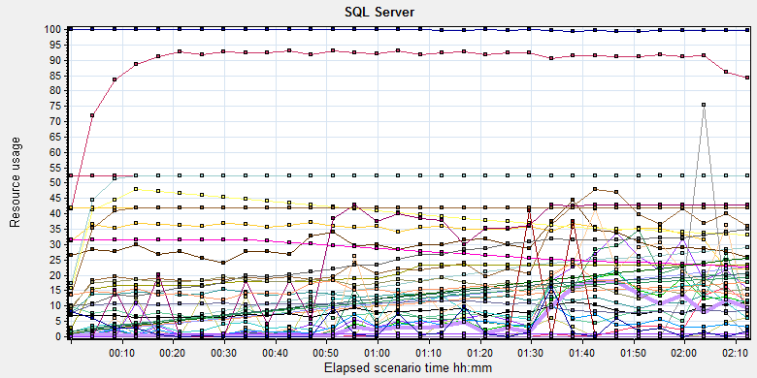

|  |  |  |  |  |  |  |
| --- | --- | --- | --- | --- | --- | --- |
| Color | Scale | Measurement | Minimum | Average | Maximum | Std. Deviation |
|  | 1 | Average Latch Wait Time (ms) (MSSQL$GCPACSWS|Latches):10.184.129.108 | 0.058 | 9.403 | 281.472 | 13.807 |
|  | 0.01 | Average Wait Time (ms) (MSSQL$GCPACSWS|Locks \_Total):10.184.129.108 | 0 | 895.603 | 30000 | 3533.439 |
|  | 1 | Buffer cache hit ratio (MSSQL$GCPACSWS|Buffer Manager):10.184.129.108 | 95.986 | 99.813 | 100 | 0.313 |
|  | 1 | Cache Hit Ratio (MSSQL$GCPACSWS|Cursor Manager by Type \_Total):10.184.129.108 | 8.163 | 89.084 | 94.973 | 10.023 |
|  | 1 | Cache Hit Ratio (MSSQL$GCPACSWS|Plan Cache SQL Plans):10.184.129.108 | 12.097 | 34.772 | 57.974 | 7.608 |
|  | 0.001 | Cache Object Counts (MSSQL$GCPACSWS|Plan Cache SQL Plans):10.184.129.108 | 297 | 16427.554 | 29227 | 8746.199 |
|  | 1 | Cache Objects in use (MSSQL$GCPACSWS|Plan Cache SQL Plans):10.184.129.108 | 2 | 26.036 | 60 | 11.003 |
|  | 0.0001 | Cache Pages (MSSQL$GCPACSWS|Plan Cache SQL Plans):10.184.129.108 | 7910 | 102648.646 | 176733 | 49282.934 |
|  | 1 | Checkpoint pages/sec (MSSQL$GCPACSWS|Buffer Manager):10.184.129.108 | 0 | 3.027 | 131.248 | 13.809 |
|  | 0.01 | Connection Memory (KB) (MSSQL$GCPACSWS|Memory Manager):10.184.129.108 | 1864 | 2995.386 | 4824 | 444.807 |
|  | 1 | Cursor flushes (MSSQL$GCPACSWS|Cursor Manager Total):10.184.129.108 | 0 | 0 | 0 | 0 |
|  | 0.0001 | Cursor memory usage (MSSQL$GCPACSWS|Cursor Manager by Type \_Total):10.184.129.108 | 3920 | 116016.06 | 228272 | 62700.901 |
|  | 0.0001 | Database pages (MSSQL$GCPACSWS|Buffer Manager):10.184.129.108 | 58748 | 392023.095 | 486019 | 63990.186 |
|  | 10 | Errors/sec (MSSQL$GCPACSWS|SQL Errors \_Total):10.184.129.108 | 0 | 0.855 | 41.424 | 1.581 |
|  | 10 | Errors/sec (MSSQL$GCPACSWS|SQL Errors User Errors):10.184.129.108 | 0 | 0.156 | 9.101 | 0.621 |
|  | 1000 | Free list stalls/sec (MSSQL$GCPACSWS|Buffer Manager):10.184.129.108 | 0 | 0.003 | 1.72 | 0.061 |
|  | 0.001 | Granted Workspace Memory (KB) (MSSQL$GCPACSWS|Memory Manager):10.184.129.108 | 0 | 6001.735 | 52504 | 8665.659 |
|  | 0.01 | Latch Waits/sec (MSSQL$GCPACSWS|Latches):10.184.129.108 | 75.104 | 803.528 | 2650.173 | 344.849 |
|  | 0.001 | Lock Memory (KB) (MSSQL$GCPACSWS|Memory Manager):10.184.129.108 | 1968 | 20048.364 | 23344 | 4293.112 |
|  | 0.0001 | Lock Requests/sec (MSSQL$GCPACSWS|Locks \_Total):10.184.129.108 | 22332.63 | 129414.921 | 836294.839 | 68818.993 |
|  | 1 | Lock Timeouts (timeout > 0)/sec (MSSQL$GCPACSWS|Locks \_Total):10.184.129.108 | 0 | 0 | 0 | 0 |
|  | 10 | Lock Timeouts/sec (MSSQL$GCPACSWS|Locks \_Total):10.184.129.108 | 0 | 0.893 | 29.399 | 1.955 |
|  | 0.01 | Lock Wait Time (ms) (MSSQL$GCPACSWS|Locks \_Total):10.184.129.108 | 0 | 1112.631 | 99008.969 | 5541.321 |
|  | 10 | Lock Waits/sec (MSSQL$GCPACSWS|Locks \_Total):10.184.129.108 | 0 | 0.347 | 7.993 | 0.731 |
|  | 1E-05 | Maximum Workspace Memory (KB) (MSSQL$GCPACSWS|Memory Manager):10.184.129.108 | 2262120 | 2798057.783 | 3151800 | 309831.646 |
|  | 1 | Memory Grants Outstanding (MSSQL$GCPACSWS|Memory Manager):10.184.129.108 | 0 | 4.969 | 39 | 7.25 |
|  | 1 | Memory Grants Pending (MSSQL$GCPACSWS|Memory Manager):10.184.129.108 | 0 | 0 | 0 | 0 |
|  | 0.01 | Number of active cursor plans (MSSQL$GCPACSWS|Cursor Manager by Type \_Total):10.184.129.108 | 45 | 1327.505 | 2589 | 710.11 |
|  | 10000 | Number of Deadlocks/sec (MSSQL$GCPACSWS|Locks \_Total):10.184.129.108 | 0 | 0 | 0.349 | 0.009 |
|  | 1 | Number of SuperLatches (MSSQL$GCPACSWS|Latches):10.184.129.108 | 0 | 0 | 0 | 0 |
|  | 0.01 | Optimizer Memory (KB) (MSSQL$GCPACSWS|Memory Manager):10.184.129.108 | 1000 | 2436.049 | 16192 | 936.71 |
|  | 1E-05 | Page life expectancy (MSSQL$GCPACSWS|Buffer Manager):10.184.129.108 | 10 | 2738363.116 | 4294965 | 2064421.029 |
|  | 0.0001 | Page lookups/sec (MSSQL$GCPACSWS|Buffer Manager):10.184.129.108 | 39985.191 | 169447.641 | 968380.029 | 86614.92 |
|  | 0.001 | SQL Cache Memory (KB) (MSSQL$GCPACSWS|Memory Manager):10.184.129.108 | 1760 | 12336.122 | 20584 | 5686.504 |
|  | 0.1 | SQL Compilations/sec (MSSQL$GCPACSWS|SQL Statistics):10.184.129.108 | 39.309 | 100.298 | 211.597 | 19.153 |
|  | 10 | SQL Re-Compilations/sec (MSSQL$GCPACSWS|SQL Statistics):10.184.129.108 | 0 | 0.12 | 92.472 | 1.794 |
|  | 0.0001 | Stolen pages (MSSQL$GCPACSWS|Buffer Manager):10.184.129.108 | 10751 | 116763.842 | 195498 | 52373.833 |
|  | 0.0001 | Target pages (MSSQL$GCPACSWS|Buffer Manager):10.184.129.108 | 524288 | 524288 | 524288 | 0 |
|  | 1E-05 | Target Server Memory (KB) (MSSQL$GCPACSWS|Memory Manager):10.184.129.108 | 4194304 | 4194304 | 4194304 | 0 |
|  | 100 | Temp Tables Creation Rate (MSSQL$GCPACSWS|General Statistics):10.184.129.108 | 0 | 0.026 | 6.645 | 0.202 |
|  | 0.0001 | Total pages (MSSQL$GCPACSWS|Buffer Manager):10.184.129.108 | 69856 | 510344.857 | 524288 | 64957.676 |
|  | 1E-05 | Total Server Memory (KB) (MSSQL$GCPACSWS|Memory Manager):10.184.129.108 | 558848 | 4082758.859 | 4194304 | 519661.404 |
|  | 0.1 | User Connections (MSSQL$GCPACSWS|General Statistics):10.184.129.108 | 92 | 155.192 | 264 | 26.431 |

E:\PerformanceResult\phase9\Report\dot_trans.gif

|  |
| --- |
| **Description:**Displays a summary of SQL Server Resources. |
|  |

## Issue analysis

During the performance testing works, We find an issue like that: If use 4GB for database , the performance test scenario will happens a lot of errors after 1 hour and the database performance will be down. So we will monitor the dataset memory usage and analysis the root reason for the issue. Development team do some change in database and set the adhoc parameter to ‘1’, but it seems it does not work.

We will analyze all resources information from up chapter to get the root reason.

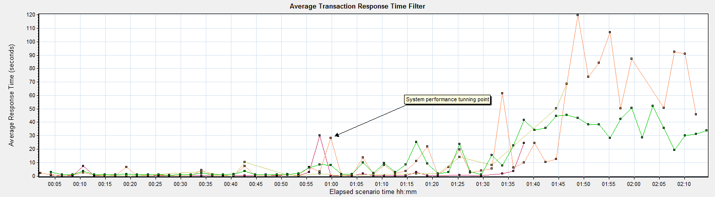

|  |  |  |  |  |  |  |  |
| --- | --- | --- | --- | --- | --- | --- | --- |
| Color | Scale | Measurement | Graph's Minimum | Graph's Average | Graph's Maximum | Graph's Median | Graph's Std. Deviation |
|  | 1 | Film PrintTask | 0.202 | 1.976 | 30.178 | 0.209 | 5.845 |
|  | 1 | Notify File 100k | 0.297 | 19.436 | 119.719 | 3.985 | 31.375 |
|  | 1 | Notify File 4M | 0.265 | 8.579 | 68.722 | 0.505 | 18.115 |
|  | 1 | Report QueryFilmReportInfo | 0.749 | 14.106 | 51.956 | 3.59 | 16.388 |

Follow the transactions result figure, we can find that some transaction response time increased with the execute time. These four transactions response time is more than 10 seconds and max value is more than 120 seconds. The performance is very bad. We should find out the root reason and fix it. We reference the server hardware resource and try to find the system bottle neck.

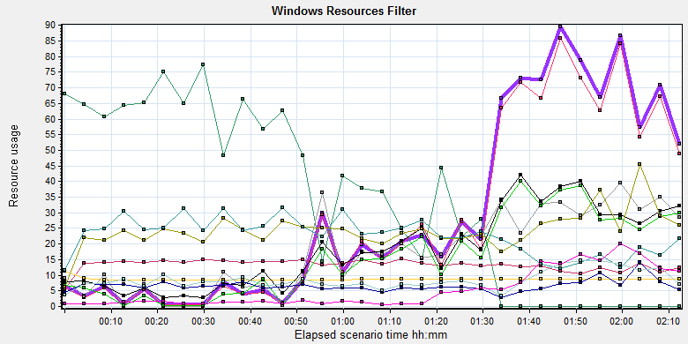

|  |  |  |  |  |  |  |  |  |  |  |  |  |  |  |  |  |  |  |  |  |  |  |  |  |  |  |  |  |  |  |  |  |  |  |  |  |  |  |  |  |  |  |  |  |  |  |  |  |  |  |  |  |  |  |  |  |  |  |  |  |  |  |  |  |  |  |  |  |  |  |  |  |  |  |  |  |  |  |  |  |  |  |  |  |  |  |  |  |  |  |  |  |  |  |  |  |  |  |
| --- | --- | --- | --- | --- | --- | --- | --- | --- | --- | --- | --- | --- | --- | --- | --- | --- | --- | --- | --- | --- | --- | --- | --- | --- | --- | --- | --- | --- | --- | --- | --- | --- | --- | --- | --- | --- | --- | --- | --- | --- | --- | --- | --- | --- | --- | --- | --- | --- | --- | --- | --- | --- | --- | --- | --- | --- | --- | --- | --- | --- | --- | --- | --- | --- | --- | --- | --- | --- | --- | --- | --- | --- | --- | --- | --- | --- | --- | --- | --- | --- | --- | --- | --- | --- | --- | --- | --- | --- | --- | --- | --- | --- | --- | --- | --- | --- | --- | --- |
| |  |  |  |  |  |  |  | | --- | --- | --- | --- | --- | --- | --- | | Color | Scale | Measurement | Minimum | Average | Maximum | Std. Deviation | |  | 0.01 | % Disk Time (PhysicalDisk \_Total):10.184.129.108 | 1.751 | 2939.153 | 32133.513 | 3906.795 | |  | 1 | % Idle Time (PhysicalDisk \_Total):10.184.129.108 | 0 | 34.493 | 99.134 | 38.038 | |  | 1 | % Processor Time (Processor \_Total):10.184.129.108 | 2.418 | 13.281 | 60.19 | 7.122 | |  | 0.001 | Available MBytes (Memory):10.184.129.108 | 8241 | 8683.866 | 12196 | 538.235 | |  | 1 | Current Disk Queue Length (PhysicalDisk \_Total):10.184.129.108 | 0 | 28.075 | 251 | 39.159 | |  | 1E-06 | Disk Read Bytes/sec (PhysicalDisk \_Total):10.184.129.108 | 0 | 17405456.288 | 101199569.311 | 20997043.214 | |  | 0.1 | Disk Reads/sec (PhysicalDisk \_Total):10.184.129.108 | 0 | 158.709 | 1387.664 | 175.535 | |  | 0.1 | Disk Transfers/sec (PhysicalDisk \_Total):10.184.129.108 | 2.324 | 181.295 | 1401.281 | 172.092 | |  | 1E-05 | Disk Write Bytes/sec (PhysicalDisk \_Total):10.184.129.108 | 170.075 | 2434220.455 | 20970786.08 | 2812939.215 | |  | 1 | Disk Writes/sec (PhysicalDisk \_Total):10.184.129.108 | 0.332 | 22.587 | 92.643 | 12.404 | |  | 0.001 | Page Faults/sec (Memory):10.184.129.108 | 73.714 | 6563.125 | 84316.49 | 11911.301 | |  | 1 | Page Reads/sec (Memory):10.184.129.108 | 0 | 8.454 | 143.133 | 20.888 | |  | 0.1 | Pages/sec (Memory):10.184.129.108 | 0 | 52.254 | 1222.853 | 163.818 | |
|  |

Follow the server hardware resource figure, we can find that the CPU and memory resource is enough for system. But the disk resource has the bottle neck. The disk is very busy after the scenario executes 50 minutes. The disk average transfer data is 18.9 MB/Seconds ((17405456+2434220)/1024/1024). We can also get that there are many page faults exist in the system. As normally, it means the memory resource is not enough. But the system exist larger free memory resource( Available MBytes (Memory): 8683.866). We guess the memory risk is happened in database because the database limits the memory size to 4GB for workgroup version.

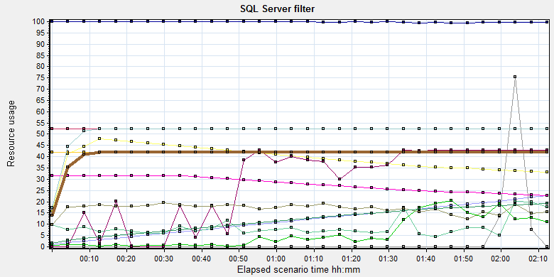

|  |  |  |  |  |  |  |
| --- | --- | --- | --- | --- | --- | --- |
| Color | Scale | Measurement | Minimum | Average | Maximum | Std. Deviation |
|  | 1 | Buffer cache hit ratio (MSSQL$GCPACSWS|Buffer Manager):10.184.129.108 | 95.986 | 99.813 | 100 | 0.313 |
|  | 0.0001 | Cursor memory usage (MSSQL$GCPACSWS|Cursor Manager by Type \_Total):10.184.129.108 | 3920 | 116016.06 | 228272 | 62700.901 |
|  | 0.0001 | Database pages (MSSQL$GCPACSWS|Buffer Manager):10.184.129.108 | 58748 | 392023.095 | 486019 | 63990.186 |
|  | 10 | Errors/sec (MSSQL$GCPACSWS|SQL Errors \_Total):10.184.129.108 | 0 | 0.855 | 41.424 | 1.581 |
|  | 1000 | Free list stalls/sec (MSSQL$GCPACSWS|Buffer Manager):10.184.129.108 | 0 | 0.003 | 1.72 | 0.061 |
|  | 0.001 | Granted Workspace Memory (KB) (MSSQL$GCPACSWS|Memory Manager):10.184.129.108 | 0 | 6001.735 | 52504 | 8665.659 |
|  | 1E-05 | Maximum Workspace Memory (KB) (MSSQL$GCPACSWS|Memory Manager):10.184.129.108 | 2262120 | 2798057.783 | 3151800 | 309831.646 |
|  | 1E-05 | Page life expectancy (MSSQL$GCPACSWS|Buffer Manager):10.184.129.108 | 10 | 2738363.116 | 4294965 | 2064421.029 |
|  | 0.0001 | Page lookups/sec (MSSQL$GCPACSWS|Buffer Manager):10.184.129.108 | 39985.191 | 169447.641 | 968380.029 | 86614.92 |
|  | 0.0001 | Stolen pages (MSSQL$GCPACSWS|Buffer Manager):10.184.129.108 | 10751 | 116763.842 | 195498 | 52373.833 |
|  | 0.0001 | Target pages (MSSQL$GCPACSWS|Buffer Manager):10.184.129.108 | 524288 | 524288 | 524288 | 0 |
|  | 1E-05 | Target Server Memory (KB) (MSSQL$GCPACSWS|Memory Manager):10.184.129.108 | 4194304 | 4194304 | 4194304 | 0 |
|  | 0.0001 | Total pages (MSSQL$GCPACSWS|Buffer Manager):10.184.129.108 | 69856 | 510344.857 | 524288 | 64957.676 |
|  | 1E-05 | Total Server Memory (KB) (MSSQL$GCPACSWS|Memory Manager):10.184.129.108 | 558848 | 4082758.859 | 4194304 | 519661.404 |

From the “Total Server Memory” and “Target Server Memory” performance count, we can find the database memory value get the max one very quickly. The Page life expectancy time is very small value during the first hour in scenario. That means the page in memory is flush very quickly. We will add more performance counter to identify the memory risk in the database.

In this version, our team want to change configuration to reduce the memory use for execute plan. But it does not work. I collect the value after the scenario by SQL statement and the result as follow:



After performance scenario execute for 2 hours, the adhoc plan has occupied 2.156GB memory.

I also collect the memory size used for store the system tables and result as follow:



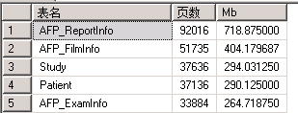

There are 2.4GB memory used to store the system tables. That means all memory is used to store the system table and execute plan. If system needs new memory resource, it will release and allocate resource. The memory resource for database is not enough because the workgroup version limited the max value to 4GB.

Second, I find there are many views exist in the database and their size is very large. Database view is a dynamic temp table store in the memory, it also cause the memory competed issues and IO read issues. The view cannot create index and the query performance are very slowly. I suggest team to modify the view or delete them.

|  |  |  |
| --- | --- | --- |
| Name | Count |  |
| AFP\_View\_AvailablePatient | 588 |  |
| AFP\_View\_AvailableStudy | 588 |  |
| AFP\_View\_FilmMediaSize | 314893 |  |
| AFP\_View\_FilmsToPrintAN | 588 |  |
| AFP\_View\_FilmsToPrintANWithoutHoldingTime | 588 |  |
| AFP\_View\_FilmsToPrintSI | 588 |  |
| AFP\_View\_FilmsToPrintSIWithoutHoldingTime | 588 |  |
| AFP\_View\_ForbiddenFilm | 14 |  |
| AFP\_View\_PrintTaskStatus | 4329285 |  |
| AFP\_View\_UnprintedFilm | 588 |  |
| AFP\_View\_UnprintedReportByAccNo | 855 |  |
| AFP\_View\_UnprintedReportByAccNoWithoutHoldingTime | 855 |  |
| AFP\_View\_UnprintedReportBySTUID | 855 |  |
| AFP\_View\_UnprintedReportBySTUIDWithoutHoldingTime | 855 |  |
| AFP\_View\_UnreportedFilm | 588 |  |
| AM\_V\_AlarmMessageList | 448908 |  |
| AM\_V\_DispatchGroupJoinReceiver | 0 |  |
| View\_Study | 1435754 |  |

Please confirm these views we really need.

Third, I compared the index between new install and upgrade version of system. There small difference between them. We should make them consistent with the new install. The detail information, please review the two files with compare tool.



## Performance tuning

After this phase testing works, I change the options of database. Set the parameter ‘Force parameter’ to true and execute the performance scenario again. The result as follow:

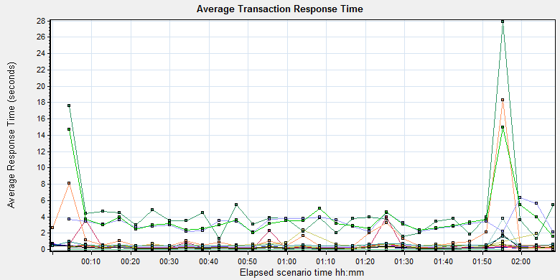

|  |  |  |  |  |  |  |  |
| --- | --- | --- | --- | --- | --- | --- | --- |
| Color | Scale | Measurement | Graph's Minimum | Graph's Average | Graph's Maximum | Graph's Median | Graph's Std. Deviation |
|  | 1 | Create New Patient | 0.232 | 0.35 | 0.737 | 0.298 | 0.122 |
|  | 1 | Film Create\_PrintTask | 1.303 | 4.751 | 27.878 | 3.807 | 5.108 |
|  | 1 | Film PrintTask | 0.199 | 0.572 | 3.974 | 0.206 | 0.952 |
|  | 1 | Film PrintTask\_Result\_Correct | 0 | 0 | 0 | 0 | 0 |
|  | 1 | Film TerminalStatus | 0.161 | 0.229 | 0.592 | 0.19 | 0.091 |
|  | 1 | Film\_PrintStatus\_CheckService | 0.153 | 0.348 | 3.782 | 0.19 | 0.644 |
|  | 1 | Fim GetTaskID\_fail | 0 | 0 | 0 | 0 | 0 |
|  | 1 | Notify File 100k | 0.391 | 1.733 | 18.318 | 0.568 | 3.353 |
|  | 1 | Notify File 4M | 0.249 | 0.642 | 2.403 | 0.531 | 0.498 |
|  | 1 | Report Print Task Correct | 0 | 0 | 0 | 0 | 0 |
|  | 1 | Report Create\_PrintTask | 2.067 | 3.263 | 6.304 | 3.289 | 0.956 |
|  | 1 | Report GetReportID\_fail | 0 | 0 | 0 | 0 | 0 |
|  | 1 | Report GetReportPath\_fail | 0 | 0 | 0 | 0 | 0 |
|  | 1 | Report PrintTask | 0.114 | 0.239 | 0.703 | 0.22 | 0.121 |
|  | 1 | Report PrintTask Status Check | 0.127 | 0.233 | 0.608 | 0.191 | 0.109 |
|  | 1 | Report QueryFilmReportInfo | 1.547 | 3.99 | 14.983 | 3.203 | 3.009 |
|  | 1 | Report TerminalStatus | 0.095 | 0.237 | 1.748 | 0.147 | 0.293 |
|  | 1 | Report Update PrintTask | 0.12 | 0.302 | 0.715 | 0.224 | 0.169 |
|  | 1 | Report Update report printer info | 0.398 | 0.537 | 1.545 | 0.457 | 0.222 |

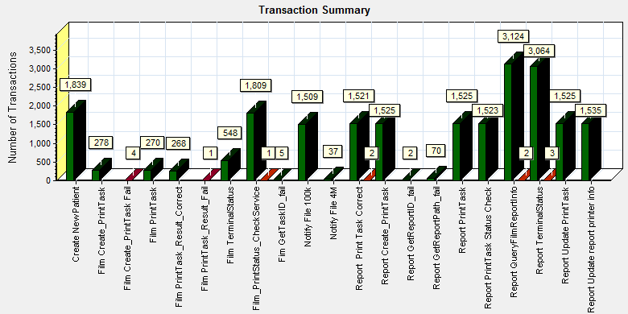

|  |  |  |
| --- | --- | --- |
| Color | Scale | Measurement |
|  | 1 | Pass |
|  | 1 | Fail |
|  | 1 | Stop |

Compare with the result with chapter 12.5.2 and 12.5.3, the response time and pass rate are better. The memory used size of adhoc execute plan also smaller than last phase.

|  |  |  |
| --- | --- | --- |
| **Name** | **Last** | **latest** |
| **Compiled Plan** | 2156Mb | 219Mb |
| **Compiled Plan Stub** | 0 | 5 |

It seems the configuration works and enhances the performance of system.

We create a new scenario which duration time set to 8 hours to simulate the typical operations under high stress. We want to know the system performance limitation with the new options and the result as follow:

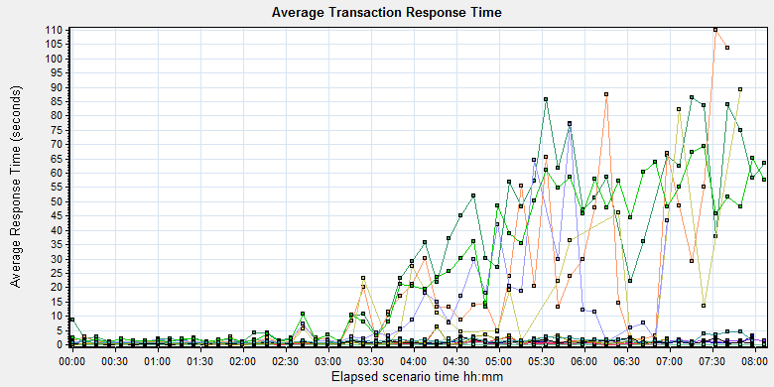

|  |  |  |  |  |  |  |  |  |  |  |  |  |  |  |  |  |  |  |  |  |  |  |  |  |  |  |  |  |  |  |  |  |  |  |  |  |  |  |  |  |  |  |  |  |  |  |  |  |  |  |  |  |  |  |  |  |  |  |  |  |  |  |  |  |  |  |  |  |  |  |  |  |  |  |  |  |  |  |  |  |  |  |  |  |  |  |  |  |  |  |  |  |  |  |  |  |  |  |  |  |  |  |  |  |  |  |  |  |  |  |  |  |  |  |  |  |  |  |  |  |  |  |  |  |  |  |  |  |  |  |  |  |  |  |  |  |  |  |  |  |  |  |  |  |  |  |  |  |  |  |  |  |  |  |  |  |  |  |  |  |
| --- | --- | --- | --- | --- | --- | --- | --- | --- | --- | --- | --- | --- | --- | --- | --- | --- | --- | --- | --- | --- | --- | --- | --- | --- | --- | --- | --- | --- | --- | --- | --- | --- | --- | --- | --- | --- | --- | --- | --- | --- | --- | --- | --- | --- | --- | --- | --- | --- | --- | --- | --- | --- | --- | --- | --- | --- | --- | --- | --- | --- | --- | --- | --- | --- | --- | --- | --- | --- | --- | --- | --- | --- | --- | --- | --- | --- | --- | --- | --- | --- | --- | --- | --- | --- | --- | --- | --- | --- | --- | --- | --- | --- | --- | --- | --- | --- | --- | --- | --- | --- | --- | --- | --- | --- | --- | --- | --- | --- | --- | --- | --- | --- | --- | --- | --- | --- | --- | --- | --- | --- | --- | --- | --- | --- | --- | --- | --- | --- | --- | --- | --- | --- | --- | --- | --- | --- | --- | --- | --- | --- | --- | --- | --- | --- | --- | --- | --- | --- | --- | --- | --- | --- | --- | --- | --- | --- | --- | --- | --- | --- |
| |  |  |  |  |  |  |  |  | | --- | --- | --- | --- | --- | --- | --- | --- | | Color | Scale | Measurement | Graph's Minimum | Graph's Average | Graph's Maximum | Graph's Median | Graph's Std. Deviation | |  | 1 | Create New Patient | 0.247 | 0.726 | 1.906 | 0.613 | 0.436 | |  | 1 | Film Create\_PrintTask | 1.02 | 28.71 | 86.349 | 22.25 | 28.507 | |  | 1 | Film PrintTask | 0.202 | 0.39 | 2.055 | 0.251 | 0.336 | |  | 1 | Film PrintTask\_Result\_Correct | 0 | 0 | 0.002 | 0 | 0 | |  | 1 | Film TerminalStatus | 0.132 | 0.577 | 2.95 | 0.477 | 0.459 | |  | 1 | Film\_PrintStatus\_CheckService | 0.157 | 0.58 | 2.189 | 0.462 | 0.458 | |  | 1 | Fim GetTaskID\_fail | 0 | 0 | 0.001 | 0 | 0 | |  | 1 | Notify File 100k | 0.504 | 18.41 | 109.97 | 6.692 | 26.371 | |  | 1 | Notify File 4M | 0.473 | 11.064 | 89.081 | 1.297 | 20.63 | |  | 1 | Report Print Task Correct | 0 | 0 | 0 | 0 | 0 | |  | 1 | Report Create\_PrintTask | 1.037 | 10.501 | 76.863 | 2.067 | 16.328 | |  | 1 | Report GetReportID\_fail | 0 | 0.001 | 0.016 | 0 | 0.003 | |  | 1 | Report GetReportPath\_fail | 0 | 0 | 0.001 | 0 | 0 | |  | 1 | Report PrintTask | 0.092 | 0.613 | 6.103 | 0.312 | 0.956 | |  | 1 | Report PrintTask Status Check | 0.092 | 0.545 | 1.946 | 0.374 | 0.459 | |  | 1 | Report QueryFilmReportInfo | 1.014 | 25.905 | 69.538 | 20.52 | 24.303 | |  | 1 | Report TerminalStatus | 0.128 | 0.784 | 2.786 | 0.545 | 0.637 | |  | 1 | Report Update PrintTask | 0.149 | 0.906 | 6.148 | 0.421 | 1.147 | |  | 1 | Report Update report printer info | 0.608 | 1.391 | 4.576 | 1.106 | 0.916 | |
|  |
|  |
| E:\PerformanceResult\PS result\MR1 Phase1\report2_20180608\Report\dot_trans.gif |
|  |
| |  | | --- | |  | |  | |
|  |
|  |

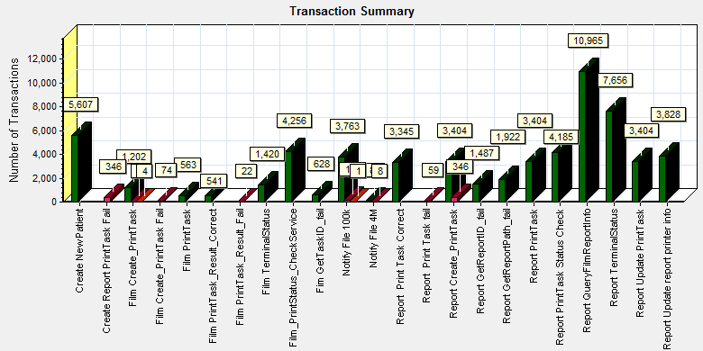

|  |  |  |
| --- | --- | --- |
| Color | Scale | Measurement |
|  | 1 | Pass |
|  | 1 | Fail |
|  | 1 | Stop |

We can get that the system performance inflection point happened after scenario execute 3.5 hours. We collect the adhoc memory used information as follow:

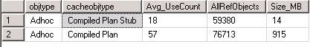

Compare with the first scenario, the value still smaller than it. The configuration of force used parameter give the useful changed for system. But the memory for database still has the resource compete issue. There are many page reads and write in the database and free pages are very small.

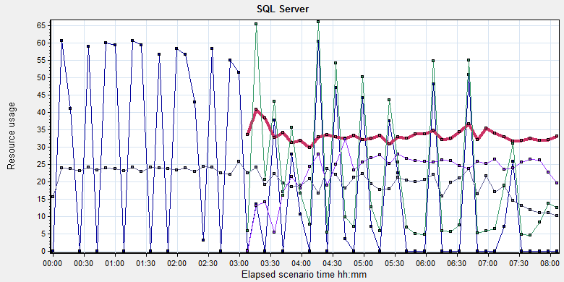

|  |  |  |  |  |  |  |
| --- | --- | --- | --- | --- | --- | --- |
| Color | Scale | Measurement | Minimum | Average | Maximum | Std. Deviation |
|  | 10 | Checkpoint pages/sec (MSSQL$GCPACSWS|Buffer Manager):10.184.129.108 | 0 | 2.124 | 127.676 | 10.935 |
|  | 0.1 | Free pages (MSSQL$GCPACSWS|Buffer Manager):10.184.129.108 | 28 | 332.371 | 2175 | 109.349 |
|  | 0.0001 | Page lookups/sec (MSSQL$GCPACSWS|Buffer Manager):10.184.129.108 | 3223.835 | 205616.368 | 1691103.452 | 150486.098 |
|  | 0.01 | Page reads/sec (MSSQL$GCPACSWS|Buffer Manager):10.184.129.108 | 0 | 2300.187 | 13956.874 | 2083.436 |
|  | 10 | Page writes/sec (MSSQL$GCPACSWS|Buffer Manager):10.184.129.108 | 0 | 2.072 | 131.503 | 6.749 |

We can see the page read counter is increase after scenario executes 3 hours. The counter value is 2500 every seconds. That means there is 19MB data need read to memory. The Free pages performance counter is keep value about 350. That means there is only 2.7MB memory resource in the database. The memory resource has bottle neck. For this issue, we find that if there is big data in view *wggc.dbo.AFP\_View\_UnprintedReportByAccNo, wggc.dbo.AFP\_View\_FilmsToPrintANWithoutHoldingTime*, the database will cause the memory reads issues.

Some transaction will use these view, the query performance for view is very slow. It will make the performance issues for system.

## Test Conclusion

Follow the latest three phase performance testing work, we find that the current configuration cannot meet the performance requirements of system. The root reason the database memory compete issues. We should try to fix the issues follow these steps and do the performance testing again to identify the result:

1. Change the parameter ‘Parameter’ to force as default for new install and upgrade version.
2. Confirm we really need use database view for our workflow. The view will use much memory resource and it`s query performance is bad.

Describe the overall verification and validation testing objectives.

Please make appropriate modifications to the sample text so it accurately reflects this project.

**<End of Document>**